

**CONTINUING AIRWORTHINESS MANAGEMENT PROCEDURE**

**(CAMP)**

|  |  |  |
| --- | --- | --- |
| **Organisation** | : | GALAXY AEROSPACE (M) SDN BHD |
| **Approval No** | : | CAMO/2016/03 |
| **Address** | : | Suite 11-14, Helicopter Centre, Malaysia International Aerospace Centre (MIAC), Sultan Abdul Aziz Shah Airport, 47200 Subang, Selangor Darul Ehsan |
| **Tel No** | : | +603 7734 7226 |
| **Fax No** | : | +603 7734 7526 |
| **CAMP Reference No** | : | GAM/CAMO/CAMP |
| **Issue Number** | : | Issue 1 |
| **Revision Number** | : | Revision 3 |
| **Date of Issue** | : | 29 April 2019 |
| **Date of Revision** | : | 02 February 2021 |
| **Copy Number** | : | GAM/CAMP/MASTER |
| **Copy Holder** | : | Technical Publication – Library GAM CAMO |

**TABLE OF CONTENT**

**TABLE OF CONTENT** i

**TRANSMITTAL LETTER** v

**LIST OF EFFECTIVE PAGES (LOEP)** vi

**AMENDMENT RECORD** viii

**DISTRIBUTION LIST** xvi

**ABBRIEVIATIONS LIST** xvii

**PART 0 GENERAL ORGANISATION** 1

**0.1** **INTRODUCTION** 1

**0.2** **SCOPE** 1

**0.3** **RESPONSIBILITIES** 1

**0.4** **DESCRIPTION OF THE ORGANISATION** 2

**0.5** **CONTINUING AIRWORTHINESS MANAGEMENT ORGANISATION** 4

**0.5.1** **TECHNICAL PUBLICATIONS** 4

**0.5.2** **TECHNICAL RECORDS** 5

**0.5.3** **TECHNICAL SERVICES** 5

**0.5.4** **CAMO PLANNER** 6

**0.5.5** **DEPUTY CAMM** 6

**0.6** **MANPOWER MANAGEMENT** 8

**0.7** **TRAINING REQUIREMENT** 9

**0.8** **COMPETENCY ASSESSMENT** 11

**PART 1 TECHNICAL PUBLICATION PROCEDURES** 1

**1.1** **INTRODUCTION** 1

**1.2** **SCOPE** 1

**1.3** **RESPONSIBILITIES** 1

**1.4** **PUBLICATION REGISTER** 2

**1.5** **PUBLICATION DISTRIBUTION** 3

**1.5.1** **INTERNAL PUBLICATIONS** 3

**1.5.2** **EXTERNAL PUBLICATIONS** 3

**1.6** **PUBLICATION MASTER LIST** 7

**1.7** **PUBLICATION TRACKING** 8

**1.8** **PUBLICATION PURCHASE / RENEWAL** 9

**1.9** **PUBLICATION CONTROL CHECK** 10

**PART 2 TECHNICAL RECORD PROCEDURES** 1

**2.1** **INTRODUCTION** 1

**2.2** **SCOPE** 1

**2.3** **RESPONSIBILITIES** 1

**2.4** **AIRCRAFT JOURNEY LOG FILING** 2

**2.5** **MAINTENANCE RECORDS ACCEPTANCE** 6

**2.6** **MAINTENANCE RECORDS UPDATING** 7

**2.6.1** **AERONET SYSTEM** 7

**2.6.1.1** **TECH LOG MODULE** 7

**2.6.1.2** **AIRCRAFT MODULE** 7

**2.6.2** **LOG BOOK ENTRY** 11

**2.6.2.1** **AIRCRAFT LOG BOOK** 11

**2.6.2.2** **ENGINE LOG BOOK** 12

**2.6.2.3** **APU LOG BOOK** 12

**2.6.2.4****PROPELLER LOG BOOK**  13

**2.6.3** **LOG CARDS UPDATING** 14

**2.6.3.1** **COMPONENT REMOVAL** 14

**2.6.3.2** **COMPONENT INSTALLATION** 14

**2.6.3.3** **COMPONENT MAINTENANCE/MODIFICATION** 15

**2.6.4** **MODIFICATION RECORD BOOK** 24

**2.7** **MAINTENANCE RECORDS FILING, RETENTION AND ARCHIVING** 25

**PART 3 CAMO PLANNING PROCEDURES** 1

**3.1** **INTRODUCTION** 1

**3.2** **SCOPE** 1

**3.3** **RESPONSIBILITIES** 1

**3.4** **AIRCRAFT REGISTER** 2

**3.5** **AIRCRAFT MONITORING** 4

**3.6** **MAINTENANCE FORECAST** 5

**3.6.1** **YEARLY FORECAST** 5

**3.6.2** **QUARTERLY FORECAST** 5

**3.6.3** **WEEKLY FORECAST** 5

**3.7** **CAMO PLANNING** 7

**3.8** **AMO COORDINATION** 8

**3.9** **WORK ORDER ISSUANCE** 9

**3.9.1** **SCHEDULE MAINTENANCE** 9

**3.9.2** **UNSCHEDULE MAINTENANCE** 10

**3.10** **WORK PACKAGE REVIEW** 11

**PART 4 TECHNICAL SERVICE PROCEDURES** 1

**4.1** **INTRODUCTION** 1

**4.2** **SCOPE** 1

**4.3** **RESPONSIBILITIES** 1

**4.4** **AIRCRAFT MAINTENANCE PROGRAMME** 2

**4.4.1** **AMP DEVELOPMENT** 2

**4.4.2** **AMP AMENDMENTS** 3

**4.4.3** **AMP COMPLIANCE** 4

**4.4.4** **AMP VARIATION** 5

**4.5** **MINIMUM EQUIPMENT LIST (MEL)** 6

**4.6** **TECHNICAL INSTRUCTION COMPLIANCE/SENTENCING** 7

**4.7** **FLIGHT TEST SCHEDULE** 8

**4.7.1** **AIRWORTHINESS FLIGHT TEST SCHEDULE (AFTS)** 8

**4.7.2** **MAINTENANCE FLIGHT TEST SCHEDULE (MFTS)** 9

**4.8** **MAINTENANCE REVIEW BOARD** 11

**4.9** **AIRCRAFT RELIABILITY PROGRAM** 13

**4.10** **REPAIR PROCESS MANAGMENT** 16

**4.11** **TECHNICAL NOTE** 25

**PART 5 AIRWORTHINESS REVIEW PROCEDURES** 1

**5.1** **INTRODUCTION** 1

**5.2** **SCOPE** 1

**5.3** **RESPONSIBILITIES** 1

**5.4** **AIRWORTHINESS REVIEW PLAN** 2

**5.5** **AIRWORTHINESS REVIEW PREPARATION** 4

**5.6** **AIRWORTHINESS REVIEW** 5

**5.6.1** **AIRCRAFT RECORDS** 5

**5.6.2** **PHYSICAL SURVEY** 6

**5.7** **AIRWORTHINESS REVIEW FINDING** 7

**5.8** **ISSUANCE OF AIRWORTHINESS REVIEW REPORT** 8

**5.9** **SUBMISSION TO CAAM FOR C OF A APPLICATION** 9

**5.10** **ISSUANCE/RENEWAL OF CERTIFICATE OF AIRWORTHINESS** 10

**5.11** **PERMIT TO FLY ISSUANCE** 11

**5.12** **AIRWORTHINESS REVIEW RECORDS RETENTION** 13

**PART 6 APPENDICES** 1

**6.1.** **LIST OF FORMS** 1

**6.2.** **LIST OF APPROVED LIMITED SCOPE OF MAINTENANCE ACTIVITIES** 3

# **TRANSMITTAL LETTER**

The Continuing Airworthiness Management Procedure Issue 1 Revision 3 dated 02 February 2021 is hereby approved by the Quality Assurance Manager (QAM). The CAM Manager is responsible to ensure that the policies, procedures, and instruction contained in this procedure are adhered to by all personnel employed in the Continuing Airworthiness Management Organisation (CAMO) in the execution of their duties.

|  |  |
| --- | --- |
| **Prepared by:**  ……………………………………………………………………  Date:  Amir Bin Abdullah Deputy Continuing Airworthiness Management Manager | **Verified by:**  ……………………………………………………………………  Date:  Zaty Nadhira Binti Mohamed Zuhari Continuing Airworthiness Management Manager |
| **Approved by:**  ……………………………………………………………………  Date:  Omar Bin Ahmad  Quality Assurance Manager | |

# **LIST OF EFFECTIVE PAGES (LOEP)**

| **CAMP Part** | **CAMP Chapter** | **Page No.** | **Revision** | **Date** |
| --- | --- | --- | --- | --- |
| 0 | 0.1 | 1 | 3 | 02 February 2021 |
| 0.2 | 1 | 3 | 02 February 2021 |
| 0.3 | 1 | 3 | 02 February 2021 |
| 0.4 | 2 – 3 | 3 | 02 February 2021 |
| 0.5 | 4 – 7 | 3 | 02 February 2021 |
| 0.6 | 8 | 3 | 02 February 2021 |
| 0.7 | 9 – 10 | 3 | 02 February 2021 |
| 0.8 | 11 | 3 | 02 February 2021 |
| 1 | 1.1 | 1 | 3 | 02 February 2021 |
| 1.2 | 1 | 3 | 02 February 2021 |
| 1.3 | 1 | 3 | 02 February 2021 |
| 1.4 | 2 | 3 | 02 February 2021 |
| 1.5 | 3 – 6 | 3 | 02 February 2021 |
| 1.6 | 7 | 3 | 02 February 2021 |
| 1.7 | 8 | 3 | 02 February 2021 |
| 1.8 | 9 | 3 | 02 February 2021 |
| 1.9 | 10 | 3 | 02 February 2021 |
| 2 | 2.1 | 1 | 3 | 02 February 2021 |
| 2.2 | 1 | 3 | 02 February 2021 |
| 2.3 | 1 | 3 | 02 February 2021 |
| 2.4 | 2 – 5 | 3 | 02 February 2021 |
| 2.5 | 6 | 3 | 02 February 2021 |
| 2.6 | 7 – 23 | 3 | 02 February 2021 |
| 2.7 | 24 | 3 | 02 February 2021 |
| 3 | 3.1 | 1 | 3 | 02 February 2021 |
| 3.2 | 1 | 3 | 02 February 2021 |
| 3.3 | 1 | 3 | 02 February 2021 |
| 3.4 | 2 – 3 | 3 | 02 February 2021 |
| 3.5 | 4 | 3 | 02 February 2021 |
| 3.6 | 5 – 6 | 3 | 02 February 2021 |
| 3.7 | 7 | 3 | 02 February 2021 |
| 3.8 | 8 | 3 | 02 February 2021 |
| 3.9 | 9 – 10 | 3 | 02 February 2021 |
| 3.10 | 11 | 3 | 02 February 2021 |
| 4 | 4.1 | 1 | 2 | 24 December 2020 |
| 4.2 | 1 | 2 | 24 December 2020 |
| 4.3 | 1 | 2 | 24 December 2020 |
| 4.4 | 2 – 5 | 3 | 02 February 2021 |
| 4.5 | 6 | 1 | 10 June 2020 |
| 4.6 | 7 | 3 | 02 February 2021 |
| 4.7 | 8 – 10 | 0 | 29 April 2019 |
| 4.8 | 11 – 12 | 1 | 10 June 2020 |
| 4.9 | 13 – 15 | 0 | 29 April 2019 |
| 4.10 | 16 – 24 | 1 | 10 June 2020 |
| 4.11 | 25 – 26 | 3 | 02 February 2021 |
| 5 | 5.1 | 1 | 0 | 29 April 2019 |
| 5.2 | 1 | 0 | 29 April 2019 |
| 5.3 | 1 | 0 | 29 April 2019 |
| 5.4 | 2 – 3 | 1 | 10 June 2020 |
| 5.5 | 4 | 0 | 29 April 2019 |
| 5.6 | 5 – 6 | 0 | 29 April 2019 |
| 5.7 | 7 | 0 | 29 April 2019 |
| 5.8 | 8 | 0 | 29 April 2019 |
| 5.9 | 9 | 1 | 10 June 2020 |
| 5.10 | 10 | 0 | 29 April 2019 |
| 5.11 | 11 – 12 | 3 | 02 February 2021 |
| 5.12 | 13 | 1 | 10 June 2020 |
| 6 | 6.1 | 1 – 2 | 3 | 02 February 2021 |
| 6.2 | 3 – 9 | 3 | 02 February 2021 |

|  |  |
| --- | --- |
| **Continuing Airworthiness Management Manager Approval:**  ……………………………………………………………………………….  Date: | **Quality Assurance Manager Approval:**  ……………………………………………………………………………….  Date: |

# **AMENDMENT RECORD**

| **ISSUE NO** | **REV**  **NO** | **DATE** | **DETAILS** | **BY** | **DATE** |
| --- | --- | --- | --- | --- | --- |
| 1 | 0 | 29-04-19 | 1. Initial | CTOO | 29-04-19 |
| 1 | 1 | 10-06-20 | 1. Chapter 0.4 – Description of the Organisation 2. Update GAM CAMO scope of approval and its AMP reference. 3. Chapter 0.5.4 – CAMO Planner 4. Revise and update CAMO planner job description. 5. Chapter 0.6 – Manpower Management 6. Insert CAME Part 5.9 for available manpower resources in GAM CAMO. 7. Chapter 0.7 – Training Requirement 8. Change post title from CAM to CAM Manager 9. Chapter 0.8 – Competency Assessment 10. Change post title from CAM to CAM Manager 11. Chapter 1.4 – Publication Register 12. Amend Publication Register form number to GAM/CAMO-026 13. Chapter 1.5 – Publication Distribution 14. Change post title from CAM to CAM Manager 15. Update Figure for Internal and External Publication Control Workflow | CAMM | 10-06-20 |
| 1 | 1 | 10-06-20 | 1. Chapter 2.5 – Maintenance Record Acceptance 2. Update procedure for maintenance record acceptance. By CAMO Planner shall sign the completed work pack for acceptance. 3. Deleted and move requirement to Part 3.10. 4. Chapter 2.6.1 – AERONET System 5. Included CAMO Planner to update AERONET system with Technical Record 6. Chapter 2.6.2 – Log Book Entry 7. Change post title from CAM to CAM Manager 8. Included modification / repair compliance for updating in aircraft log book. 9. Chapter 3.9.2 – Unschedule Maintenance 10. Corrected grammar of sentence. 11. Assign reference control number format for Unschedule Maintenance Check (UMC) 12. Chapter 3.10 – Work Package Review 13. Inserted criteria for work package review and acceptance by CAMO planner. 14. (UMC) form GAM/CAMO-005 15. Chapter 4.6 – Technical Instruction Compliance / Sentencing 16. Include GEN as controlled TIC reference for general information letter and update TIC controlled number format. | CAMM | 10-06-20 |
| 1 | 1 | 10-06-20 | 1. Inserted requirement to attach evidence with TIC as reference (log card, work sheet, etc.) 2. Change post title from CAM to CAM Manager 3. Chapter 4.8 – Maintenance Review Board 4. Change post title from CAM to CAM Manager 5. Chapter 4.10 – Repair Process Management 6. Revised and updated repair process management as per CAAM requirements. 7. Chapter 4.11 – Technical Note 8. Revise and update the procedure for Technical Note 9. Chapter 5.4 – Airworthiness Review Plan 10. Change post title from CAM to CAM Manager 11. Chapter 5.9 – Submission to CAAM for C of A Application 12. Change post title from CAM to CAM Manager 13. Chapter 5.11- Permit to Fly Issuance 14. Inserted procedure for Permit to Fly (PTF) issuance. | CAMM | 10-06-20 |
| 1 | 2 | 24-12-20 | 1. Cover Page 2. Amended cover page to include organisation name and approval. 3. Table of Content 4. Inserted new Chapter 4.4.4 – AMP Variation 5. Transmittal Letter 6. Update CAMP revision status | CAMM | 24-12-20 |
| 1 | 2 | 24-12-20 | 1. Part 0 – General Organisation 2. Reformatting to include numbering list system (a, b, c) for each paragraph. 3. Chapter 0.4 – Description of the Organisation 4. Update GAM CAMO scope of approval and its AMP reference. 5. Chapter 0.5 – Continuing Airworthiness Management Organisation 6. Inserted post for Deputy CAMM in the organisation chart 7. Change post title from CAM to CAM Manager 8. Chapter 0.5.5 – Deputy CAMM 9. Include terms of reference for Deputy CAMM 10. Chapter 0.7 – Training Requirement 11. Update table to include training requirement for Deputy CAMM. 12. Chapter 0.8 – Competency Assessment 13. Update table to include Job Competency Assessment form GAM/CAMO-032. 14. Part 4 – Technical Service Procedures 15. Reformatting to include numbering list system (a, b, c) for each paragraph. 16. Chapter 4.4.4 – AMP Variation 17. Added procedure for AMP Variation request to CAAM. | CAMM | 24-12-20 |
| 1 | 2 | 24-12-20 | 1. Chapter 6.1 – List of Forms 2. Register and update CAMO forms. 3. Chapter 6.2 – List of Approved Limited Scope of Maintenance Activities 4. Amended manual reference for Main Rotor Head – Install Procedure for AW139 in Table a. item no. 6. 5. Included list of maintenance flight test for aircraft type EC120B, B300 and R44. | CAMM | 24-12-20 |
| 1 | 3 | 02-02-21 | 1. Chapter 0.4 – Description of the Organisation 2. Update CAMO additional location at PGU Subang. 3. Update GAM CAMO scope of approval and its AMP reference. 4. Chapter 0.5.5 – Deputy CAMM 5. Amended CAME Reference. 6. deleted task for monitoring of fess for permit to fly issuance by GAM. 7. Chapter 0.6 – Manpower Management    1. Updated total man hours available per year. 8. Chapter 0.7 – Training Requirement    1. Updated table and formatting 9. Chapter 0.8 – Competency Assessment 10. Updated assessment interval every two years. | CAMM | 02-02-21 |
| 1 | 3 | 02-02-21 | 1. Chapter 1.4 – Publication Register 2. Revised Publication Register procedure to include AD reverification and re-evaluation for every aircraft inducted into GAM-CAMO. 3. Chapter 1.5.1 – Internal Publications 4. Included type of internal publications (CAME, CAMP, CAN). 5. Chapter 1.5.2 – External Publications 6. Introduce task to monitor biweekly AD issued by EASA and FAA. 7. Chapter 1.6 – Publication Master List 8. Updated procedure to include vertical bar for changes in Master List. 9. Chapter 2.6 – Maintenance Records Updating 10. Inserted period for record updating no later than 30 days from maintenance completion. 11. Chapter 2.6.2 – Log Book Entry 12. Inserted Chapter 2.6.2.4 Propeller Log Book 13. Chapter 2.6.4 – Modification Record Book (MRB) 14. Included Notices 8301 an 7201 as part of MRB. 15. Updated procedure for AD and SB status report generated from AERONET. | CAMM | 02-02-21 |
| 1 | 3 | 02-02-21 | 1. Chapter 2.7 – Maintenance Records Filing, Retention and Archiving 2. Included period to retain AJL for at least 36 months after the date of the last entry. 3. Chapter 3.4 – Aircraft Register 4. Revised Aircraft Register procedure to include LLP and AD status report verification for every aircraft inducted into GAM-CAMO. 5. Chapter 3.5 – Aircraft Monitoring 6. Revised Aircraft Monitoring procedure to include requirement to monitor AMP Temporary Revision in AERONET. 7. Chapter 3.9 – Work Order Issuance 8. Revised Work Order Issuance procedures to include requirements for complex maintenance task. 9. Chapter 4.4.1 – AMP Development 10. Updated procedure for requirement of minutes of meeting on AMP review. 11. Chapter 4.6 – Technical Instruction Compliance 12. Revised Technical Instruction Compliance procedures to include requirements to enter and monitor AMP Temporary Revision in AERONET. | CAMM | 02-02-21 |
| 1 | 3 | 02-02-21 | 1. Chapter 4.11 – Technical Note 2. Assigned form number GAM/CAMO-036 for technical note. 3. Chapter 5.11 – Permit to Fly (PTF) Issuance 4. Included procedure for monthly reporting to CAAM on PTF issuance. 5. Chapter 6.1 – List of Forms 6. Register and update CAMO forms. 7. Chapter 6.2 – List of Approved Limited Scope of Maintenance Activities 8. Revised and updated list of maintenance flight test for aircraft type EC120B and B300. | CAMM | 02-02-21 |

# **DISTRIBUTION LIST**

|  |  |
| --- | --- |
| **COPY NUMBER** | **HOLDER** |
| GAM/CAMP/MASTER | Technical Publication – Library GAM CAMO |
| GAM/CAMP/01 | Accountable Manager GAM CAMO |
| GAM/CAMP/02 | Quality Assurance Manager GAM CAMO |
| GAM/CAMP/03 | CAM Manager GAM CAMO |
| GAM/CAMP/04 | Continuing Airworthiness Management Office |

# **ABBRIEVIATIONS LIST**

|  |  |
| --- | --- |
| A/C | Aircraft |
| AD | Airworthiness Directives |
| AFTS | Airworthiness Flight Test Schedule |
| AJL | Aircraft Journey Log |
| AMO | Aircraft Maintenance Organisation |
| AMP | Aircraft Maintenance Programme |
| APU | Auxiliary Power Unit |
| ARC | Authorised Released Certificate |
| ARF | Airworthiness Review Finding |
| ARR | Airworthiness Review Report |
| ARS | Airworthiness Review Staff |
| BMRC | Base Maintenance Release Certificate |
| BT | Bolletino Tecnico (Technical Bulletins) |
| CAAM | Civil Aviation Authority of Malaysia |
| CAM | Continuing Airworthiness Management |
| CAME | Continuing Airworthiness Management Exposition |
| CAMM | Continuing Airworthiness Management Manager |
| CAMO | Continuing Airworthiness Management Organisation |
| CAMP | Continuing Airworthiness Management Procedure |
| CAMS | Continuing Airworthiness Management System |
| CMM | Component Maintenance Manual |
| EMM | Engine Maintenance Manual |
| GAM | Galaxy Aerospace (M) Sdn Bhd |
| GAMS | Galaxy Aerospace Management System |
| ICA | Instruction for Continuing Airworthiness |
| IETP | Interactive Electronic Technical Publication |
| LBE | Log Book Entry |
| MEL | Minimum Equipment List |
| MMEL | Master Minimum Equipment List |
| MRB | Maintenance Review Board |
| O.R.I.O.N | Optimized Reader for Internet and Other Networks |
| OEM | Original Equipment Manufacturer |
| P/N | Part Number |
| PSR | Physical Survey Report |
| QAM | Quality Assurance Manager |
| RFM | Rotorcraft Flight Manual |
| S/N | Serial Number |
| SB | Service Bulletin |
| SMI | Schedule Maintenance Inspection |
| STC | Supplemental Type Certificate |
| STSE | Senior Technical Service Engineer |
| TC | Type Certificate |
| TIC | Technical Instruction Compliance |
| TN | Technical Note |
| TSE | Technical Service Engineer |
| TSN | Time Since New |
| TSO | Time Since Overhaul |
| WO | Work Order |
| WP | Workpack |
| WS | Worksheet |

**PART 0**

**GENERAL ORGANISATIONS**

# **PART 0 GENERAL ORGANISATION**

* 1. **INTRODUCTION**

1. This Continuing Airworthiness Management Procedures (CAMP) defines the procedures and guidelines for CAMO personnel on managing the continuing airworthiness of the aircraft in accordance with the requirements defined in GAM CAME and CAAM Part M Regulations.
   1. **SCOPE**
2. This chapter covers the role and responsibilities of each personnel within the CAMO.
   1. **RESPONSIBILITIES**
3. All CAMO personnel
   1. **DESCRIPTION OF THE ORGANISATION**
4. Galaxy Aerospace Malaysia (GAM) Continuing Airworthiness Management Organisation (CAMO) is a Civil Aviation Authority of Malaysia (CAAM) approved organisation performing Part M Subpart G and I privileges for commercial and non-commercial aircraft.
5. Galaxy Aerospace Malaysia is also an independent Part 145 approved organisation to satisfy the requirement of CAAM continuing airworthiness requirements and/or may also uses a suitable CAAM AMO contractor.
6. GAM CAMO office is located at:
7. CAMO HQ

Suite 11-14, Helicopter Centre,

Malaysia International Aerospace Centre,

Sultan Abdul Aziz Shah Airport,

47200 Subang, Selangor.

1. CAMO PGU  
   Pangkalan Semenanjung,

Pasukan Gerakan Udara PDRM,  
47200 Subang, Selangor.

1. The following continuing airworthiness management capabilities of GAM CAMO are based on CAAM approval under Part M Subpart G and I:

| **Aircraft Type** | **Airworthiness**  **Management** | **Airworthiness Review** | **Permit to Fly** | **AMP** |
| --- | --- | --- | --- | --- |
| AW139 | ✓ |  | ✓ | RMPAOF/ENG/PUB/MS/AW139  YTLPG/CAMO/AMP/AW139  JBPM/CAMO/AMP/AW139 |
| EC120 | ✓ | - | - | GKSB/CAMO/AMP/ EC120B  MYCAS/HFA/AMP/EC120B |
| AS355F1 | ✓ | - | - | - |
| A109S | ✓ | - | - | GAM/CAMO/AMP/A109S |
| AW189 | ✓ | ✓ | ✓ | JBPM/CAMO/AMP/ AW189 |
| EC155B | ✓ | ✓ | ✓ | HRHSOP/CAMO/AMP/EC155B |
| EC155B1 | ✓ | ✓ | ✓ | GAM/CAMO/AMP/EC155B1 |
| AS365N2 | ✓ | ✓ | ✓ | GAM/CAMO/AMP/AS365N2 |
| BELL 429 | ✓ | ✓ | ✓ | GAM/CAMO/AMP/429 |
| A119 | ✓ | ✓ | ✓ | PBH/CAMO/AMP/A119 |
| A109E | ✓ | ✓ | ✓ | JBPM/CAMO/AMP/A109E |
| B300 | ✓ | ✓ | ✓ | RMPAOF/CAMO/AMP/B300 |
| R44 | ✓ | ✓ | ✓ | LLFA/CAMO/AMP/R44 |

* 1. **CONTINUING AIRWORTHINESS MANAGEMENT ORGANISATION**

CAMO Personnel

CAAM Post Holder

* + 1. **TECHNICAL PUBLICATIONS**

1. Technical Publications Executive is responsible for the following:
2. procure and administer all airworthiness and operational data / instruction /documents required for continuing airworthiness and maintenance activities according to the scope of work available for the organisation;
3. maintain a technical library to keep master copy of all required publications;
4. establish an effective system to replicate and distribute all required information /documents distributed to the relevant recipient;
5. establish and maintain a register of all airworthiness and operational data / instruction /documents acquired and distributed including their location and status;
6. the focal point to receive report for publication discrepancy;
7. any other duties as directed by the CAM Manager.
   * 1. **TECHNICAL RECORDS**
8. The Technical Records is the one responsible for the assistance in the upkeep of all aircraft maintenance records with compliance to relevant civil aviation authority requirements. The Technical Records are responsible for the following functions:
9. maintain and manage any records associated with the maintenance management or operation such as aircraft logbooks;
10. liaison with Maintenance Planning and Part 145 AMO in particular in respect of component configuration and status;
11. support the performance of Airworthiness Reviews (ARR) process to ensure correct availability of back to birth records for Continuing Airworthiness;
12. importation and Exportation of Aircraft Technical Records as required;
13. perform QC Data checks of the various information's which managed by the Technical records office and resolve any ambiguities, technical or other problems from Engineering, Operations and Crew.
14. any other duties as directed by the CAM Manager
    * 1. **TECHNICAL SERVICES**
15. Technical Service is the one whose main responsibility to provide technical service support to operation and production area pertaining to all company’s aircrafts. The Technical Services are responsible for the following functions:
16. check TIC applicability to aircraft type or components, Serial No.;
17. carry out aircraft weighing subjected to CAAM approval;
18. prepare aircraft weight and balance report;
19. provide engineering and technical support;
20. produce used aircraft report for the application of certificate of airworthiness;
21. prepare airworthiness flight test schedule;
22. liaison with CAAM and other airworthiness authorities and OEM in the scope of Technical Services;
23. to perform and monitor the reliability program to improves aircraft, power plants, and/or systems reliability through data collection, analysis, corrective action, and follow-up;
24. perform any other duties as assigned by CAM Manager
    * 1. **CAMO PLANNER**
25. CAMO Planning Executive to ensure all aircraft maintenance planning is in place. The Maintenance Planner is responsible for the following functions:
26. raise Work Pack for every confirmed Work Order;
27. gather and consolidate maintenance and inspection requirement for a maintenance or workshop work, as per approved maintenance programme requirement;
28. gather and advise customer of any additional requirement especially Airworthiness Directives or Service Bulletins;
29. register the Workpack and Worksheets raised;
30. prepare Workpack and associated Worksheets and consult Part 145 AMO to verify scope and content of the Workpack;
31. liaise with Part 145 AMO of aircraft maintenance downtime or period needed to complete a particular maintenance or workshop task;
32. prepare Daily Maintenance Report which is to be made available to CAM Manager, Part 145 AMO and Operator on every maintenance or workshop task;
33. ensure all parts used on aircraft or a workshop task are recorded in the worksheet;
34. to assist Part 145 AMO organising all outstanding parts for a maintenance or workshop task
35. to compile, check and acceptance of all completed Workpack and Worksheets are accounted for, completed and duly signed. For Scheduled Inspections, ensure the Maintenance Release Certificate raised and duly signed;
36. Any other tasks deem fit by CAM Manager.
    * 1. **DEPUTY CAMM**
37. The Deputy CAM Manager is responsible to assist CAM Manager with day-to-day activities as per CAME Part 0 para. 0.3.5.2.
38. He/she will also be additionally assigned with the following tasks:
    1. sentencing of Technical Instruction Compliance (TIC);
    2. preparation of CAMO fleet for yearly forecast on C of A, C of R and any other regulatory requirements with CAAM;
    3. planning and scheduling of aircraft surveillance audit by ARS; and
    4. any other tasks deem fit by CAM Manager.

* 1. **MANPOWER MANAGEMENT**

1. This procedure is to ensure that sufficient appropriate staff is always available to perform the continuing airworthiness management activities within GAM CAMO.
2. The manpower availability is monitored by means of automation manpower management tool which display the balance ratio of manpower to tasks and its sufficiency.
3. The current status of total man hours available in GAM CAMO can be referred to Part 5.9 of CAME.
4. The man hours availability are reviewed periodically in relation to increase number of aircraft and increase in work load.
5. The planning of man hours is calculated based on the available man hours against the required man hours.
6. Available Man Hours

These are the amount of man hours for personnel able to work (working hours). The working hours for GAM CAMO personnel are:

|  |  |  |
| --- | --- | --- |
| Time | : | 0830 hours – 1730 hours |
| Break | : | 1 hour |
| Duration | : | 8 hours |

Thus, the amount of work for a day is 8 hours for each personnel. Based on the company working days, 5 days a week, the available working hours for one personnel in a year, 52 weeks, is:

|  |
| --- |
| [52 (weeks/year) x 5 (days/weeks) x 8 (hours/day)] – [14 (Annual Leaves/year) x 8 (hours/day)] – [7 (Medical Leave/year (50% utilisation) x 8 (hours/day)] – [18 (Public Holiday/year) x 8 (hours/day)] – [265 (unproductive hours/year) = **1503 hours/year** |

1. Required Man Hours

These are the man hours for a CAMO personnel to complete a particular task. The man hours are then total up to achieve the required man hours for each personnel within GAM CAMO.

The required man hours are the amount of a personnel working hours that has to be provisioned in this department in order to accomplish all the work and functions as detailed in this chapter. The required man hours can be referred to Part 5.9 of CAME.

* 1. **TRAINING REQUIREMENT**

1. The main purpose for training is to equipped GAM CAMO personnel with the necessary skills, knowledge and work etiquette to carry out the functions of, and satisfy the responsibilities associated with, the Part M Subpart G and I continuing airworthiness management functions.
2. Quality department shall review the training needs yearly or when significant changes occur with the CAAM regulations, organisation procedures and/or the aircraft types managed by GAM CAMO.
3. The Quality department shall plan and execute training program and syllabus for all CAMO staff involved in the continuing airworthiness activities as required by CAM Manager.
4. Courses that are not within the capability of GAM shall be outsourced to an organisation that are of acceptable to CAAM.
5. The type of training that is required for all CAMO personnel are listed in the following table:

|  |  |  |  |  |  |  |  |  |  |  |  |  |
| --- | --- | --- | --- | --- | --- | --- | --- | --- | --- | --- | --- | --- |
| **No** | **Course** | **Position** | | | | | | | | | **Remarks** | |
| **AM** | **QAM** | **CAMM** | **Deputy CAMM** | **ARS** | **CAMO Planner** | **Technical Service** | **Technical Record** | **Technical Publication** | **Initial** | **Continuation** |
| 1 | CAME & CAMP | O | M | M | M | M | M | M | M | M | / | / |
| 2 | Part M – Continuing Airworthiness Management | M | M | M | M | M | M | M | M | M | / |  |
| 3 | Aircraft General Familiarisation | O | O | O | O | M | O | O | O | O | / |  |
| 4 | Human Factor | O | M | M | M | M | M | M | M | M | / | / |
| 5 | Air Legislation | O | M | M | M | M | M | M | M | M | / |  |
| 6 | CAMS (AERONET) | O | O | M | M | M | M | M | M | M | / |  |
| 7 | Aircraft General Info Training | O | O | M | M |  | M | M | M | M | / |  |
| **Legend** | |
| **M** | **Mandatory** |
| **O** | **Optional** |

1. Initial training is provided to ensure that all personnel are equipped with the basic knowledge, skills and experience to enable them to perform continuing airworthiness management on aircraft.
2. Continuous training is also required to ensure that all personnel are continuously trained to familiarise on changes with the CAAM regulations, organisation procedures and/or the aircraft types managed by GAM CAMO.
   1. **COMPETENCY ASSESSMENT**
3. The competency of staff performing the continuing airworthiness activities are established and control to a standard as agreed by the QAM.
4. In addition to the necessary expertise related to the job function, competence must include an understanding of the application of human factors and human performance issues appropriate to that person’s function in the organisation.
5. To attain the appropriate levels of competency, Job Competency Assessment form GAM/CAMO-032 is used to conduct and record the competency assessment of all CAMO personnel.
6. Competency assessment shall be performed every two years by CAM Manager together with QAM and include analysis for the need of additional training or support to individuals according to the required task.
7. Based on the assessment, personnel that shows a satisfactory level of competency shall grant with authorisation for signing and document validation in their respective work scope.

**PART 1**

**TECHNICAL PUBLICATION PROCEDURES**

# **PART 1 TECHNICAL PUBLICATION PROCEDURES**

* 1. **INTRODUCTION**

This chapter defines the Technical Publication control procedures for all controlled maintenance data. This is inclusive of internally issued publications, Airworthiness Directives (AD), Service Bulletins (SB), Maintenance Manuals, Flight Manuals and those publications that are deemed relevant to the continuing airworthiness of the aircraft.

* 1. **SCOPE**

The process of publication control, distribution and updating the maintenance data within GAM CAMO.

* 1. **RESPONSIBILITIES**

1. Technical Publication Personnel
2. Publication Holder
   1. **PUBLICATION REGISTER**
3. The minimum requirement of publications for GAM CAMO are the following;
   * 1. CAME
     2. Airworthiness Directives (AD) issued by competent authority, state of registry, aircraft and engine TC/STC holder;
     3. Aircraft Maintenance Planning Documents (MPD) i.e. AMPI, MSM, ALS
     4. Instructions for Continuing Airworthiness (ICA) issued by STC holder and any organisation that publishes such data.
4. Aircraft publication subscription shall be provided by the owner of the aircraft or be subscribed by GAM whichever as stipulated in the CAMO contract.
5. Technical Publication personnel shall subscribe for email notification from OEM and Authority to alert for any new/revised publications that had been issued.
6. Internal publications that are issued by CAMO Department shall be received by Technical Publication from the author of the publication.
7. Technical Instruction Compliance (TIC) form *GAM/CAMO-001* will be raised by Technical Publication, not limited to AD, SB and MPD, for further evaluation of the publications via GAMS portal.
8. For every aircraft induction into GAM-CAMO, either new or used, TIC shall be raised by Technical Publication for all Airframe and Engine AD for re-verification and re-evaluation by GAM. Refer TIC procedure Part 4 para. 4.6 of this CAMP.
9. Upon receipt of all publications, Technical Publication personnel will then register using form *GAM/CAMO-026 Publication Register.*
10. The *Publication Register* is filed yearly for record purposes.
    1. **PUBLICATION DISTRIBUTION**
       1. **INTERNAL PUBLICATIONS**
11. Internal publications published by CAMO departments (CAME, CAMP, CAN) are distributed according to the Distribution List of the publication. For those publications without Distribution List, Technical Publication shall consult with CAM Manager or his/her delegate to determine the number of copyholders.
12. Technical Publication personnel shall make copies of the publication for each copyholder. The copy number and locations of the publication are registered in the Publication Master List form *GAM/CAMO-023.*
13. For revised publications, copies of the amendment pages are distributed to the publication holder in accordance with the Publication Master List.
14. 2 copies of Document Acceptance Statement form *GAM/CAMO-016* shall accompany together with the publication upon distribution to the copyholder.
15. The recipient would require signing both the Document Acceptance Statement as an acknowledgment of receipt. One copies to be retained in front page of the publication and the other is returned to Technical Publication for record purposes.
16. The publications are also uploaded into the server and stored in a hard disk as a means of backup and kept in a secure vault room.
    * 1. **EXTERNAL PUBLICATIONS**
    1. Electronic publications issued by OEM such as IETP, EMM and SB’s are downloaded by Technical Publication from the OEM portal.
    2. For Airworthiness Directives and Notices issued by Authority, Technical Publication shall download directly from the respective Authority website. Biweekly AD issued by EASA and FAA shall also be monitored by Technical Publication to prevent any missed receipt notification of individual ADs.
    3. These publications will be uploaded into the server followed by an email for distribution and notification. The recipient shall have restricted access to the publications that can only view and download without modifying the contents.
    4. The publications are also stored in a hard disk as a means of backup and kept in a secure vault room.
    5. For electronic manuals (IETP, EMM etc), the controlled computers shall also be updated with the latest revision of the publications.



Figure 1 Internal Publications Control Workflow



Figure 2 External Publications Control Workflow

* 1. **PUBLICATION MASTER LIST**
  2. Publication Master List form *GAM/CAMO-023* shall contain the list of current publications controlled by GAM CAMO.
  3. The list shall be checked for its latest revision and updated monthly. Publications that had been updated since the last issued master list shall be identified with a vertical bar.
  4. The copy number and locations of the publications are also defined in the list.
  5. Internal publications shall have a separate Master List from the external publications.
  6. For external publications, each aircraft type will have their respective Master List to be controlled.
  7. **PUBLICATION TRACKING**

1. Technical Publication shall issue a Document Acceptance Statement form *GAM/CAMO-016* with every distribution of hard copy to the relevant copyholders.
2. Once the publication had been updated by the copyholder, he/she shall sign the form and return to Technical Publications as an acknowledgement of receipt.
3. The Document Acceptance Statement form shall be kept by Technical Publication as a means of record that the publication had been distributed.
   1. **PUBLICATION PURCHASE / RENEWAL**
4. A request for new publications subscriptions can be made to Technical Publication by providing the details required as per below:
   1. Publication reference/part number and description
   2. Publisher/Vendor
   3. Format of publication (hard copy/soft copy)
   4. Subscription period
5. Technical Publication then shall liaise with the associated publishers and vendors on purchasing/renewing the required publications.
6. The newly acquired publications shall be control as per this chapter of the CAMP.
   1. **PUBLICATION CONTROL CHECK**
7. To ensure only the current publications are circulating within the CAMO, Technical Publication shall perform an inventory check at least once a year.
8. Technical Publication shall ensure all Document Acceptance Statement form that has been issued are returned and signed by the recipient of the copyholder.
9. He/she shall also ensure that all distributed publications are updated, in good condition and safe-kept by each copyholder

**PART 2**

**TECHNICAL RECORD PROCEDURES**

# **PART 2 TECHNICAL RECORD PROCEDURES**

* 1. **INTRODUCTION**

The Technical Records are responsible for updating and archiving of aircraft records following the requirements of AN 6101 para. 5.5 (M.305) and CAME, Part 1 Continuing Airworthiness Procedure.

* 1. **SCOPE**

This section outlines the procedure of managing the aircraft continuing airworthiness records within the GAM organisation.

* 1. **RESPONSIBILITIES**

Technical Records Personnel

* 1. **AIRCRAFT JOURNEY LOG FILING**

1. Each Aircraft Journey Log (AJL) form *GAM/CAMO-008* contains 50 pages with serialized number for ease of accountability and are in four (4) copies for each tech log number.
2. The first copy (original) to be kept by Technical Records, the second copy for the Aircraft Operator, the third copy as a standby and the forth copy to be retained in the aircraft journey log.
3. Technical Record personnel shall be accountable to retrieve the AJL from aircraft technical logbook by any means either received from Operator/AMO or personally obtain from the AJL.
4. The AJL shall be reviewed by Technical Record to ensure that:
   1. the AJL are properly filled and closed
   2. the total flight hours, landing, start, cycle, etc. are correct
   3. all open items in the AJL are closed with sign and stamp
   4. all Deferred Defect are recorded/closed in accordance with MEL
5. If any discrepancy is found within the AJL, Technical Record shall consult with the flight operation department or the Part 145 organisation as applicable for correction.
6. When transferring between two AJL, ensure that a reference number between the two AJL is available. The contracted AMO’s Maintenance Engineer shall enter a statement in the defect and rectification column by writing down the AJL Page Serial Number where the data is transferred to or from as applicable. Refer Figure 4 and 5.
7. Once satisfactory with the AJL, the aircraft values are entered in the Tech Log module of AERONET system. Refer para. 2.7.
8. The first copy is filed, and each aircraft registration shall have their own AJL file for record keeping purposes.
9. The AJL would also require to be scan and stored in the server and hard disk, as a means of backup.

|  |
| --- |
|  |

Figure 3 AJL Process Workflow

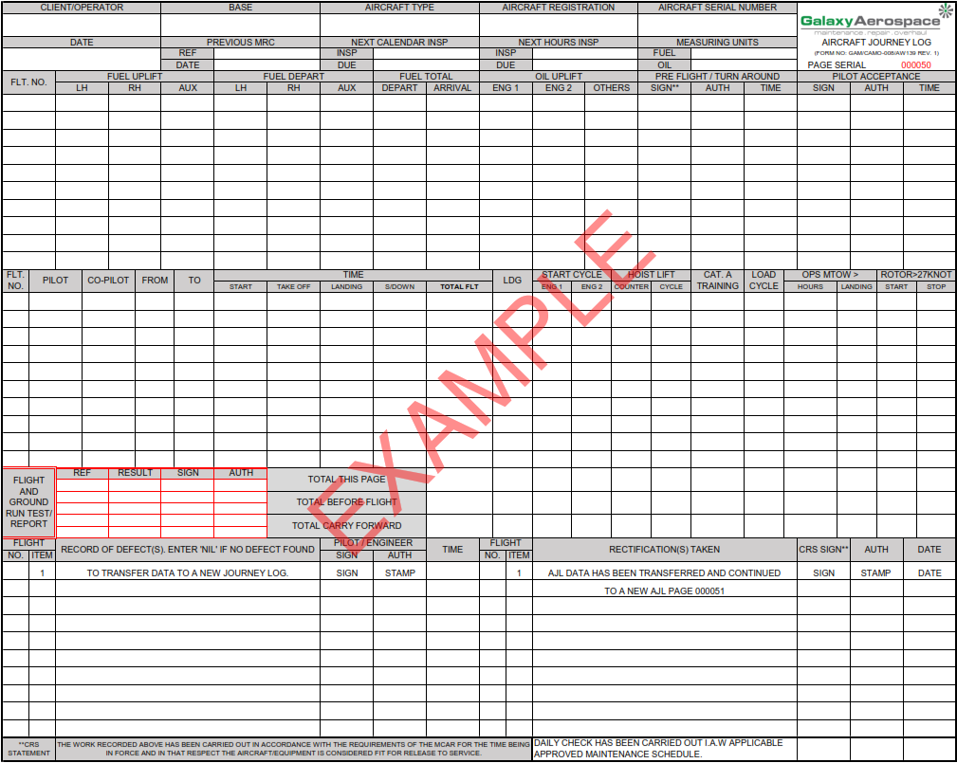

Figure 4 Transferring Data to New AJL

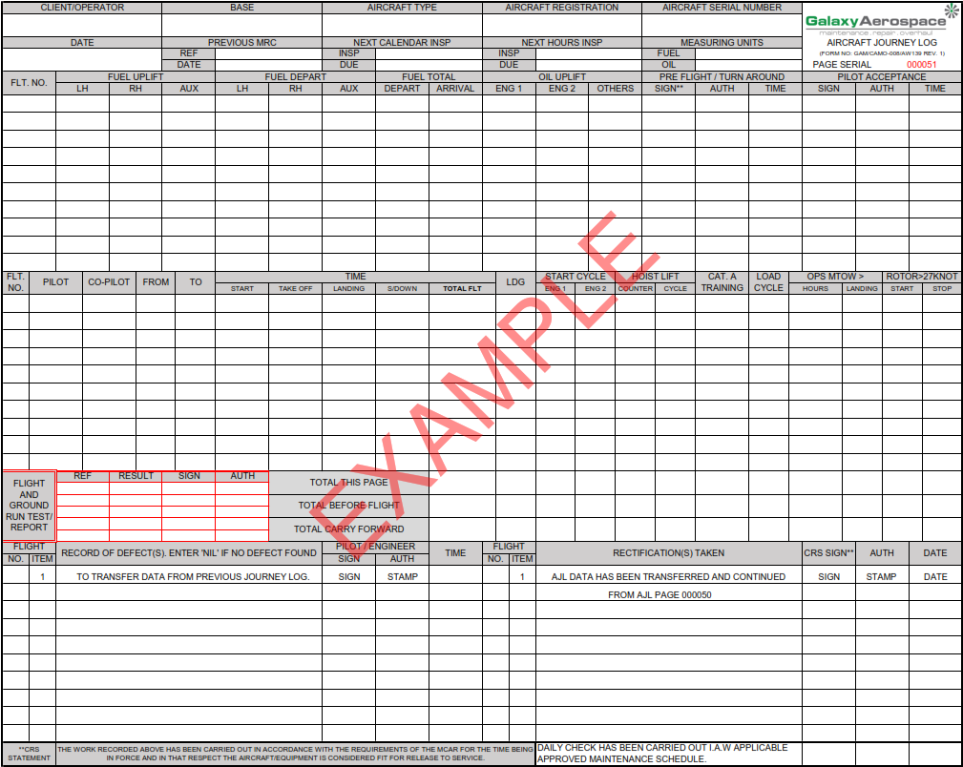

Figure 5 Transferring Data from Previous AJL

* 1. **MAINTENANCE RECORDS ACCEPTANCE**

1. Upon completion of maintenance by the Part 145 organisation, CAMO Planner shall review and verify the workpack before acceptance.
2. Technical records then shall re-verify afterwards before updating the maintenance record.
3. A completed workpack shall consist of:
   1. the work park and worksheet properly filled, signed, stamp and dated by AMO
   2. a minimum of serviceable tag (ARC/CoC for any components/parts installation).
   3. Parts report for all components replacement that had been properly filled, signed, and stamped
   4. Log cards for hard time component installation available and properly filled
   5. Test reports such as borescope inspection, battery servicing, maintenance flight test report etc.
   6. AJL copies for ground run performed.
   7. BMRC for base scheduled maintenance and all inspections including unscheduled maintenance that had been carried out during the time.
   8. Deleted.
   9. **MAINTENANCE RECORDS UPDATING**
4. All continuing airworthiness records shall be updated as soon as practicable but no later than within 30 days from the date of maintenance completion.
   * 1. **AERONET SYSTEM**
5. The AERONET system is updated by Technical Record in conjunction with CAMO Planner for every flights and maintenance performed on the aircraft.
   * + 1. **TECH LOG MODULE**
6. The aircraft values recorded in AJL are updated in the Tech Log module of AERONET. This shall be done by entering the values in Part 2 of Tech Log module. Refer Figure 6.
7. Once the values had been saved in Part 2, tick the “*update burn rate*” and “*update a/c hours and cycles*” box and click the “*Update*” button in Part 1 of Tech Log module. This will update the system to the new aircraft values. Refer Figure 7.
8. Ensure that the total aircraft values reflected in the AERONET are identical to those values recorded in the Aircraft Journey Log.
   * + 1. **AIRCRAFT MODULE**
9. For maintenance performed on the aircraft, the update shall be done under Aircraft module in AERONET.
10. The aircraft maintenance shall be update either in the Inspection, Modification, ADs, and/or SBs tab depending on the inspection performed.
11. A “Complete” button can be found aligned along each of the inspection. Technical Record shall update the maintenance that had been performed by clicking the button. Refer Figure 8.
12. A pop-up will open as per Figure 9 and require the user to enter the aircraft hours, cycles and date in which the inspection had been performed.
13. The system then will automatically calculate the next due for the inspection to be carried out.
14. The maintenance complete shall not be updated by editing the last inspection column and insert the new values. Updating this way will erase previous data and thus, there will not be a history of the maintenance performed.

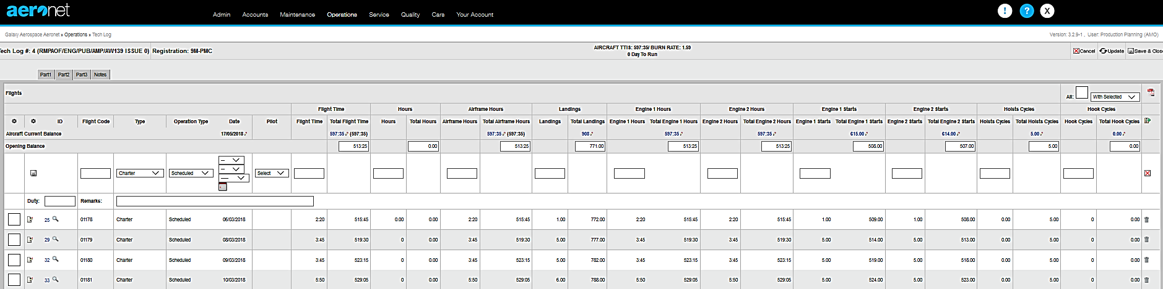

2. Save button

Insert additional info if required to close the tech log journal i.e. engine replace, hoise replace etc.

1. Enter aircraft values

Figure 6 Aircraft Values Entry in AERONET Tech Log Module Part 2

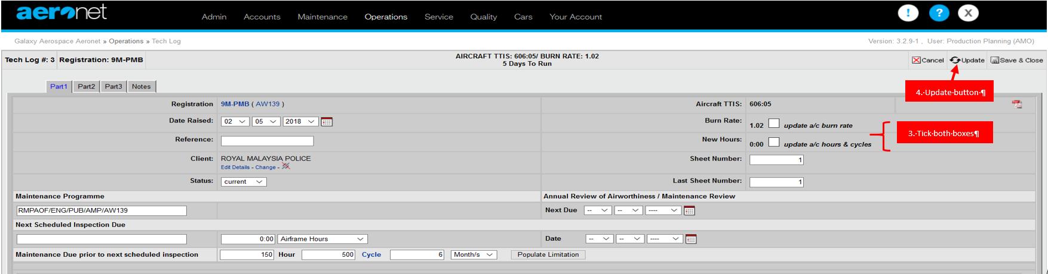

Figure 7 Aircraft Values Update in AERONET Tech Log Module Part 1

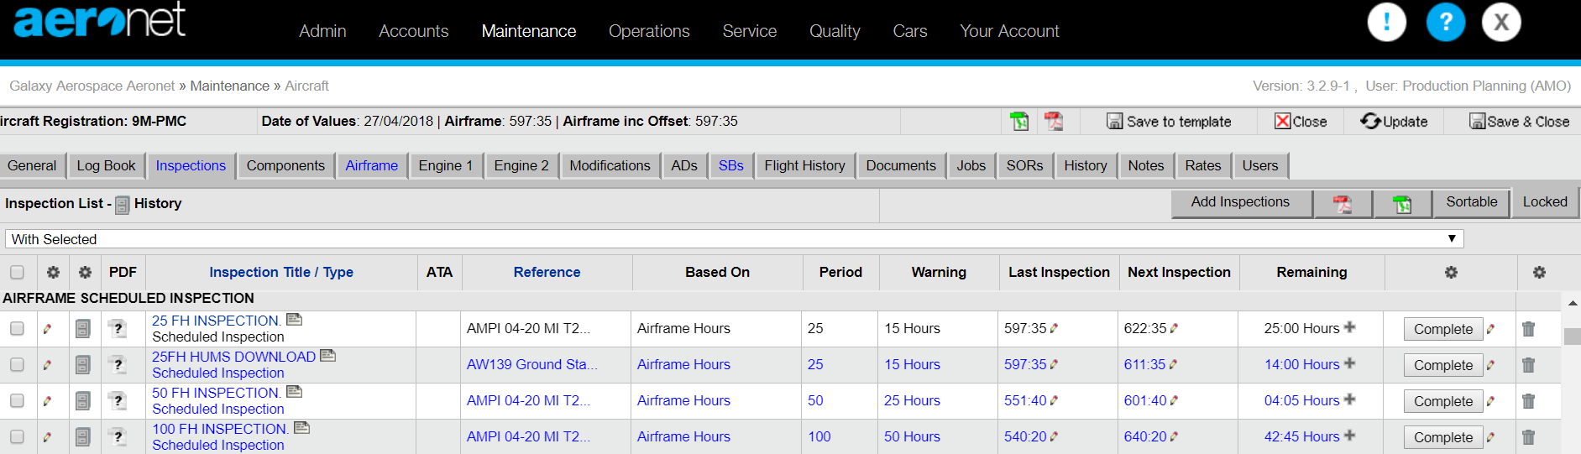

1. Complete button

*Figure 8 AERONET Inspection Completion Update*

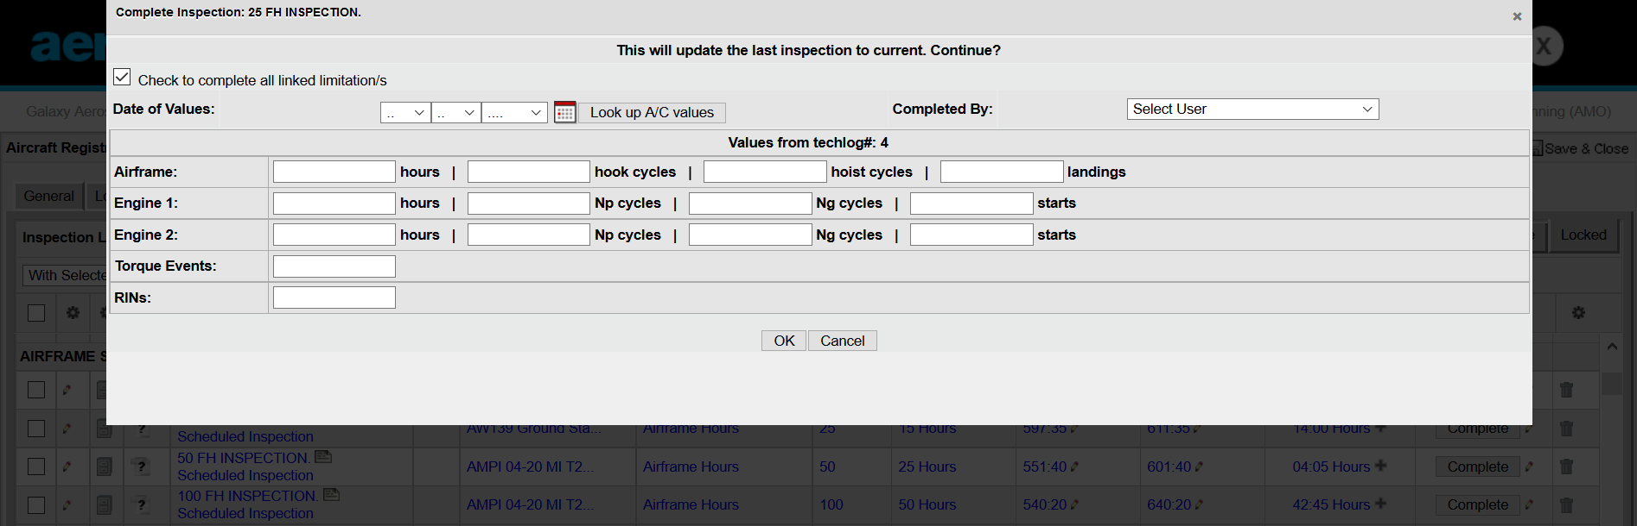

3. Save data

2. Enter aircraft values at inspection performed

Figure 9 Aircraft Value Request from AERONET upon Inspection Completion Update

* + 1. **LOG BOOK ENTRY**

1. Maintenance that has been carried out on the aircraft shall be properly recorded in the aircraft records.
2. A separate Log Book must be kept for each aircraft, engine/s, and APU.
3. ‘Instruction for use’ of the Log Book and particulars to be recorded can be found in the Log Book itself.
4. Technical Record personnel shall make an entry on the logbook using form *GAM/CAMO-014 Log Book Entry.*
5. Any error entry made in the log books shall be corrected with a single strikethrough and initialled upon. The use of any other correction method on the logbooks are not allowed.
6. Only technical record personnel that have been assessed and authorised by CAM Manager shall validate with its sign and stamp on the LBE.
   * + 1. **AIRCRAFT LOG BOOK**
7. For aircraft logbook, form *GAM/CAMO-018*, all maintenance performed on the airframe shall be recorded.
8. Record the following in the airframe log book:
   1. Flying hours, landings, cycles and date of inspection performed.
   2. Schedule maintenance inspection checks carried out with WP number.
   3. Un-schedule maintenance inspection / Defect rectification.
   4. The result of test performed i.e. engine power assurance check, ground run, track and balance reading etc.
   5. Approved Concessions (include copy of Concession form).
   6. AD / SB / Modification compliance.
      * 1. **ENGINE LOG BOOK**
9. Each engine is provided with a logbook from the OEM. The logbook can be used to record flight time, cycle, and maintenance.
10. In cases where GAM Engine logbook, form *GAM/CAMO-019,* is used, the data from the OEM logbook must be transferred accurately.
11. For engine log book, record. the following:
    1. Flying hours and Cycles
    2. Time Since New (TSN), Time Since Overhaul (TSO)
    3. Maintenance, Modifications, Inspections
    4. The result of test performed i.e. engine power assurance check
    5. AD / SB Compliance
    6. Engine/Module changes
    7. ARC engine (include copy)
    8. Approved Concessions (include copy of Concession form)
    9. Component / Sub-assembly replacement
       * 1. **APU LOG BOOK**
12. For APU log book, record the following:
    1. Flying hours and Cycles
    2. Time Since New (TSN), Time Since Overhaul (TSO)
    3. Maintenance, Modifications, Inspections
    4. AD / SB Compliance
    5. APU change
    6. Approved Concessions (Include Concession slip)
    7. Component / Sub-assembly replacement
       * 1. **PROPELLER LOG BOOK**
13. For propeller log book, record the following:
    1. Flying hours and Cycles
    2. Time Since New (TSN), Time Since Overhaul (TSO)
    3. Maintenance, Modifications, Inspections
    4. AD / SB Compliance
    5. Propeller change
    6. Approved Concessions (Include Concession slip)
    7. Component / Sub-assembly replacement
       1. **LOG CARDS UPDATING**
14. A component log card is required for monitoring each hard time component with their respective interval as listed in OEM Section 4 and Section 5 Time Limits of the maintenance publication.
15. The log card for components that are installed on the aircraft shall be in ATA chapter sequence compiled in the OEM Helicopter Log Book.
16. The replacements of component may be due to overhaul, scheduled/unscheduled inspections, and operational requirements
17. The log cards shall be updated for:
    1. any installation/removal of components;
    2. any maintenance inspection (including AD/SB/modification) that had been carried out on the component.
18. Example of instructions on filling up the log card can be referred to Figure 12 – Figure 21.
    * + 1. **COMPONENT REMOVAL**
19. Technical Record shall verify the correct P/N and S/N as per workpack raised and remove the log card from the logbook.
20. He/she shall then update the component log card for TSN and TSO hours during removal.
21. The AERONET is also updated for the component removal by unlinking from the aircraft in the airframe or engine tab of AERONET as applicable. Refer Figure 10.
22. Remove and scan the log card before sending to Part 145 organisation for component processing.
    * + 1. **COMPONENT INSTALLATION**
23. Verify the correct P/N and S/N as per workpack raised.
24. Check the status of component (either new, overhaul, repair, inspected or etc.) from the EASA/FAA form 1.
25. Check the hours for TSN and TSO from the ARC and component log card.
26. Create and link the component in the AERONET to the applicable aircraft. Refer Figure 11. Ensure the hours/cycle/landing of component and the component life limit interval are entered correctly in the system.
27. Update the log card for component installation details if not already have been filled by Part 145.
28. The log card is scan and update in the server before kept in the log book.
    * + 1. **COMPONENT MAINTENANCE/MODIFICATION**
29. The log card shall be updated should there be any maintenance performed or modification (SB) embodied on the component.
30. The data that are required for updating are the aircraft hours/cycles the maintenance performed and date.
31. Authorised Technical Record personnel shall sign the log card upon updating.

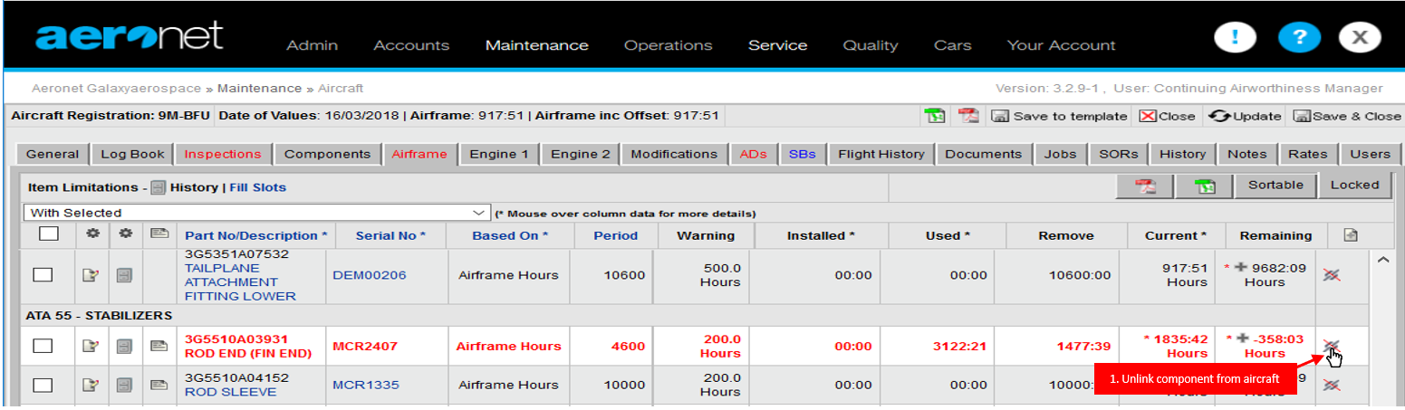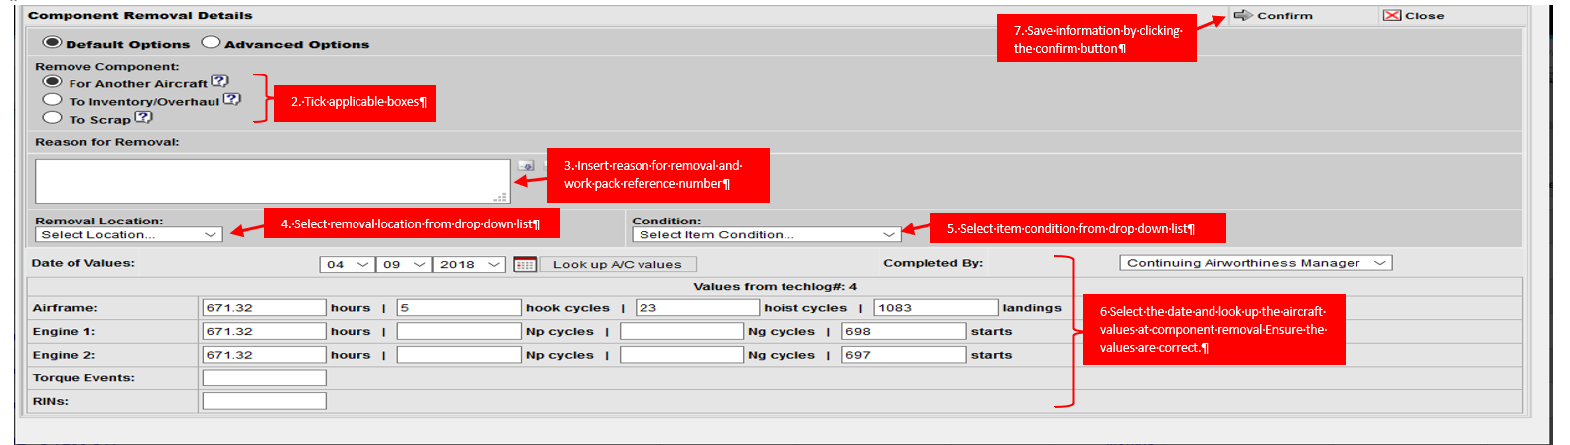*Figure 10 Component Removal in AERONET*

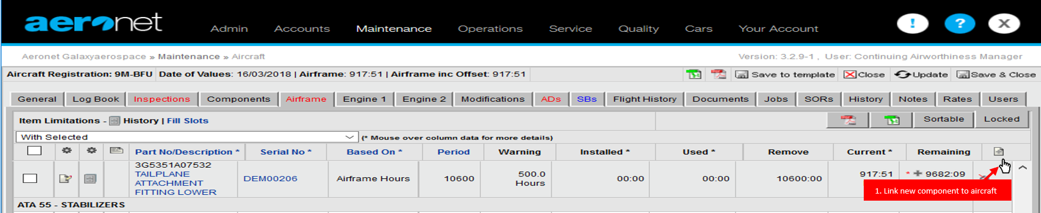

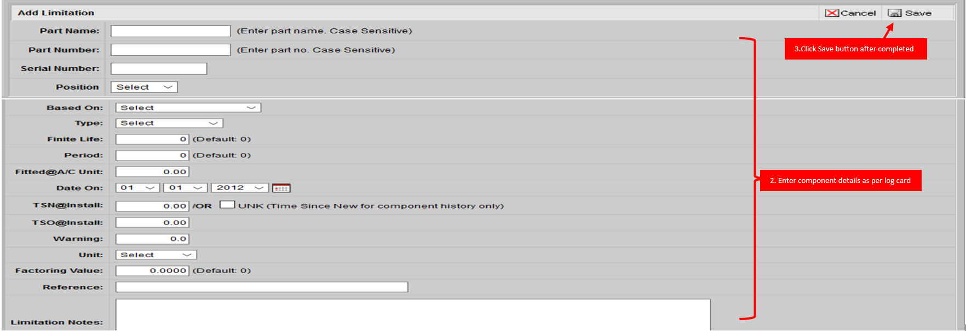Figure 11 Component Installation in AERONET

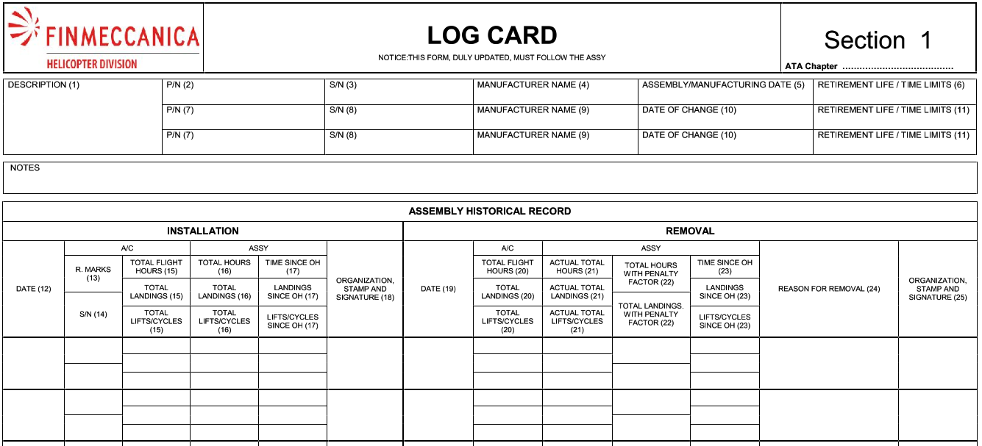

Figure 12 Component Log Card – Section 1

|  |
| --- |
|  |

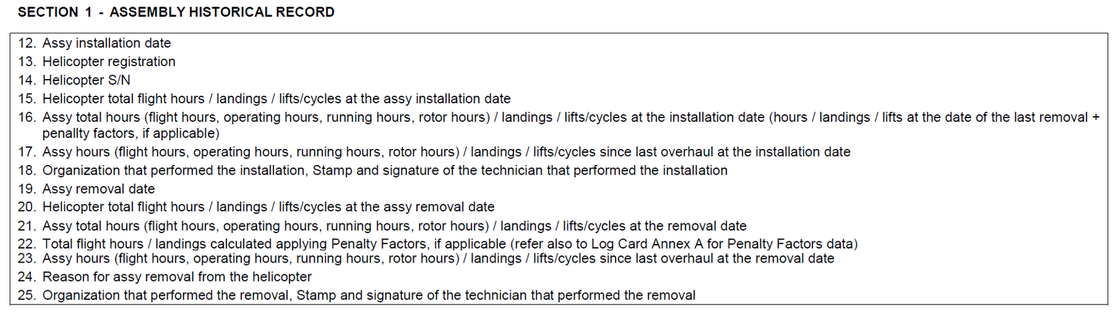

Figure 13 Log Card Filling Instructions – Section 1

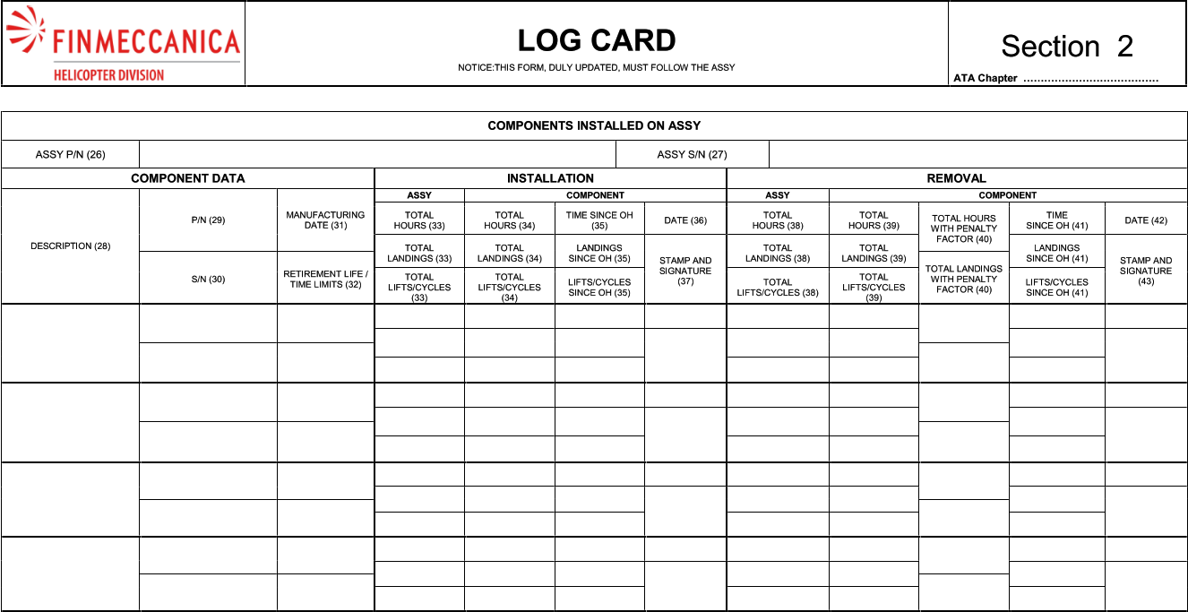

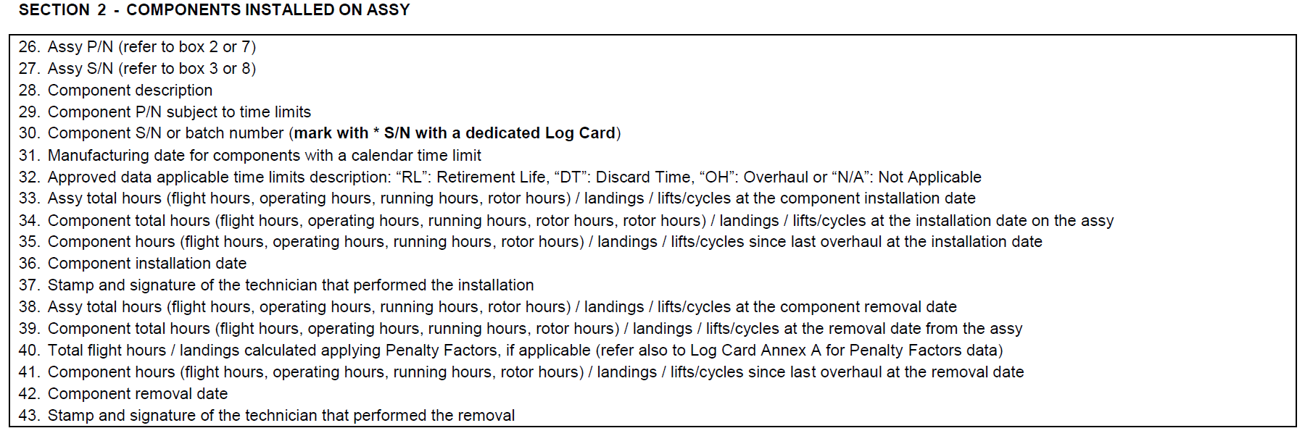Figure 14 Component Log Card - Section 2

Figure 15 Log Card Filling Instructions - Section 2

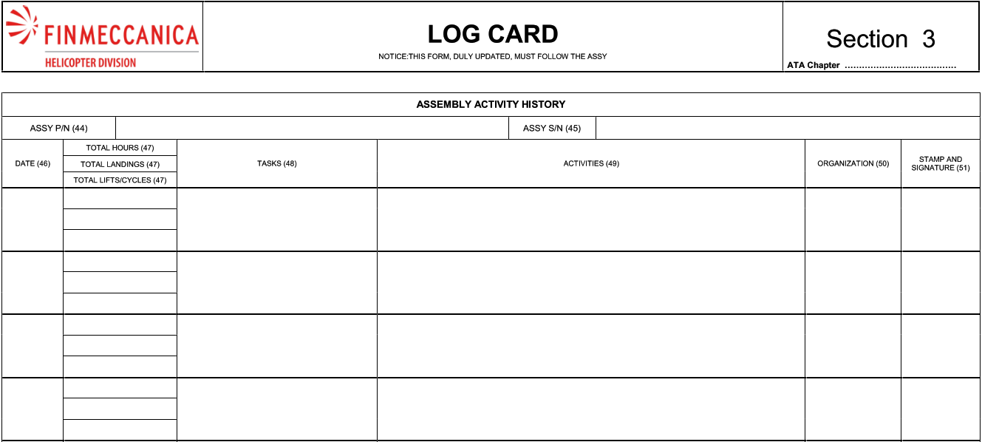

Figure 16 Component Log Card - Section 3

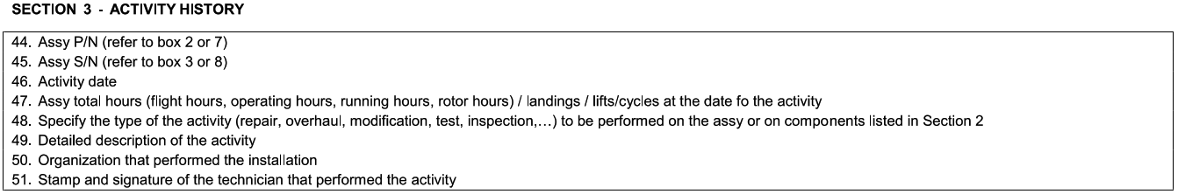

Figure 17 Log Card Filling Instructions - Section 3

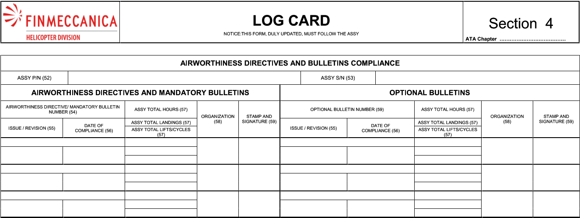

Figure 18 Component Log Card - Section 4

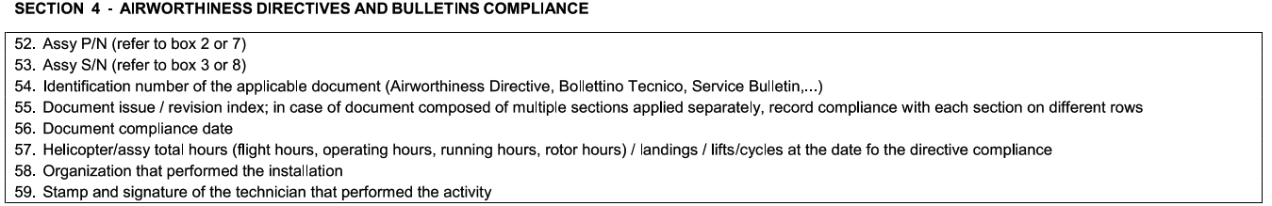

Figure 19 Log Card Filling Instructions - Section 4

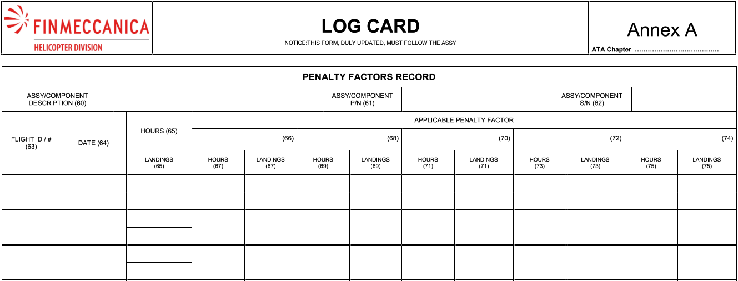

Figure 20 Component Log Card - Annex A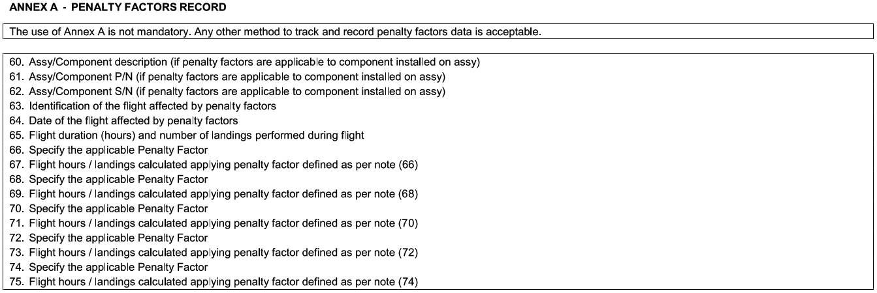

Figure 21 Log Card Filling Instructions - Annex A

* + 1. **MODIFICATION RECORD BOOK**

1. The modification record book is a document produced by GAM CAMO to show the current aircraft configuration status.
2. The document consists a compilation of:
   1. CAAM Notices and MCAR declaration;
   2. Notices 8301 and 7201 compliance (for C of A issuance)
   3. Airframe, Engine and APU (if applicable) AD status.
   4. Airframe, Engine and APU (if applicable) SB status.
   5. Aircraft Modification/De-modification.
   6. CAAM Operator’s Compliance Checklist Declaration.
   7. Aircraft software declaration (if available).
3. The Airworthiness Directives and Service Bulletin status list can be generated directly from AERONET for update in the Modification Record Book. The report generated needs to be verified and signed by the authorised Technical Record personnel.
   1. **MAINTENANCE RECORDS FILING, RETENTION AND ARCHIVING**
4. Continuing airworthiness records shall include the following:
   1. Time, cycle and landing record
   2. Aircraft, Engine, Engine module, component and equipment maintenance and overhaul record as necessary.
   3. Repair and modification record
   4. Status of AD, SB, LLP, repair, modification
   5. Components history records/log cards
   6. Aircraft, APU, engine and journey log books
   7. Modification Record Book
   8. Airworthiness Review record
   9. Aircraft maintenance and component release
   10. Aircraft delivery document from manufacturer
   11. Work order
   12. Weight and Balance Report
   13. Compass Swing Record
   14. Deferred Defect sheet
5. The records listed above shall be retained for a period of 24 months after aircraft have been permanently withdrawn from service. AJL shall be retained for at least 36 months after the date of the last entry.
6. The records are retained in a fire, theft, water and alteration protected environment throughout the validity of the contract.
7. Technical Records shall control all access to all aircraft records.
8. All the records as per Part 2 of this CAMP are also scanned and stored in the server and/or any means of electronic storage as a means of backup.

**PART 3**

**CAMO PLANNING PROCEDURES**

# **PART 3 CAMO PLANNING PROCEDURES**

* 1. **INTRODUCTION**

The CAMO planning department are responsible to ensure that the maintenance required for each aircraft are accomplished in a timely manner and to provide the optimum aircraft availability for operation while strictly adhering to the airworthiness requirements of the operator’s aircraft.

* 1. **SCOPE**

The CAMO Planning department shall be responsible for monitoring, forecasting and planning of the aircraft maintenance tasks based on but not limited to:

1. Approved Aircraft Maintenance Programme
2. Aircraft Maintenance Publication Tasks
3. Airworthiness Directives (AD’s)
4. Service Bulletins (SB’s)
5. Modification Document
   1. **RESPONSIBILITIES**

CAMO Planner personnel

* 1. **AIRCRAFT REGISTER**

1. Every aircraft inducted into GAM CAMO, either used or new, shall be registered using the Continuing Airworthiness Management Software (CAMS). For interim aircraft, any other means of registered is acceptable for tracking.
2. Initial aircraft setup in the CAMS shall be done in the Aircraft Configuration module. Refer Figure 22.
3. Each type of aircraft shall have their own aircraft configuration template.
4. The inspections and tasks templates, derived from the aircraft maintenance programme and the aircraft maintenance publications, are created in this module.
5. There are several tabs in the module which include for the creation of scheduled inspections and tasks, airframe and engine components and AD’s and SB’s template.
6. After completing the particular aircraft type configuration template, an aircraft of the same type later can be easily created and registered in the AERONET.
7. Aircraft Templates will ensure consistency with individual aircraft data and make certain that inspections are not missed or overlooked.
8. Upon completion of the aircraft register, the Life Limited Parts and Airworthiness Directives AERONET status report shall be printed by CAMO Planner.
9. Then, the status report shall be signed and verified by CAMM or Deputy CAMM.
10. The verified report shall be kept for archive and records.

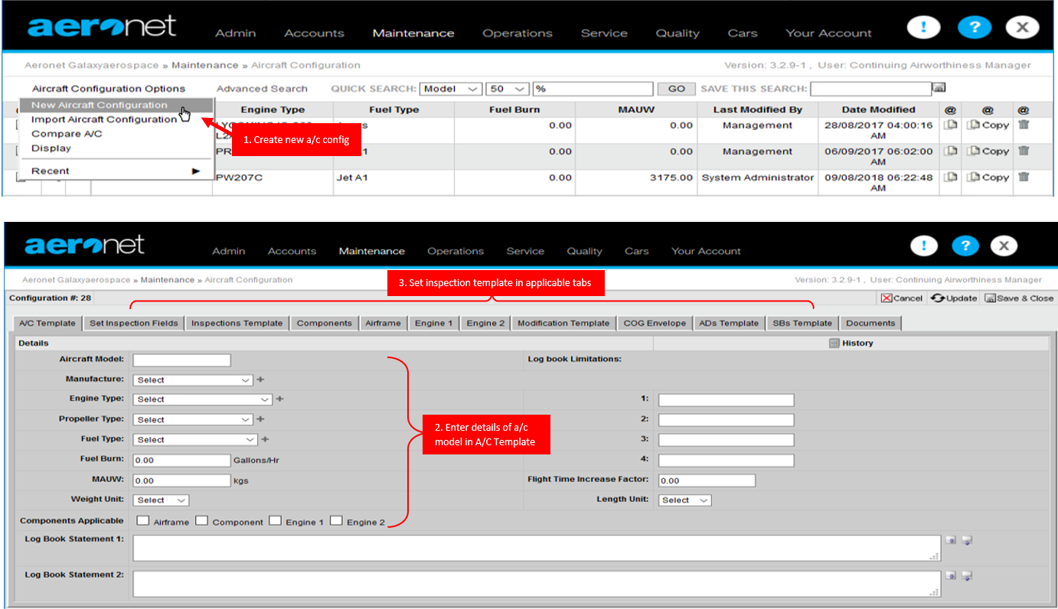*Figure 22 Aircraft Register in AERONET*

* 1. **AIRCRAFT MONITORING**

1. The CAMO planner shall at all times monitor the aircraft maintenance status to ensure that all maintenance is performed within the prescribed limits.
2. The AERONET Aircraft Module are colour coded for quick reference:
   1. If text displays RED, the limitation is overdue.
   2. If text displays BLUE, the limitation is within the warning period.
   3. If text displays GREEN, the limitation has an extension applied.
3. The warning limit of inspections in the AERONET shall be set to:
   1. 50% of flight hours and calendar interval for inspection below 100 hours included and 6 months included,
   2. 50 hours for inspections above 100 hours, and 90 days for inspections above 6 months.
4. Daily Fleet Status are issued daily to the operator, if required, at the end of the day using respective format. This summarizes the aircraft serviceability within the 24 hours period.
5. In addition to the aircraft monitoring, CAMO planner shall monitor all AMP Temporary Revision expiry status in AERONET and advise CAMM or Deputy CAMM to ensure that all AMP with Temporary Revision has been submitted to CAAM for approval.
   1. **MAINTENANCE FORECAST**
6. A Maintenance Forecast can be generated through AERONET under Part 1 of Tech Log module. Refer Figure 23.
7. For forecast generated through AERONET, a range of values for limitation can be set and the AERONET will automatically project the hours and landings based on the aircraft average burn rate calculated by the system.
8. These maintenance forecasts are able to be downloaded and save in a pdf format.
9. The types of forecast to be distributed are dependent upon the client’s request either by weekly or daily update.
   * 1. **YEARLY FORECAST**
10. A yearly (12 month) forecast shall be generated on a three-monthly basis
11. This forecast will display the major maintenance and component replacement tasks only.
12. The forecast is then distributed to the aircraft operator and the contracted maintenance organisation for the planning of operations and maintenance.
    * 1. **QUARTERLY FORECAST**
13. A quarterly (3 month) forecast is generated minimum once a month in advanced to show the predicted downtime of the aircraft for all maintenance required.
14. This includes for the line and base maintenance check, modification, airworthiness directives, service bulletin and etc.
15. The forecast shall be used as a planning tools for spares, manpower and downtime for maintenance.
    * 1. **WEEKLY FORECAST**
16. This shows the nearest maintenance within the 100 hour and 3-month period interval.
17. The forecast shall be used by operator for the planning of flight operations.

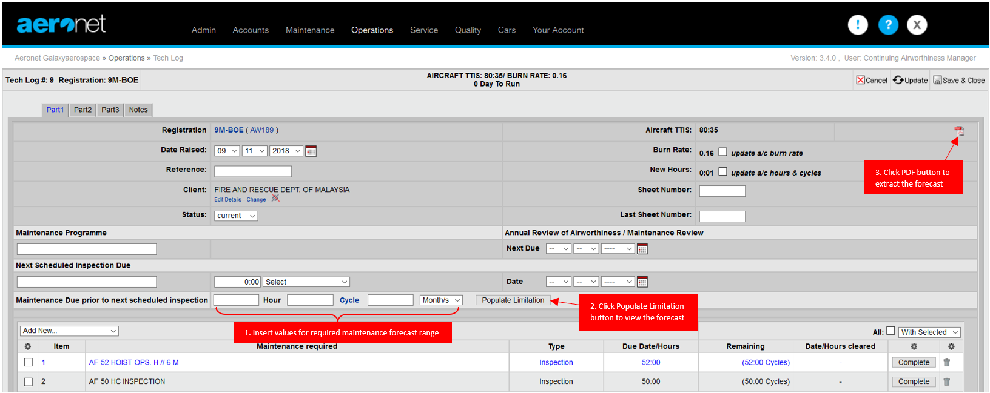

Figure 23 Generate Maintenance Forecast in AERONET

* 1. **CAMO PLANNING**

1. The CAMO Planner shall plan that all aircraft maintenance checks required by the approved aircraft maintenance programme are performed within the prescribed time limits.
2. Particular attention should also be paid on AD and SB requiring repetitive compliance. A maintenance check shall be performed within the required time limit. Additionally, out of phase maintenance requirement shall also be reviewed particularly those that are aligned within the scheduled maintenance.
3. Rectification of defects including deferred defect shall be planned to the nearest scheduled maintenance check except in the case of defect hazards seriously affect the flight safety, rectification shall be carried out before further flight.
4. Accomplishment of modifications shall be planned in such away it is aligned with a suitable scheduled maintenance check for optimum aircraft downtime.
   1. **AMO COORDINATION**
5. CAMO Planner shall liaise with the contracted Part 145 organisation to ensure that all maintenance activities are properly coordinated.
6. For scheduled base maintenance workpack, the CAMO planner shall initiate and call out for a pre-check workscope meeting with the AMO, 1 month prior to inspection commencement.
7. The meeting will encompass of the following matter:
   1. Maintenance timeline;
   2. Scope of work package; and
   3. Spares availability.
   4. Man power.
   5. Or any other issue related to maintenance.
   6. **WORK ORDER ISSUANCE**
      1. **SCHEDULE MAINTENANCE**
8. All Work Order are issued by CAMO Planning for maintenance inspections required to the contracted Part 145 Organisation.
9. The maintenance paperwork is issued either by GAM CAMO or the contracted Part 145 organisation based on the stipulated contract.
10. For paperwork issued by GAM CAMO, a Workpack Control form *GAM/CAMO-004* together with the Worksheet form *GAM/CAMO-005* are used (if required).
11. All Work Sheet must be accompanied with the necessary reference data for the accomplishment of the maintenance task. For other associated approved data such as AD, SB, ICA’s and etc., it shall be printed and attached together with the Work Sheet.
12. For complex maintenance tasks (e.g. task that require other components to be removed and reinstalled to access the main component to perform maintenance), CAMO Planner shall transcribe each task onto the Work Sheet and subdivided into clear stages to ensure a record of the accomplishment of the complete maintenance task.
13. Parts Report is required for any replacement of components that had been performed during the maintenance.
14. A column for duplicate inspection is required to be include in the Work Sheet for control system components that are disturbed during maintenance as defined in CAAM’s AN 51.
    * 1. **UNSCHEDULE MAINTENANCE**
15. For unscheduled maintenance or defects rising from maintenance/operations, additional workpack will be raised by the Part 145 organisation.
16. For paperwork raised by the contracted AMO, CAMO shall be informed prior task carried out and the Worksheet form GAM/CAMO-005 may be used for rectifications.
17. The reference for unscheduled maintenance shall bear the following reference no.:

UMC-REG-YY-XXX

Aircraft type (AW139, AW189 etc

Running Number

Year

* 1. **WORK PACKAGE REVIEW**

1. In coordination with Technical Record, CAMO planner shall also check for the completed work packs for any outstanding task due to deferred work, spares availability or any other requirements.
2. CAMO Planner shall raise additional workorders or instructions to the contracted Part 145 organisation where any inspection tasks are not completed and not in full compliance with the regulations.
3. All completed work package received and reviewed are signed for acceptance by the CAMO Planner. A completed workpack shall consist of:
   1. the work park and worksheet properly filled, signed, stamp and dated by AMO
   2. a minimum of serviceable tag (ARC/CoC for any components/parts installation).
   3. Parts report for all components replacement that had been properly filled, signed, and stamped
   4. Log cards for hard time component installation available and properly filled
   5. Test reports such as borescope inspection, battery servicing, maintenance flight test report etc.
   6. AJL copies for ground run performed.
   7. BMRC for base scheduled maintenance and all inspections including unscheduled maintenance that had been carried out during the time.

**PART 4**

**TECHNICAL SERVICE PROCEDURES**

# **PART 4 TECHNICAL SERVICE PROCEDURES**

* 1. **INTRODUCTION**

1. This section outlines the procedure to ensure that the operations of the aircraft remains adheres to the aircraft continuing airworthiness.
   1. **SCOPE**
2. The CAMO Technical Services Department shall be responsible for the compliance with the approved aircraft maintenance programme, airworthiness directives, modification and repairs for all of GAM CAMO aircraft.
   1. **RESPONSIBILITIES**
3. Technical Services Personnel
   1. **AIRCRAFT MAINTENANCE PROGRAMME**
      1. **AMP DEVELOPMENT**
4. For those AMP request by operator to be establish by GAM CAMO, the CAM Manager or his/her delegated personnel shall be responsible for the preparation of the AMP.
5. The AMP is developed by extracting the information from the OEM aircraft and engine maintenance program along with the relevant ADs, SBs, modifications and any other requirements by the OEM, CAAM, Operator and other related regulatory bodies.
6. The basis of developing the AMP are the following:
   1. Maintenance tasks and intervals as recommend by the OEM.
   2. MRB.
   3. OEM Airworthiness Limitations & Inspections Requirements.
   4. The requirements of Airworthiness Directives, Alert/Mandatory Service Bulletin, SIL’s SL’s, etc applicable to the aircraft.
   5. Maintenance Manuals.
   6. Vendor instructions for continued airworthiness including installed optional equipment, STC’:s etc.
   7. Authority Requirements and results from operators AMP effectiveness analysis.
   8. Requirements due to operating experiences.
   9. When applicable, continuing structural integrity program and/or corrosion control program.
   10. When applicable, reliability programs for condition monitoring aircraft systems, components and power plants.
   11. Mandatory maintenance task and interval as declared by the OEM shall be specified in the AMP.
7. The AMP shall be initially reviewed and signed by the operator before submission to CAAM for approval. A Minute of meeting for the review conducted will be issued.
8. 2 copies of AMP, AMP checklist and the Minute of Meeting shall be submitted to CAAM for approval.
9. Once approved by CAAM, it shall then be distributed according to the Distribution List page of the AMP.
   * 1. **AMP AMENDMENTS**
10. The AMP shall be reviewed annually to reflect the current operating experiences and the latest revisions of all relevant and applicable documentations
11. Type of Aircraft Maintenance Programme amendments are:
    1. “A” Amendment

These are mandatory amendments promulgated by the authority, Civil Aviation Authority of Malaysia.

* 1. “B” Amendment

These are amendments which have been requested by the operator and approved by the authority, Civil Aviation Authority of Malaysia.

1. “C” Amendment

Amendments initiated by GAM CAMO and approved by QAM. Correction to typographical errors; reflection of part numbers changes to consumable parts; changes to not decreasing the inspection frequency and life of any components are reflected in the ‘C’ amendments.

1. Temporary Revision shall be issued to ensure the requirements are not to be missed from time to time should there be additional instructions and or requirement.
2. These Temporary Revision shall accompany together with the Temporary Revision Amendment Form and obtain the approval from QAM.
3. This Temporary Revision shall be issued on yellow coloured papers and placed adjacent to the current page requiring temporary revision. These pages shall be removed upon incorporation of Amendment A or B of the concerned pages.
4. The Temporary Revision shall be submitted to CAAM for approval within 90 days.
   * 1. **AMP COMPLIANCE**
5. GAM CAMO shall adhere to the maintenance requirements as defined in the AMP by means of maintenance planning procedures.
6. Under normal operating conditions, an established interval for accomplishment of scheduled maintenance cannot be exceeded.
7. However, circumstances may exist that justify, under controlled conditions, use of a tolerance or a maintenance interval configurable as a onetime extension of an interval for an individual aircraft.
8. These tolerances, subject to CAAM approval, shall respect the following rules:
   1. The operator may vary the period described by the AMP provided that such a variation within the limits indicated in AMP.
   2. Interval tolerances can be applied ONLY when the period prescribed by this Inspection Program cannot be complied with due to circumstances which could not reasonably have been foreseen by operator.
   3. Interval tolerances cannot be assumed as maintenance planning tool
   4. Interval tolerances DO NOT apply to AD, authority requirement, interval specified in the Minimum Equipment List (MEL), mandatory airworthiness limitations task prescribed by the AMP.
9. When an interval tolerance is used, IT IS NOT CUMULATIVE, therefore the subsequent interval shall be computed as per the original scheduled interval. Example:
   1. Task interval: 100 FH, Maximum variation; 10 FH, if the task is conducted at 105 FH, the subsequent task must be performed as per original scheduled at 200 FH (+10 FH)
   2. Task interval: 24 months, Maximum variation: 30 days. If the task is conducted at 25 months, the subsequent task must be performed as per original scheduled at 48 months (+ 30 days)
   3. Task interval: 100 FH, Maximum variation; 10 FH, if the task is conducted at 85 FH, the subsequent task must be performed as per original scheduled at 185 FH (+10 FH)
   4. Task interval: 24 months, Maximum variation: 30 days. If the task is conducted at 23 months, the subsequent task must be performed as per original scheduled at 47 months (+ 30 days).
10. For items controlled by more than 1 limit, i.e. items controlled by flying hours and calendar time, the more restrictive limit shall be applied.
    * 1. **AMP VARIATION**
11. For circumstances defined in para. 4.4.3 (c) above, the variation to the interval can be requested to CAAM using AMP Variation Request form GAM/CAMO-033. The controlled number are formatted as below:

GAM/CAMO/VAR/YY/XX

Running Number

Year

1. CAMM shall filled the form with necessary information on the inspection/component requested for variation.
2. The application shall be attached together with the supporting documents below as applicable:
   1. related section of approved AMP and the maintenance manuals;
   2. risk assessment on the variation requested;
   3. worksheet of mitigation inspections carried out; and
   4. supporting technical note from OEM (for airworthiness limitation components).
3. The application then shall be forwarded to QAM for review.
4. Upon satisfactory review, the application shall be submitted to CAAM for approval.
5. CAMM shall advised AMO on the deviation from the AMP once approved by CAAM.
   1. **MINIMUM EQUIPMENT LIST (MEL)**
6. For those MEL request by operator to be establish by GAM CAMO, the Technical Service department shall be responsible for the preparation of the MEL.
7. The MEL will be based upon the following documents which is then suited to the aircraft configuration and operating environment:
   1. Master Minimum Equipment List
   2. MCAR 2016
   3. CAAM FOD-CAT
   4. Rotorcraft Flight Manual
   5. Aircraft Maintenance Manual
8. The MEL shall contain the following:
   1. List of Effective Pages (LOEP).
   2. Preamble including statement on the incorporation of the latest MMEL revision.
   3. Table of Contents.
   4. Revision Index.
   5. Explanation of abbreviations/symbols.
   6. Policy/Procedure to defer MEL defects.
   7. Air Transport Association (ATA) specification numbering.
   8. Repair categories/interval – Operator shall comply to the repair categories/interval as stated in the MEL Deviations to the repair categories/interval shall be approved by the CAAM through the operators Quality Section.
9. Any item which is related to the airworthiness of the aircraft or is required by Civil Aviation Legislation which is not included in this MEL must be operative before a flight is dispatched.
10. The MEL prepared will then be initially reviewed by a committee member of CAM Manager, QAM, Part 145 representative and aircraft operator before submission to CAAM for approval.
11. Upon satisfactory review, the MEL shall be submitted to CAAM Airworthiness Sector and Flight Operations Sector for the final approval.
    1. **TECHNICAL INSTRUCTION COMPLIANCE/SENTENCING**
12. *Technical Instruction Compliance/Sentencing (TIC) form GAM/CAMO-001* are used for the evaluation and sentencing of the AD’s, SB’s and any other technical publications by Technical Service for the aircraft contracted to CAMO.
13. Technical service personnel will receive the TIC raised by Technical Publication through email notification.
14. The TIC controlled number are formatted as below:

TIC-TYPE-YY-XXX

Aircraft type (AW139, AW189 etc.) or for general information letter (GEN)

Running Number

Year

1. Only Technical Service personnel that have been properly accessed and accepted as qualified per para. 0.8 are authorised to sentence the TIC’s.
2. The TIC shall be sentenced in accordance with the aircraft configuration. Related attachment to the TIC, such as log card, worksheet etc., shall be attached together for reference.
3. The sentenced TIC will then go through CAM Manager or his/her delegate for verification and task delegation to CAMO Planner.
4. CAMO planner will include and update the AD/SB inspection and sentencing in the AERONET and monitor accordingly.
5. AMP Temporary Revision shall be included into the AERONET for monitoring purpose to ensure that all AMP with Temporary Revision has been submitted to CAAM for approval before the Temporary Revision is due.
6. After maintenance planner have updated the AERONET, the form will once again go through CAM Manager or his/her delegate for compliance verification.
7. The completed TIC form will need to return to Tech Pub for filing purposes.
   1. **FLIGHT TEST SCHEDULE**
8. The purpose of the airworthiness flight test is to ensure that the aircraft’s flight characteristics and its functioning in flight do not differ significantly from the normal characteristics for the type and to check the flight performance against the appropriate sections of the flight manual.
9. Additionally, maintenance flight test may be carried out following a maintenance activity on an aircraft to provide reassurance of performance or establish the correct functioning of a system that cannot be fully establish during ground checks.
10. Both of these flight tests must only be conducted in accordance with the schedules that had been prepared by Technical Service and approved by CAAM or internally approved by QAM as applicable.
    * 1. **AIRWORTHINESS FLIGHT TEST SCHEDULE (AFTS)**
11. The scope of the Airworthiness Flight Test shall include:
    1. Aircraft Performance

The aircraft’s performance must meet with the scheduled performance contained within the Rotorcraft Flight Manual (RFM). The performance should not have significantly degraded since the last flight test and any measured degradation shall be accounted for.

* 1. Handling Qualities

The aircraft should handle/fly as intended. Stall characteristics should be benign or normal for the type.

* 1. Systems

All aircraft systems should be serviceable and fit for purpose or, if permissible, clearly labelled as inoperative. Autopilots and Flight Control Systems should be comprehensively tested to ensure the perform as intended with degraded modes assessed where possible.

1. The AFTS shall have the following reference number:

GAM/CAMO/AC TYPE/AFTS

Aircraft Type

1. The content and conduct of the flight test shall be standardised as far as possible to ensure that the appropriate tests are always made.
2. The schedules should at least cover the following:
   1. Procedures in respect of minimum flight test crew, RFM limitations and approved flight test pilots
   2. Flight Test Certificate or equivalent
   3. Flights under Permit to Fly
   4. Mandatory placards/markings checking
   5. Defects and their rectifications
   6. Load sheet
   7. Low speed handling tests, climb tests, autorotation test, power assurance checks and dive to never exceed speed (Vne) test
   8. Columns for test crew to record as satisfactory or not
   9. Comparison of actual test results with the RFM data
3. The completed scheduled together with CAAM Statement of Compliance (SOC) form CAAM/AW/8101-01 each in 2 copies shall be submitted to CAAM for approval.
   * 1. **MAINTENANCE FLIGHT TEST SCHEDULE (MFTS)**
4. The maintenance flight tests shall be performed either due to:
   1. Extensive maintenance check outside of the scope of aircraft maintenance manual or major modification affecting the aircraft performance that cannot be checked on ground; or
   2. Rotor Track and Balance as instructed in the aircraft maintenance manual after post maintenance operations or adjustment to the dynamic control components; or
   3. Functional Check Flights as instructed in the aircraft maintenance manual, for instance after engine installation affecting the aircraft performance that cannot be checked on ground.
5. For maintenance flight test due to (i) above, the maintenance flight test schedule shall be submitted to CAAM for approval.
6. For maintenance flight test due to (ii) above, the maintenance flight test schedule shall be internally approved by QAM.
7. For maintenance flight test due to (iii) above, the check flight will be performed in accordance with the aircraft maintenance manual.
8. The MFTS shall have the reference number:
9. for CAAM approved MFTS:

GAM/CAMO/AC TYPE/MFTS

Aircraft Type

1. for GAM approved MFTS:

GAM/CAMO/AC TYPE/MFTS/RTB

Aircraft Type

1. The MFTS shall have the following content but not limited to:
   1. Procedures in respect of minimum flight test crew, RFM limitations and approved flight test pilots
   2. Flight Test Certificate or equivalent
   3. Flights under Permit to Fly
   4. Mandatory placards/markings checking
   5. Defects and their rectifications
   6. Load sheet
   7. Columns for test crew to record as satisfactory or not
   8. **MAINTENANCE REVIEW BOARD**
2. The Maintenance Review Board (MRB) holds monthly meetings and constitutes of the following members:

|  |  |  |
| --- | --- | --- |
|  | Technical Services Engineer | Permanent member |
|  | CAM Manager or his/her delegate | Permanent member |
|  | EM or his delegate | Permanent member |
|  | Logistic supervisor or his delegate | Permanent member |
|  | QAM or his delegate | Permanent member |
|  | Technical Services Engineer (Reliability) | Secretary |

1. Other personnel or specialists (non-voting) shall be enlisted to provide expert advice as required, depending on the circumstances.
2. The MRB meeting must comprise of the five permanent members for the meeting to be conducted.
3. The followings shall be in the agenda but not limited to:
   1. Reliability reports are evaluated, and a review of each delay and cancellation is carried out.
   2. Identify any adverse trends and associated technical problems for further investigation.
   3. Determine required actions to reduce recurring defect or significant event.
   4. Formulate actions that can rectify dispatch reliability being below set targets.
   5. Review actions taken on PIREP Rate Alert’s and high unscheduled removal rate components.
   6. Proposals for corrective and preventive actions and for Maintenance Program changes are evaluated from incident, decisions made by majority vote. The minutes of board meetings, administrative files and substantiating data for decisions are retained by Technical Services Department.
   7. To discuss any other matter related to aircraft current status and Maintenance operation activity in related to CAMO and Technical Services department.
   8. To discuss the current status of Airworthiness Directive and Service Bulletin implementation and consideration
4. Technical Services shall carry out an annual review of the program for effectiveness which includes (but not limited to) the following areas:
5. Suitability of ALERTS (upper control limits) values for each ATA parameter being monitored.
6. Completeness and integrity of data sources.
7. Effectiveness of actions taken for ALERTS being investigated
8. Any corrective action issued and matter discussed in MRB meeting should be recorded in Minutes of Meeting.
   1. **AIRCRAFT RELIABILITY PROGRAM**
9. Technical Service shall collect reliability data every month and the results collected are published in a reliability report which includes trend analysis. The reliability report is produced on monthly, quarterly and annually basis.
10. The reliability report must contain details on the reportable defects, such as the aircraft involved, date, finding and any other relevant details as follows but not limited to:

| **REPORT DATA** | **RELIABILITY INDICATOR** | **REPORTING PERIOD** |
| --- | --- | --- |
| Utilization   * Number of AC * Total flight hour * Total flight cycles (landing) | * Aircraft and APU flight hours and cycle | * Monthly * 3-month rolling average * 12-months rolling average |
| Technical Delays   * Delays more than 30 minutes caused by technical problem. | * Technical Dispatch Reliability |
| Component removals   * Scheduled and unscheduled engine removals * Component removals defect | * Component removal rates * Threshold exceedances * Threshold exceedances by ATA chapter |
| Defects   * PIREP (Pilot Report) * Repetitive defects   (when same defect repeated 3 times within 1 month or 30 FH) | * PIREP count by ATA chapter |
| Engine monitoring   * Engine TBO * Engine current performance | * Engine flight hours * Power Assurance Check |

1. The reliability report is then distributed to at least the permanent member of MRB and to the appropriate type certificate holders if the aircraft is subscribed under their reliability data sharing program.
2. The reliability data and reliability indicator published in the reliability report is reviewed and analyse during the monthly MRB meeting for:
   1. identification of recurrence defects and unscheduled removal component trends;
   2. adverse trend in reliability;
   3. unreliable systems and components;
   4. maintenance task and system resulting in high defect levels.
3. The MRB meeting shall determine if further action is necessary to improve fleet reliability result from Reliability Report Review

TS to retrieve past month maintenance activity and other related data

TS to convert collected data into statistical order for analysis

TS to produce Reliability Report of past month

To advise related personnel to carry out corrective action that do not required MRB consent

MRB meeting to review reliability data of the past month

If available, corrective action to be recorded in Minute of Meeting (MoM)

Figure 24 Reliability Program Process Flow

* 1. **REPAIR PROCESS MANAGMENT**

1. This procedure details how Technical Services manages repair process en route for approval.
2. Repair means elimination of damage and/or restoration to an airworthy condition following initial release into service by the manufacturer of any product, part, or appliance.
3. If the repair of damage is not covered by an existing repair solution according to the Repair Manual or other approved data, the damage details shall be forwarded by the AMO to the Technical Services Department.
4. Technical Service then shall liaise with the TC Holder by raising Technical Query (TQ) and/or Repair Instruction Query (RIQ), as applicable, for the repair procedure.
5. For Airbus Helicopter (AH) product repairs document, AH will issue a Repair Design Approval Sheet (RDAS) See Figure 26 for a sample of Airbus Helicopter RDAS.
6. For Leonardo Helicopter (LH) product repairs document, LH will issue PSEAW and/or Repair Scheme for the repair instruction. Refer Figure 27 for a sample of Leonardo Helicopter (PSEAW).
7. These documents contain the essential information for implementation of repair, including applicability, repair classification, reference of parts, damage description, related substantiation documents, impact on Maintenance Program and Operational Procedures (incl. limitations) and detailed repair procedure.
8. All documents from the DOA TC Holder shall be evaluated internally and documented in Engineering Order Approval Sheet (EOAS) form GAM/CAMO-028.
9. The EOAS shall consist of:
   1. Repair Classifications

The classification of repairs conforms to the definition in the following criteria:

1. Structural Performance

Repair which has appreciable effect on static strength, fatigue behaviour (if the new lifetime of the repaired part is below the lifetime published for the original part in the airworthiness limitations section of the maintenance manual), damage tolerance, flutter and stiffness characteristics, requires changes of materials or processes of a critical part is considered ‘major’.

1. Systems

Repair which has appreciable effect on the operation of the complete system (i.e. significant impact on critical function) and on system redundancy is considered ‘major’.

1. Operational Characteristics

Repair which has appreciable effect on stall characteristics, handling characteristics, performance and drag and vibration is considered ‘major’.

Repair which has appreciable effect on changes to load path and load sharing, changes to noise and emissions and fire protection / resistance is considered ‘major’.

Repair which requires a permanent additional inspection to the approved maintenance programme is considered ‘major’.

Repair which requires methods, techniques or practices that are unusual (i.e. unusual material selection, heat treatment, material processes, jigging diagrams etc) is considered ‘major’.

* 1. Description of Damage

This section shall detail on the overview of the damage area with photos.

* 1. Description of Repair

The repair procedures, materials, tooling, references and the instruction for continued airworthiness are detailed in this section.

* 1. Engineering drawing for the repaired area.
  2. Compliance checklist

This will be supplemental document to the EOAS for the compliance requirement with the related aircraft airworthiness certification requirement.

1. The EOAS shall be submitted to CAAM together with the Statement of Compliance (SOC) form or to the appropriately approved DOA for approval.

 *Figure 25 Process Flow for Repair Management*

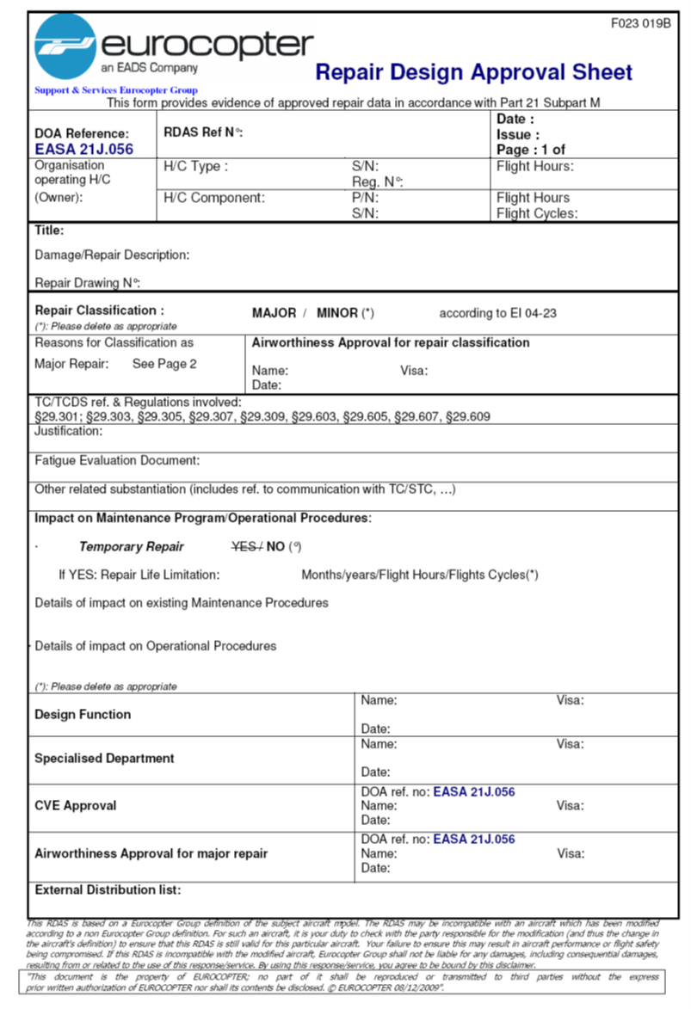

*Figure 26* EUROCOPTER RDAS SAMPLE – PAGE 01

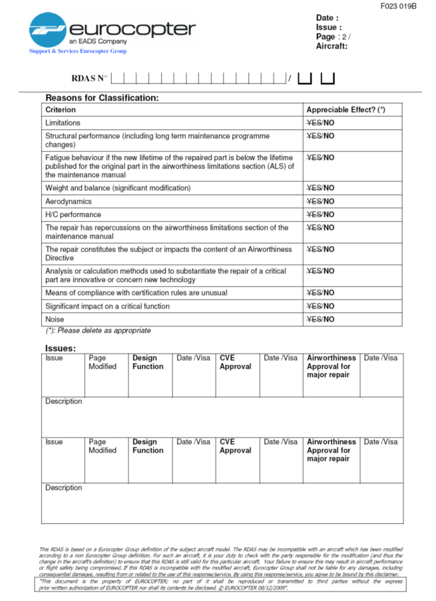

*Figure 26* EUROCOPTER RDAS SAMPLE – PAGE 02

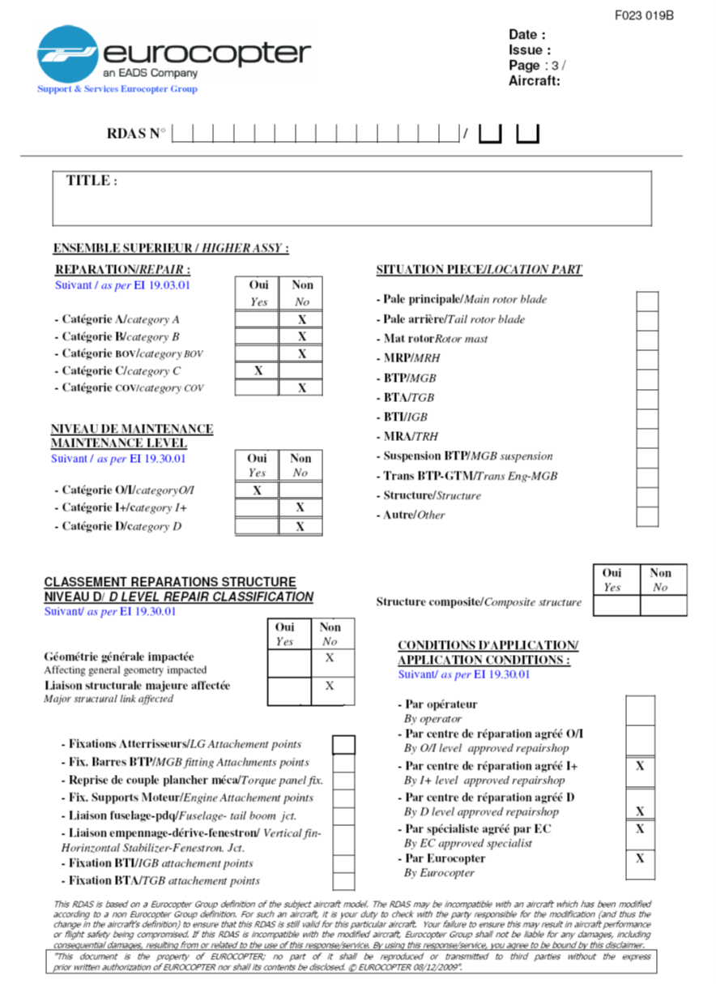

*Figure 26* EUROCOPTER RDAS SAMPLE – PAGE 03

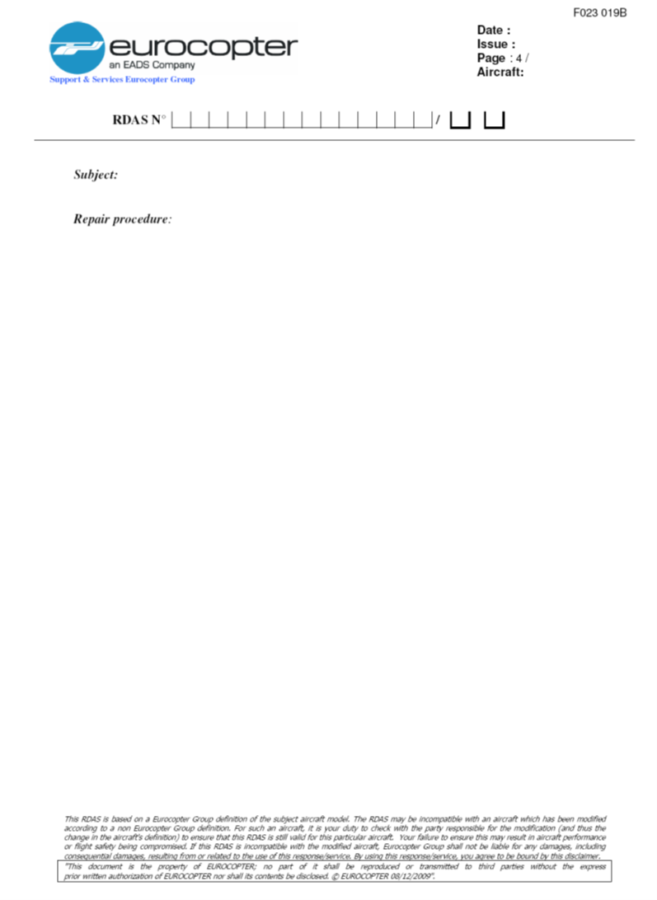

*Figure 26* EUROCOPTER RDAS SAMPLE – PAGE 01

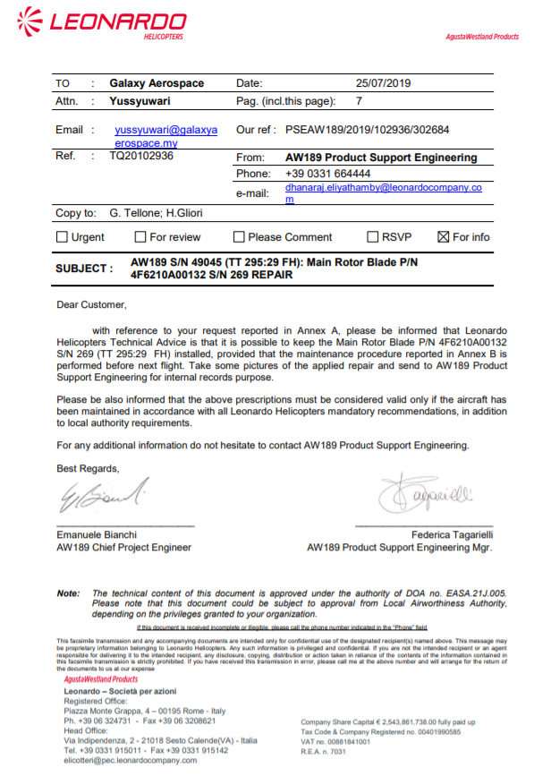

*Figure 27* LEONARDO HELICOPTER PSE SAMPLE – PAGE 01

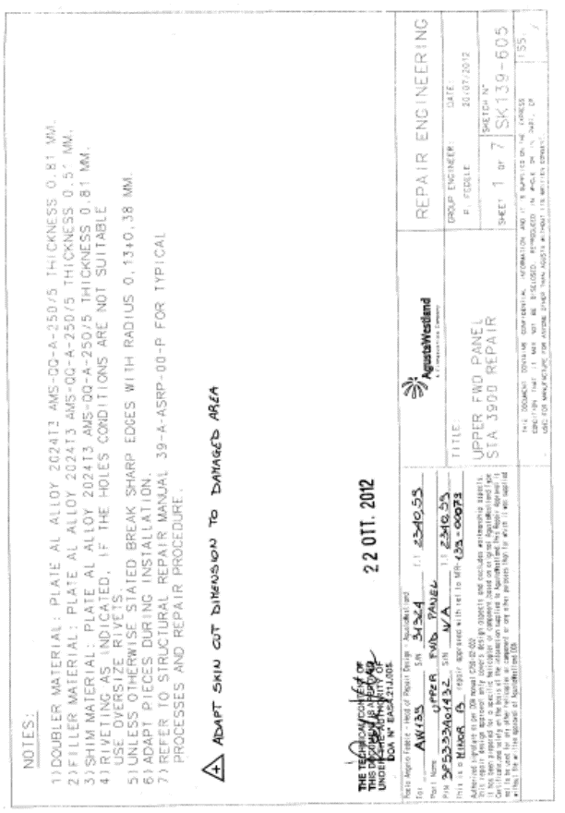

*Figure 27* LEONARDO HELICOPTER PSE SAMPLE – PAGE 02

* 1. **TECHNICAL NOTE**

1. This paragraph outlines the process for providing an official response to all technical queries from other GAM departments, Suppliers and Customers.
2. Technical Note (TN) is used to address technical queries that require an extensive investigation by Technical Services department. It is also used to capture & record all technical investigations for future references.
3. In addition, it provides a means to check that all contents are verified before distribution.
4. This paragraph is applicable to all technical queries which are not related to design document change and requires extensive technical investigation.
5. The scope of technical queries includes but not limited to:
   1. Technical Proposal to Commercial department
   2. Feasibility Report to Commercial department
   3. Non-compliance Report to Quality department
6. The technical queries shall be requested in the form of electronic mail which has been verified accordingly.
7. Technical query may be requested by any other GAM departments (including CAMO, Quality & Maintenance), suppliers or direct customers.
8. Technical Services personnel shall determine if this query is related to change of Technical documents. If yes, an email shall be raised by the requestor.
9. Technical Services personnel shall determine if this query involves extensive investigation which a TN is necessary.
10. Upon confirmation of the need for Technical Note, Technical Services shall register the TN using form GAM/CAMO-036 by assigning a new reference number as follows:

TN-X-XX/XXX

**Running Number**

**Year identification**

**in response to:**

**A – Maintenance**

**B – Quality**

**C – CAMO**

**D – Logistic**

**E – Supplier**

**F – Others**

**X – Multiple Parties**

**Technical Note Identifier**

1. A summary of the request must be recorded to provide an overview of the technical query.
2. Consecutively, any assumption, condition and requirement shall be stated clearly to facilitate the investigation.
3. A full investigation report shall be detailed by the TSE. Upon finalization, the TN shall be checked and verified by STSE and CAM Manager.
4. If approved, the TN shall be archived and distributed to relevant parties. If not approved, proper definition of assumptions, requirements and conditions shall be re-checked.

**PART 5**

**AIRWORTHINESS REVIEW**

**PROCEDURES**

# **PART 5 AIRWORTHINESS REVIEW PROCEDURES**

1. **INTRODUCTION**

The Airworthiness Review Activities, Process Flow and Procedures of GAM are defined within this part of the CAMP.

1. **SCOPE**

This section applies to all CAAM approved and GAM authorised Airworthiness Review Staff.

1. **RESPONSIBILITIES**

Airworthiness Review Staff

1. **AIRWORTHINESS REVIEW PLAN**
2. A periodic airworthiness review of the aircraft on its continuing airworthiness records ensures that the aircraft or its engine, propeller or part complies with the applicable airworthiness requirements and remains in a condition for safe operation throughout its operating life.
3. The airworthiness review may be performed up to a maximum of 90 days prior to the expiry of the certificate of airworthiness
4. CAM Manager or his/her delegate shall prepare the plan and appoint ARS to perform the airworthiness review of all GAM CAMO contracted aircraft for the renewal of Certificate of Airworthiness.
5. The plan shall be reviewed together with the ARS and any feedback provided will be considered and amend accordingly.



Figure 25 Airworthiness Review Process Flow

1. **AIRWORTHINESS REVIEW PREPARATION**
2. The ARS shall notify the respective CAMO department for review of continuing airworthiness within reasonable days in advance.
3. The ARS shall notify the respective maintenance contractor for aircraft physical survey within reasonable days prior to the physical survey.
4. The aircraft records below shall readily made available at the time of the review:
   1. Aircraft Logbook
   2. Engine Logbook
   3. APU Logbook
   4. Component Log Card
   5. Technical Log and Maintenance Record from last airworthiness review
   6. Modification Record Book
   7. Weight and Balance
   8. Maintenance Status
   9. Component Status
   10. OEM Publication Index (Printed from OEM portal)
   11. Publication Master List
   12. Aircraft Certificates
5. **AIRWORTHINESS REVIEW**
   1. **AIRCRAFT RECORDS**
6. The ARS must perform a full documented review of the aircraft continuing airworthiness records.
7. The ARS shall ensure that:
   1. airframe, engine and propeller flying hours and associated flight cycles have been properly recorded;
   2. the flight manual is applicable to the aircraft configuration and reflects the latest revision status;
   3. all the maintenance due on the aircraft according to the approved maintenance programme has been carried;
   4. all known defects have been corrected or, when applicable, carried forward in a controlled manner;
   5. all applicable airworthiness directives have been applied and properly registered;
   6. all modifications and repairs applied to the aircraft have been registered and are approved according to DOA;
   7. all service life limited components installed on the aircraft are properly identified, registered and have not exceeded their approved service life limit;
   8. all maintenance has been released in accordance with this Part;
   9. the current mass and balance statement reflect the configuration of the aircraft and is valid;
   10. the aircraft complies with the latest revision of its type design;
   11. if required, the aircraft holds a noise certificate corresponding to the current configuration of the aircraft.
8. The document review shall make against the requirement as specified in the following documents:
   1. MCAR 2016
   2. Airworthiness Notices
   3. CAME
   4. Maintenance data
   5. Flight Manual
   6. Airworthiness Directives / Service Bulletin
   7. Aircraft Maintenance Programme
   8. Minimum Equipment List
   9. Type Certificate
9. Any findings found during the review shall be raised using form *GAM/CAMO-024 Airworthiness Review Finding.*
   1. **PHYSICAL SURVEY**
10. The ARS shall carry out a physical survey of the aircraft by using form *GAM/CAMO-003 Physical Survey Report.*
11. The PSR shall have the reference number related to the ARR:

GAM/PSR/REG/YY/XX

ARR Running Number

Aircraft Registration (excluding 9M)

Year

1. Through the physical survey of the aircraft, the airworthiness review staff shall ensure that:
   1. all required markings and placards are properly installed;
   2. the aircraft complies with its approved flight manual;
   3. the aircraft configuration complies with the approved documentation;
   4. no evident defect can be found that has not been addressed
   5. no inconsistencies can be found between the aircraft and the documented review of records
2. For ARS not appropriately qualified to the aircraft type being surveyed shall be assisted by Type Rated LAE.
3. Attachment of photos during the physical survey in the report is highly recommended.
4. Any findings found during the review shall be raised using form *GAM/CAMO-024 Airworthiness Review Finding*.
5. **AIRWORTHINESS REVIEW FINDING**
6. Any findings found during the review shall be raised using form GAM/CAMO-024 Airworthiness Review Finding.
7. The ARF shall have the reference number related to the ARR:

GAM/ARF/REG/YY/XX-ZZ

ARF Running Number

Aircraft Registration (excluding 9M)

Year

ARR Running Number

1. The findings raised shall be addressed to CAM Manager for the appropriate actions and rectifications.
2. Attachment showing the findings shall be attached together for evidence recording purposes.
3. The findings are classified into the following categories:
   1. Level 1 – Any significant non-compliance with requirements in Notice 6102 which lowers the safety standard and hazards seriously the flight safety. The corrective actions shall be immediately rectified.
   2. Level 2 – Any non-compliance with requirements laid down in Notice 6102 which could lower the safety standard and possibly hazard the flight safety. The corrective actions shall be taken within 14 days.
4. The written corrective actions shall be attached together with the rectification and signed by the appropriate auditee in form *GAM/CAMO-024 Airworthiness Review Finding* and returned to ARS for his/her review.
5. The ARS shall either accept or reject the corrective action taken. If the corrective action is not acceptable, the ARS shall state the reason and raised the ARF with a new revision number.
6. All ARF raised during the review shall be filed together with the Airworthiness Review Report.
7. **ISSUANCE OF AIRWORTHINESS REVIEW REPORT**
8. Upon satisfactory review of the aircraft continuing airworthiness records, the ARS shall issue the Airworthiness Review Report form *GAM/CAMO-002*.
9. The ARR shall have the following reference number:

GAM/ARR/REG/YY/XX

Aircraft Registration (excluding 9M)

Year

Running Number

1. At the end of the report, ARS shall sign the report to certify that all of the records have been reviewed for the said period and a physical survey of the aircraft undertaken on the said aircraft was found to be fully in compliance with all of the applicable requirements of CAAM Part M.
2. **SUBMISSION TO CAAM FOR C OF A APPLICATION**
3. The following shall be submitted to CAAM for the application of issuance/renewal of Certificate of Airworthiness:
   1. Cover Letter (2 copies)
   2. CAAM Application for Certificate of Airworthiness (form AW8301)
   3. Airworthiness Review Report
   4. Physical Survey Report
   5. Airworthiness Review Findings
   6. Copy of payment receipt of fees
   7. Original Certificate of Airworthiness
4. An email regarding the C of A application submission shall also be sent to CAAM with the attachment of all of the above documents
5. For avoidance of application being unnecessarily rejected by the CAAM, CAM Manager shall review the application before the submission.
6. The application shall be submitted at least 45 days before the expiry date of the current Certificate of Airworthiness to ensure a consecutive period of validity.
7. **ISSUANCE/RENEWAL OF CERTIFICATE OF AIRWORTHINESS**
8. The Certificate of Airworthiness is issued upon satisfactory review of the application by CAAM.
9. The ARS shall pass the certificate to Technical Publication for distribution and updating.
10. The Airworthiness Review plan shall be updated to reflect the new C of A expiry date.
11. **PERMIT TO FLY ISSUANCE**
12. GAM has been granted the privilege to issue the Permit to Fly (PTF) in accordance with CAAM Notice 8305 for aircraft as listed in CAME Part 5.2.
13. Only ARS that have been approved by CAAM and authorised by QAM for the privilege can issue the PTF as per the procedure herein.
14. The scope for the issuance of PTF by the ARS are only limited to maintenance flight test as required by the maintenance manual and for airworthiness flight test as per CAAM approved Airworthiness Flight Test Schedule (AFTS).
15. The scope for the maintenance activities that require for the flight test are stipulated in Part 6.2 List of Approved Limited Scope of Maintenance Activities of this CAMP.
16. The PTF with condition for aircraft which the C of A has not been issued shall be initiated by CAMO Planner.
17. For PTF with Flight Condition and PTF with condition for maintenance flight test shall be initiated by Engineer-in-Charge (EIC) of the AMO.
18. The request for PTF shall be via electronic mail to the ARS and copied to CAM Manager and QAM Manager.
19. ARS then shall identify if the requested PTF is for PTF with Flight Conditions or PTF with Conditions. He then shall process the PTF application and register in a Master List with PTF reference number:

PTF/REG/YY/XX

Year

Aircraft Registration

PTF Running Number

1. The respective ARS shall raise the PTF form GAM/CAMO-022 with the assigned PTF number and send to the appointed EIC.
2. PTF form shall consists of:
   1. Section A: PTF Application
   2. Section B: PTF Certificate
   3. Section C: PTF Aircrew Briefing

1. The appointed LAE shall provide the details and declaration in Section A: PTF Application with all the supporting documents required for the PTF. This form and all the supporting documents shall be forwarded to the ARS when the aircraft is ready to carry out the flight test.
2. The nominated ARS shall review and verify the supporting documents for the PTF application. The nominated ARS shall issue Section B: PTF Certificate once satisfied that all requirements pertaining to the PTF has been met.
3. The appointed LAE shall print the completed PTF form. Section B: PTF Certificate shall be printed in duplicate. One copy to be displayed on board of aircraft and one to be kept at line office.
4. Section C: PTF Aircrew Briefing shall be completed by the appointed LAE and the flight crew. The appointed LAE shall email the completed Section C to the nominated ARS prior to the intended flight. This process shall be repeated whenever there are changes in the flight crew.
5. A PTF issued by GAM CAMO shall only be valid for 7 days. The completed PTF form (Section A, B & C), respective Work Order and related MCFS/AFTS shall be kept together as aircraft records.
6. A new PTF application shall be required for the following conditions:
   1. Additional maintenance task requiring PTF (Initial maintenance task to be included in the new PTF application form)
   2. Issued PTF has expired
7. There shall be only one PTF issued for an aircraft at any one time. In the event of a new PTF issued, it shall supersede the previous one. This will be annotated in the front page of the PTF form by ARS.
8. CAM Manager and QAM shall be copied in all communication pertaining to the issuance of PTF by the ARS. CAM Manager shall notify CAAM on monthly basis for the permit to fly issuance for reporting purposes.
9. **AIRWORTHINESS REVIEW RECORDS RETENTION**
10. The Airworthiness Review Report (ARR) and the Permit to Fly (PTF) issuance shall form part of the respective aircraft continuing airworthiness records.
11. Each ARR and PTF together with all its supporting document shall be retained in accordance with para. 2.7 of this CAMP.
12. These records shall be retained until a period of two (2) years after the aircraft has been permanently withdrawn from service.
13. The access to these records shall be restricted and retained in a fire, theft, water, and alteration protected environment.

**PART 6**

**APPENDICES**

# **PART 6 APPENDICES**

1. **LIST OF FORMS**
2. Technical Instruction Compliance Form (GAM/CAMO-001R2)
3. Airworthiness Review Report (GAM/CAMO-002R1)*
4. Physical Survey Report (GAM/CAMO-003R1)*
5. Workpack Control (GAM/CAMO-004)
6. Worksheet (GAM/CAMO-005)
7. Maintenance Release Certificate (GAM/CAMO-006)
8. Company Authorization Certificate (GAM/CAMO-007)
9. Aircraft Journey Log AW139 (GAM/CAMO-008/AW139 REV 2)*
10. Aircraft Journey Log AW189 (GAM/CAMO-008/AW189 REV 0)*
11. Aircraft Journey Log General (GAM/CAMO-008/GEN REV 0)*
12. Aircraft Journey Log B300 (GAM/CAMO-008/B300 REV 0)*
13. Aircraft Journey Log Helang Flying Academy (GAM/CAMO-008/HELANG REV 0)*
14. Audit Check List (GAM/CAMO-009)
15. Audit Plan (GAM/CAMO-010)
16. Work Package Handover (GAM/CAMO-011)
17. Parts Report (GAM/CAMO-012)
18. Aircraft Deferred Defect Record (GAM/CAMO-013)*
19. Logbook Entry (Airframe & Engine) (GAM/CAMO-014R1)
20. Test Flight & Ground Run Form (GAM/CAMO-015)
21. Document Acceptance Statement (GAM/CAMO-016)
22. Modification Record Sheet – Airworthiness Directive (GAM/CAMO-017R1)
23. Aircraft Logbook (GAM/CAMO-018R1)*
24. Engine Logbook (GAM/CAMO-019R1)*
25. Conformity Inspection (GAM/CAMO-020)*
26. Modification Installation Approval (GAM/CAMO-021R1)*
27. Permit to Fly Approval (GAM/CAMO-022R1)*
28. Publication Master List (GAM/CAMO-023)
29. Airworthiness Review Finding (GAM/CAMO-024)
30. Document Revision Amendment Form (GAM/CAMO-025)
31. Publication Register (GAM/CAMO-026)
32. Modification Record Sheet – Service Bulletin (GAM/CAMO-027)
33. Engineering Order Approval Sheet (EOAS) (GAM/CAMO-028)
34. Pilot Limited Certification Authorisation – Application form (GAM/CAMO-029)
35. Pilot Limited Certification Authorisation – Task Training (GAM/CAMO-030)
36. Component Log Card (GAM/CAMO-031)
37. Job Competency Assessment Form (GAM/CAMO-032)
38. AMP Variation Request Form (GAM/CAMO-033)
39. Propeller Logbook (GAM/CAMO-034)
40. CAMO Variation Approval Checklist (GAM/CAMO-035)
41. Technical Note (GAM/CAMO-036)

* Forms reflected in CAME approved by CAAM

1. **LIST OF APPROVED LIMITED SCOPE OF MAINTENANCE ACTIVITIES**
2. AW139 Maintenance Activities that requires Rotor Track & Balance Flights

| ***No.*** | ***Maintenance Flight Test (MFT)*** | ***Maintenance Task*** | ***Condition*** |
| --- | --- | --- | --- |
|  | **Main Rotor Track and Balance**  39-A-18-10-01-00A-37CA-A  OR  39-A-18-10-03-00A-37CA-A  (IF A/C EQUIPPED WITH HUMS) | **Main rotor blade - Install procedure**  39-A-62-11-01-00A-720A-A | If perform maintenance operations on the main rotor blade after removal from helicopter |
|  | **Vibration absorber installation – Adjust**  39-A-18-61-00-00A-271A-A | - |
|  | **Main rotor blade - Other procedures to protect surfaces**  39-A-62-11-01-00A-259A-B | - |
|  | **Balance weight pocket cover (main rotor blade) - Replacement (remove and install a new item)**  39-A-62-11-01-06A-921A-A | - |
|  | **Top conical ring - Install procedure**  39-A-62-21-05-00A-720A-A | - |
|  | **Main rotor head - Install procedure**  39-A-62-22-00-00A-720B-A | - |
|  | **Lag damper - Install procedure**  39-A-62-22-02-00A-720A-A | If lag damper is replaced |
|  | **Pitch control lever - Install procedure**  39-A-62-22-03-00A-720A-A | - |
|  | **Flapping limiter - Install procedure**  39-A-62-22-04-00A-720A-A | If flapping limiter is replaced |
|  | **Flapping limiter support - Install procedure**  39-A-62-22-05-00A-720A-A | - |
|  | **Droop stop bracket - Install procedure**  39-A-62-22-06-00A-720A-A | If droop stop bracket is replaced |
|  | **Anti-rotation block - Install procedure**  39-A-62-22-07-00A-720A-A | If replaced the anti-rotation block with a new item |
|  | **Tension link and elastomeric bearing assembly - Install procedure**  39-A-62-22-08-00A-720A-A | - |
|  | **Tension link - Install procedure**  39-A-62-22-09-00A-720A-B | If new elastomeric bearing is installed |
|  | **Elastomeric bearing - Install procedure**  39-A-62-22-10-00A-720A-B | If new elastomeric bearing is installed |
|  | **Droop stop pin – Adjust**  39-A-62-22-12-00A-271A-A | - |
|  | **Scissors attachment flange - Install procedure**  39-A-62-22-15-00A-720A-A | - |
|  | **Sliding ring – Replacement**  39-A-62-22-17-00A-920A-B | If new pitch link is installed |
|  | **Pitch link - Install procedure**  39-A-62-31-01-00A-720A-A | - |
|  | **Tail rotor - Blade track and balance check**  39-A-18-10-02-00A-37CA-A  OR  39-A-18-10-03-00A-37CA-A  (IF A/C EQUIPPED WITH HUMS) | **Tail rotor blade assembly - Install procedure**  39-A-64-11-01-00A-720A-A | If perform maintenance operations on the tail rotor blade after removal from helicopter |
|  | **Blade damper attachment - Install procedure**  39-A-64-11-02-00A-720A-A | If new blade damper attachment is installed |
|  | **Elastomeric bearing - Install procedure**  39-A-64-11-03-00A-720A-B | If new elastomeric bearing is installed |
|  | **Lag damper - Install procedure**  39-A-64-21-02-00A-720A-A | If lag damper is replaced |
|  | **Top conical ring - Install procedure**  39-A-64-21-03-00A-720A-A | If new top conical ring is installed |
|  | **Slip ring drive - Install procedure**  39-B-64-21-04-00A-720A-A | - |
|  | **Pitch link - Install procedure**  39-A-64-31-01-00A-720A-A | If new pitch link is installed |
|  | **Scissors - Install procedure**  39-A-64-31-02-00A-720A-A | If new scissors is installed |
|  | **Sliding control assembly - Install procedure**  39-A-64-31-04-00A-720A-A | If new sliding control assembly is installed |
|  | **Tail rotor control system – Adjust**  39-A-67-21-00-00A-271A-A | - |

1. AW139 Maintenance Activities that requires Functional Check Flights

|  |  |  |  |
| --- | --- | --- | --- |
| ***No.*** | ***Maintenance Flight Test (MFT)*** | ***Maintenance Task*** | ***Condition*** |
|  | **Helicopter general - Check flight after engine installation**  39-A-00-00-00-00A-34BA-A. | **Number 1 engine - Install procedure**  39-A-71-02-01-00A-720A-A | - |
|  | **Number 2 engine - Install procedure** 39-A-71-02-02-00A-720A-A | - |
|  | **Helicopter general information - Functional check**  39-A-00-00-00-00A-34AA-A | **Number 1 pump - Operation test**  39-A-29-11-02-00A-320A-A | - |
|  | **Number 2 pump - Operation test**  39-A-29-12-02-00A-320A-A | - |
|  | **Number 4 pump - Operation test**  39-A-29-12-03-00A-320A-A | - |

1. AW189 Maintenance Activities that requires Rotor Track & Balance Flights

| ***No.*** | ***Maintenance Flight Test (MFT)*** | ***Maintenance Task*** | ***Condition*** |
| --- | --- | --- | --- |
|  | **Main rotor - Tracking check**  89-A-18-10-01-00A-373A-A | **Main rotor blade – Install procedure**  89-A-62-11-01-00A-720A-A | - |
|  | **Top conical ring – install procedure**  89-A-62-21-03-00A-720A-A | - |
|  | **Lag damper - Install procedure**  89-A-62-22-03-00A-720A-A | If lag damper is replaced |
|  | **Flapping limiter – Install procedure**  89-A-62-22-05-00A-720A-A | If flapping limiter is replaced |
|  | **Flapping limiter support – install procedure**  89-A-62-22-06-00A-720A-A | - |
|  | **Droop stop bracket – install procedure**  89-A-62-22-07-00A-720A-A | If droop stop bracket is replaced |
|  | **Anti-rotation block – install procedure**  89-A-62-22-08-00A-720A-A | If anti-rotation block is replaced |
|  | **Tension link and elastomeric bearing assembly – install procedure**  89-A-62-22-09-00A-720A-A | - |
|  | **Droop stop pin – adjust**  89-A-62-22-13-00A-271A-A | - |
|  | **Pitch link – install procedure**  89-A-62-31-01-00A-720A-A | - |
|  | **Adapter – install procedure**  89-A-62-31-03-00A-720A-A | - |
|  | **Tail rotor - Tracking check**  89-A-18-10-02-00A-373A-A | **Tail rotor blade assembly - Install procedure**  89-A-64-11-01-00A-720A-A | If install a new or repaired tail rotor blade assembly or a new elastomeric bearing |
|  | **Blade damper attachment - Install procedure**  89-A-64-11-02-00A-720A-A | If new blade damper attachment is installed |
|  | **Lag damper - Install procedure**  89-A-64-11-02-00A-720A-A | If new lag damper is installed |
|  | **Top conical ring - Install procedure**  89-A-64-21-03-00A-720A-A | If new top conical ring is installed |
|  | **Slip ring drive - Install procedure**  89-B-64-21-03-00A-720A-A | - |
|  | **Pitch link - Install procedure**  89-A-64-31-01-00A-720A-A | - |
|  | **Scissors group - Install procedure**  89-A-64-31-02-00A-720A-A | If scissor is replaced |
|  | **Spider and slider assembly - Install procedure**  89-A-64-31-04-00A-720A-A | - |

1. AW189 Maintenance Activities that requires Functional Check Flights

|  |  |  |  |
| --- | --- | --- | --- |
| ***No.*** | ***Maintenance Flight Test (MFT)*** | ***Maintenance Task*** | ***Condition*** |
|  | **Helicopter general - Check flight after engine installation**  89-A-00-00-00-00A-34BA-A | **Number 1 engine - Install procedure**  89-A-71-01-01-00A-720A-A | - |
|  | **Number 2 engine - Install procedure**  89-A-71-01-02-00A-720A-A | - |
|  | **Helicopter general information - Functional check flight**  39-A-00-00-00-00A-34AA-A | **Number 1 pump - Operation test**  89-A-29-11-02-00A-320A-A | - |
|  | **Number 2 pump - Operation test**  89-A-29-12-02-00A-320A-A | - |
|  | **Number 4 pump - Operation test**  89-A-29-12-03-00A-320A-A | - |

1. A109E Maintenance Activities that requires Rotor Track & Balance Flights

|  |  |  |  |
| --- | --- | --- | --- |
| ***No.*** | ***Maintenance Flight Test (MFT)*** | ***Maintenance Task*** | ***Condition*** |
|  | **Main rotor tracking and dynamic balance**  62-00-8 | Main rotor blades installation  62-11-6 Para D | - |
|  | Main rotor head installation  62-21-13 Para D | - |
|  | Main rotor head installation  62-21-54 Para D | If mix an elastomeric bearing made by “Paulstra” with those made by “Lord” (or “vice versa”) |
|  | Rotating controls - Pitch change links Installation  62-31-12 Para F | - |
|  | **Tail rotor dynamic balancing**  64-00-8 | Tail rotor blades installation  64-11-6 Para. D |  |
|  | Tail roto hub reassembly  64-21-11 Para. Z |  |
|  | **Tail rotor dynamic balancing**  64A-00-8 | Tail roto hub reassembly  64A-11-6 Para. D |  |
|  | **Tail rotor static balancing**  64-00-16 | Tail rotor blades installation  64-11-6 Para. D | Only if one or both tail rotor blades have been replaced |
|  | **Tail rotor static balancing**  64A-00-15. | Tail roto hub reassembly  64A-21-11 Para. B | For tail rotor hub assy P/N 109-0162-02 |
|  | Tail roto hub reassembly  64-21-11 Para. C | For the tail rotor hub assy modified with P/N 109-0162-01 or P/N 109-0824-49 |

1. EC120B Maintenance Activities that requires Maintenance Flight Test

| ***No.*** | ***Maintenance Flight Test (MFT)*** | ***Maintenance Task*** | ***Condition*** |
| --- | --- | --- | --- |
|  | **Checks and Corrections for Horizontal (Y) and Vertical (Z) Vibrations - Main Rotor**  AMM 62-00-00,5-1 | Removal /Installation - Main Rotor Blades  AMM 62-11-00,4-1 | If installed new or repaired blade, or after interchanged two blades |
|  | Assembly - Main Rotor Hub,  AMM 62-21-00,4-2 | If replaced a main rotor hub or one of its components |
|  | Removal / Installation - Flared Housing / Swashplates / Hub Couplings,  AMM 62-32-00,4-1 | If replaced a pitch-change rod or a ball end-fitting |
|  | Installation - Rotor Head Assembly  AMM 62-20-00,4-2 |  |
|  | Adjustment - Main Rotor Controls  AMM 67-10-00,5-1 |  |
|  | Replacement - End-fittings on the pitch and roll rods,  AMM 67-10-00,8-12 |  |
|  | **Balancing – Tail Rotor Hub**  AMM 64-21-00,5-1 | Installation - Tail Rotor Hub  AMM 64-21-00,4-2 | If you replaced or repaired a component, or changed the position of some components |
|  | Assembly - Tail Rotor Hub,  AMM 64-21-00,4-4 |  |
|  | **Flight Test Schedule**  FLM Section 8.3 | Procedure after Detection of Chips and Lighting of the "MGB P" and "MGB TEMP" Warning Lights - MGB / TGB  AMM 05-50-00,6-10 |  |
|  | Fault finding by vibration analysis  AMM 05-50-00,6-13 |  |
|  | Fault finding by vibration analysis with STEADYControl ® adjustment equipment AMM 05-50-00,6-14 |  |
|  | Fuel System – Adjusted Fuel Control Unit Removal / Installation  EMM Task 73-23-00-900-802-A01 |  |
|  | Fuel System – Adjusted Fuel Control Unit Tests (Except Electrical)  EMM Task 73-23-00-900-802-A01 |  |

1. B300 Maintenance Activities that requires Maintenance Flight Test

| ***No.*** | ***Maintenance Flight Test (MFT)*** | ***Maintenance Task*** | ***Condition*** |
| --- | --- | --- | --- |
|  | **Flow Control Valve - Adjustment/Test**  AMM 21-10-05-5 | **No.1 Engine Flow Control Valve - Adjustment/Test**  AMM 21-10-05-5 |  |
|  | **No.2 Engine Flow Control Valve - Adjustment/Test**  AMM 21-10-05-5 |  |
|  | **Pressurization Check Procedures - (Flight Test)**  AMM 21-30-00, 101 | **Outflow Valve And Safety Valve - Adjustment/Test**  AMM 21-30-03-5 | Functional Test Method 1 |
|  | **Air Pressure Controller-Limiter - Removal/Installation**  AMM 21-30-13-4 |  |
|  | **Stall Lift Computer - Adjustment/Test**  AMM 27-31-03-5 | **Stall Lift Computer - Adjustment/Test**  AMM 27-31-03-5 | 1. If Lift Computer Or Lift Transducer Is Replaced, or 2. If The Stall Warning System Has Failed In Any Manner Or The Stall Warning Margin Has Changed Without Explanation, or 3. In Order To Set A Specific Margin, |
|  | **Flight Control System - B. Flight Checks**  AMM 27-00-00-2 | **Flight Control System - Rigging and Trim Procedures - D. Wings**  AMM 27-00-00-2 |  |
|  | **Flight Control System - Rigging and Trim Procedures - F. Ground Adjustable Trim Tab**  AMM 27-00-00-2 |  |
|  | **Power Lever Sense Switch - Adjustment/Test**  32-60-09-5 | **Power Lever Sense Switch - Adjustment/Test**  AMM 32-60-09-5 |  |
|  | **Propeller - Adjustment/Test - Propeller Dynamic Balancing**  AMM 61-10-01-5 | **Propeller - Adjustment/Test - Propeller Dynamic Balancing – C.Flight Test**  AMM 61-10-01-5 |  |

1. R44 Maintenance Activities that requires Maintenance Flight Test

| ***No.*** | ***Maintenance Flight Test (MFT)*** | ***Maintenance Task*** | ***Condition*** |
| --- | --- | --- | --- |
|  | **Special Instruction for Reassembling and Flight Testing R44 series helicopter after crating for export**  AMM 1.700 | Special Instruction for Reassembling and Flight Testing R44 series helicopter after crating for export  AMM 1.700 |  |
|  | **Track and Balance**  AMM 10.200 | Collective travel rigging  AMM 10.122 |  |
|  | Main Rotor Blade Installation  AMM 9.112 |  |
|  | Repair of Main Rotor Blade  AMM 9.140 |  |
|  | Swashplate installation  AMM 8.142 |  |
|  | Utility Float Main Landing Gear Installation  AMM 5.520 |  |
|  | 12 years Inspection  AMM 2.600 |  |
|  | **Autorotational RPM Adjustment**  AMM 10.250 | Utility Float Main Landing Gear  Installation  AMM 5.520 |  |
|  | **Flight Check**  AMM 2.220 | Flight Check for 100-Hour / Annual Inspection  AMM 2.200 |  |
|  | 12 years Inspection  AMM 2.600 |  |
|  | **Functional Flight Test of**  **Longitudinal Cyclic Trim Elastic Cords**  AMM 8.130 | Longitudinal Cyclic Trim Elastic  Cord  AMM 8.130 |  |