|  |  |  |  |
| --- | --- | --- | --- |
| **9M-YTL FINDINGS** | | | |
| **NO.** | **INSPECTION** | **REMARKS** | **ACTION** |
| **AIRFRAME SMI (FH) INTERVAL** | | | |
| B6 | 200 FH INSP | NOT LISTED ON AERONET | LISTED |
| B24 | 20000 FH INSP | NOT LISTED ON AERONET | LISTED |

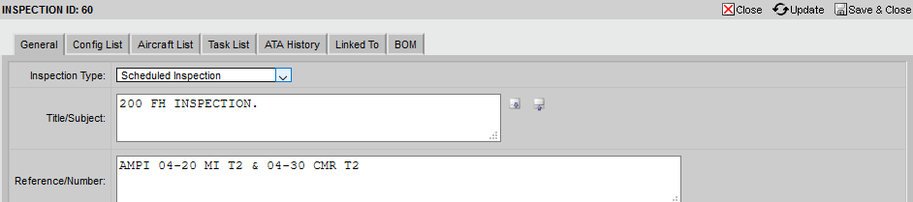

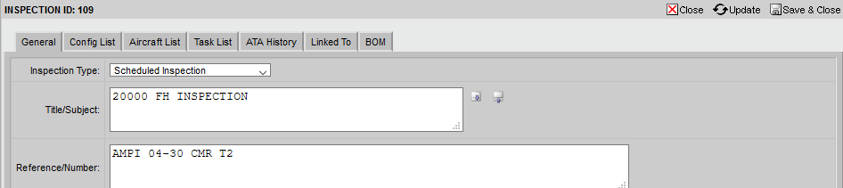

|  |  |  |  |
| --- | --- | --- | --- |
| **AIRFRAME SMI (CALENDAR) INTERVAL** | | | |
| C4 | 1 Y INSP | NOT LISTED ON AERONET | LISTED (N/A) |



|  |  |  |  |
| --- | --- | --- | --- |
| **AIRFRAME SMI SPECIFIC INTERVAL** | | | |
| D2 | 150 / 1 Y INSP | NOT LISTED ON AERONET | LISTED (N/A) |
| D17 | CHECK POST INSTALLATION OF MR HUB RETAINING ASSEMBLY BOLTS | NOT LISTED ON AERONET | LISTED |
| D18 | CHECK POST INSTALLATION OF TR HUB RETAINING ASSEMBLY BOLTS | NOT LISTED ON AERONET | LISTED |

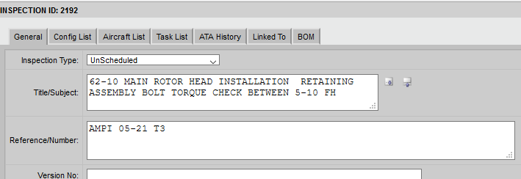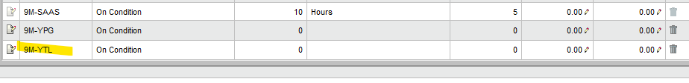

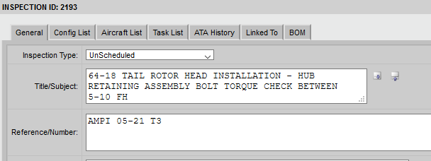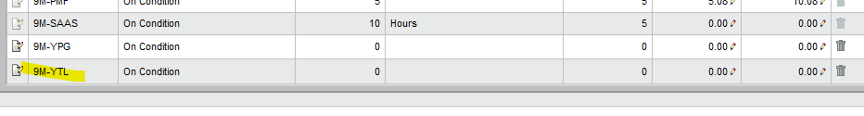

|  |  |  |  |
| --- | --- | --- | --- |
| **CCP (MILD)** | | | |
|  | 2 W INSP | NOT LISTED ON AMP | SETTLED |
|  | 600 FH / 1 Y INSP | NOT LISTED ON AMP | SETTLED |
| **ENGINE RECOMMENDED MAINTENANCE TASK (OPERATING ENVIRONMENT)** | | | |
| H1 | ENGINE WASHING | NOT LISTED ON AERONET | LISTED ON OUT OF PHASE INSPECTION |
| H2 | ENGINE WASHING | NOT LISTED ON AERONET | LISTED ON OUT OF PHASE INSPECTION |
| H3 | ENGINE WASHING | NOT LISTED ON AERONET | LISTED ON OUT OF PHASE INSPECTION |

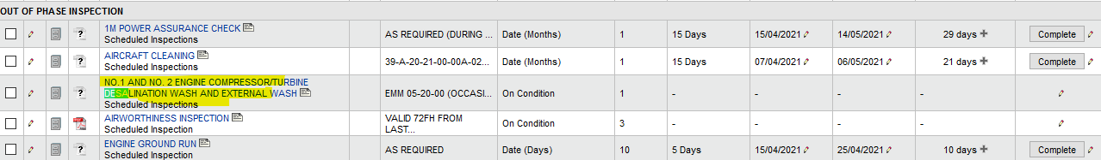

|  |  |  |  |
| --- | --- | --- | --- |
| **EWIS INSP** | | | |
| O1 | EWIS INSP | NOT LISTED ON AERONET |  |
| **POST MOD / REPAIR** | | | |
| L1 | MOD / REPAIR INSP | NOT LISTED ON AERONET  (NOT SURE) |  |
| **OPERATOR REQUIREMENT** | | | |
| M1 | OPERATOR REQUIREMENT | NOT LISTED ON AERONET (NOT SURE) |  |