|  |  |  |  |
| --- | --- | --- | --- |
| **9M-YPG FINDINGS** | | | |
| **NO.** | **INSPECTION** | **REMARKS** | **ACTION** |
| **AIRFRAME SMI (FH) INTERVAL** | | | |
| B6 | 200 FH INSP | NOT LISTED ON AERONET | LISTED |
| B24 | 20000 FH INSP | NOT LISTED ON AERONET | LISTED |

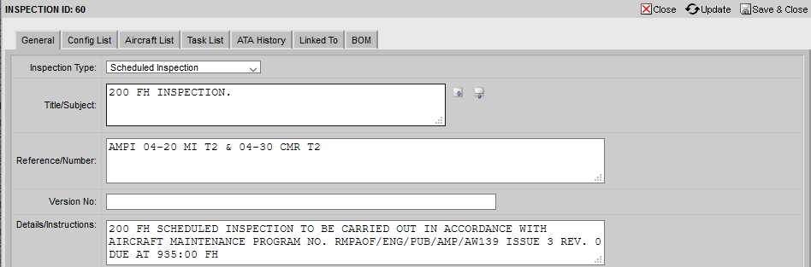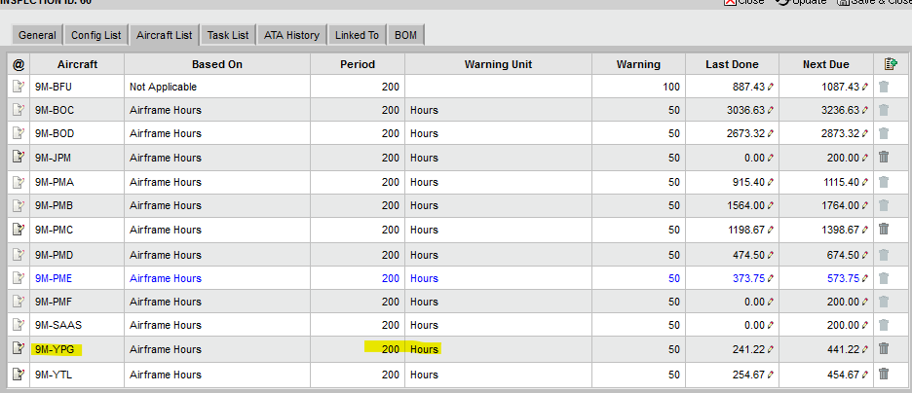

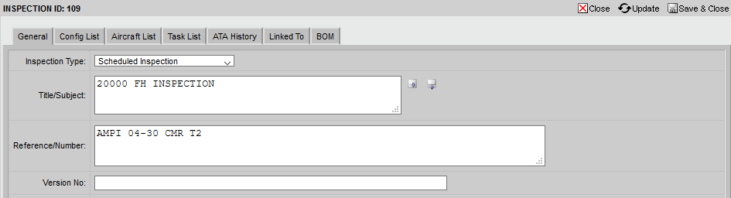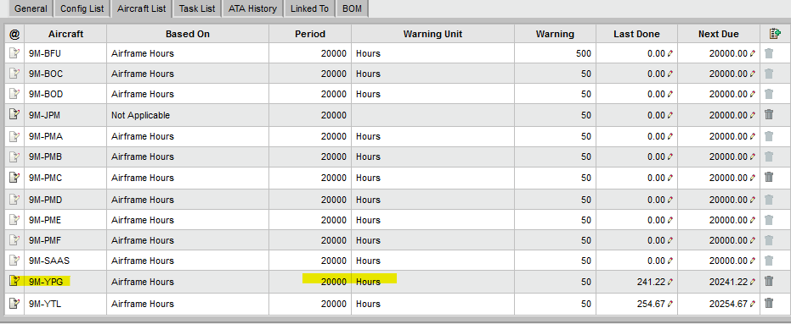

|  |  |  |  |
| --- | --- | --- | --- |
| **ENGINE RECOMMENDED MAINTENANCE TASK (OPERATING ENVIRONMENT)** | | | |
| H1 | ENGINE WASHING | AERONET BASED ON  (ON-CONDITION) | LISTED |
| H2 | ENGINE WASHING | LISTED |
| H3 | ENGINE WASHING | LISTED |

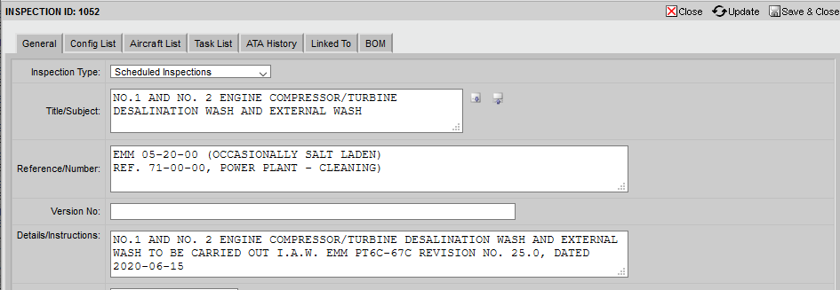

|  |  |  |  |
| --- | --- | --- | --- |
| **ENGINE (1 AND 2) SCHEDULE INSP** | | | |
| G1 | 12 FH INSP | OC @ AF HOUR ON AERONET | IN AIRWORTHINESS INSPECTION |
|  | INSPECTION A/C FLOWN IN VOLCANIC ASH OR SMOKE | NOT LISTED ON AMP | NOTED |
| **EWIS INSP** | | | |
| O1 | INSP OF EWIS | NOT LISTED ON AERONET |  |
| **POST MOD / REPAIR** | | | |
| L1 | INSP. POST MOD | NOT LISTED ON AERONET (NOT SURE) |  |
| **OPERATOR REQUIREMENT** | | | |
| M1 | OPERATOR REQUIREMENT | NOT LISTED ON AERONET (NOT SURE) |  |

|  |  |  |  |
| --- | --- | --- | --- |
| **EWIS INSP** | | | |
| O1 | EWIS INSP | NOT LISTED ON AERONET |  |