|  |  |  |  |
| --- | --- | --- | --- |
| **9M-JPM FINDINGS** | | | |
| **NO.** | **INSPECTION** | **REMARKS** | **ACTION** |
| **AIRFRAME SMI (FH) SPECIFIC INTERVAL** | | | |
| C1 | CHECK POST INSTALLATION OF MR HUB RETAINING ASSEMBLY BOLTS | LISTED ON AERONET (AF SMI HOURS INTERVAL COLUMN) |  |
| C2 | CHECK POST INSTALLATION OF TR HUB RETAINING ASSEMBLY BOLTS | LISTED ON AERONET (AF SMI HOURS INTERVAL COLUMN) |  |
| C3 | CHECK MAST VIBRATION ABSORBER – HALF CONICAL RING INSTALLATION BOLTS | LISTED ON AERONET (AF SMI HOURS INTERVAL COLUMN) |  |
| C4 | CHECK POST INSTALLATION OF MAST VIBRATION ABSORBER ASSEMBLY | LISTED ON AERONET (AF SMI HOURS INTERVAL COLUMN) |  |

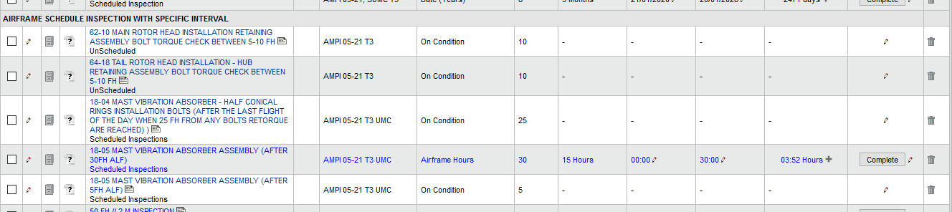

|  |  |  |  |
| --- | --- | --- | --- |
| **ENGINE #1 SCHEDULED INSP** | | | |
| F5 | 600 FH INSP | NOT LISTED ON AERONET |  |

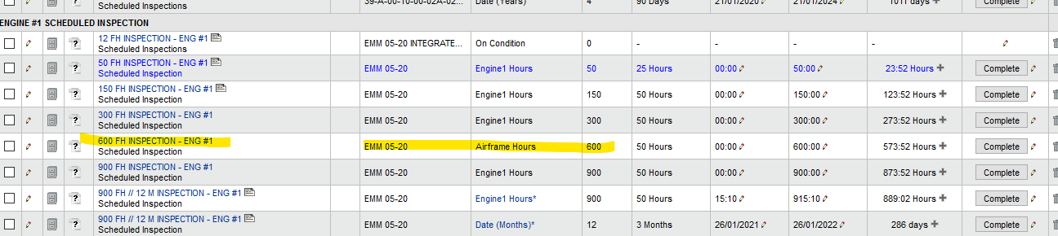

|  |  |  |  |
| --- | --- | --- | --- |
| **ENGINE WASHING** | | | |
| G1, G2, G3 | ENGINE WASHING | LISTED ON AERONET (CCP INSP PROGRAM COLUMN) |  |

