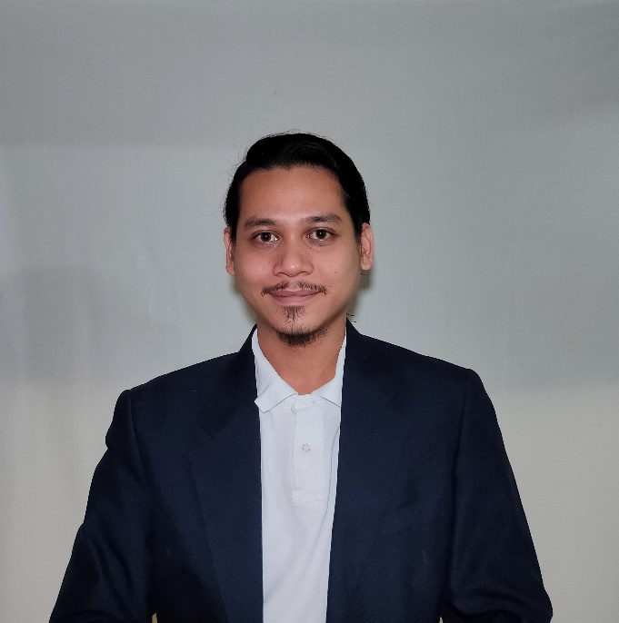**NAJMI AIMAN BIN ZABIDI**

FRESH GRADUATE BACHELOR IN AGRIBUSINESS



+60173616211

najmiaiman96@gmail.com

https://www.linkedin.com/in/najmi-aiman-zabidi/

Port Dickson, Negeri Sembilan

# CAREER AND PERSONAL STATEMENT

A graduated agribusiness student that is driven by a desire to excel and motivate to apply the technical abilities learned in business world as well relevant knowledge gained and exposed to. With these technical know-hows, accountability and problem-solving ability, I can go beyond the competencies with your organization. In addition, with my interpersonal skills, building rapport with all levels, and communicates well (both in English & Bahasa Melayu), I am confident I will be a key player to your organization and/or project management team.

# EDUCATION

# Bachelor’s Degree

UNIVERSITI PUTRA MALAYSIA *09/2018 – 08/2021*

Course: Bachelor in Agribusiness , 3.202

Thesis: Diversification Strategy Of Agricultural Sector : Between Coconut & Palm Oil

# Diploma

UNIVERSITI PUTRA MALAYSIA *06/2014 – 05/2018*

Course: Diploma in Agribusiness , 2.96

# Sijil Pelajaran Malaysia

SEKOLAH MENENGAH KEBANGSAAN *01/2009 – 11/2013*

TINGGI PORT DICKSON

*\*2A-s: Bahasa Malaysia, Sejarah 2C: Biology, Physics*

*3B+: Mathematics, English, Agama Islam*

# RELEVANT EXPERIENCES

**CUSTOMER SERVICE ASSOCIATE**

IGT Solutions Pvt. Ltd. 10/2021 – Present

* Reservation Agent for American Airlines.
* Assisting customer through chats and picking up calls.
* Exposed to USA and International Air Transport Association (IATA) policy.
* Learned about airlines product, rules and regulations.
* Assisting premium/VIP passenger under AAdvantage programme.
* Work in a team to solve problem/issue.

**AGRIBUSINESS TRAINEE**

Hazs Dagangan Enterprise 10/2020 - 08/2021

* Intern as Assistant Manager and Marketing Officer.
* Led a team in production sector.
* Learned and exposed to small-medium enterprise.
* Assisted the head manager in producing, sales, marketing and distribution.
* Learned in joining programme held by government such as FAMA and MARA.
* Learned to handle equipment in production site.

Malaysian Agriculture Research and Development Institute (MARDI) 10/2017 – 03/2018

* Intern as Research Assistant at Department of Agribusiness and Social Science.
* Join project under Research Officer on Durian commodity.
* Involved in MAHA 2018 as a surveyor.
* Handling questionnaire for survey.
* Publish an article on Seed Industry in Malaysia.

**PART TIME**

VMC Technologies Distribution 11/2018 – 08/2020

* Work as Retail Manager when the company started.
* Check in and out for stock at retail.
* Filing and billing for company.
* Involve in sales and marketing.
* As a team leader for co-workers.
* Dealing and negotiate with supplier.

# SKILLS

* Cost-Benefit Analysis
* Financial Feasibility
* SWOT Analysis
* Microsoft Word
* Adobe Photoshop
* Adobe Premiere Pro
* IBM SPSS
* Microsoft Excel
* Microsoft PowerPoint

# ACHIEVEMENTS

• Publish an article at FFTC Agricultural Policy Platform (FFTC-AP) on “The Malaysian Agriculture Seed Industry – Seed Policy and Development.” (Oct 2017). https://ap.fftc.org.tw/author/2209

  Involve in R&D Project with MARDI on Durian commodity.

• Volunteering at MAHA 2018.

  Volunteering and joining CSR programme with UPM at Zoo Melaka.

  Involve in “Program Keluarga Angkat” di Kg Penan Muslim Batu 10, Bintulu, Sarawak at UPM Kampus Bintulu.

• Involve in SUKOL UPM represent college for football at university level.

# REFERENCE

• **MUHAMMAD NAZRIN BIN AZILLAH**   • **DR FAZLIN BT ALI**  

Chief Executive Officer Academic Advisor

VMC Technologies Distribution Universiti Putra Malaysia,

Faculty of Agriculture

+60178816980 +60193336639

nazrin.azillah9@gmail.com fazlin_ali@upm.edu.my