Sample of Amendment

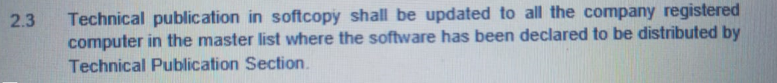
All computers that have been installed with Technical be registered in the Distribution User List (GAM/E -xxx) and to be endorsed by SMM.

Publication shall be registered in the Distribution User List (GAM/E -xxx) and to be endorsed by SMM.

