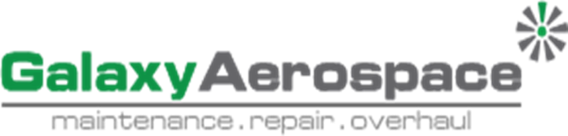

ENVIRONMENT, SAFETY & HEALTH POLICY
Galaxy Aerospace (M) Sdn. Bhd. are committed to be a leader in Maintenance Repair & Overhaul (MRO) industry and shall continuously improve to maintain a positive and sustainable environment, safety & health (ESH) culture.
We shall also continuously:
- Providing the necessary resources for the implementation of ESH policy and to deliver a safe product/ service.
- Ensuring ESH is a primary accountability and/ or responsibility of all management and staffs including implementing the effective Safety Management System (SMS) and its component at all levels.
- Comply with all applicable legal and other regulatory requirements.
- Strive to improve the level of ESH performance.
- Encourage a culture of fair reporting of all safety hazards in which management will not initiate disciplinary action against any personnel, who in good faith, due to unintentional conduct, disclose a hazard or safety incident.

………………………………………………………
Name : Dato’ Shamsul Kamar Bin Samsudin
Designation : Accountable Executive
Date : xx/xx/xxxx

