WAS | IS
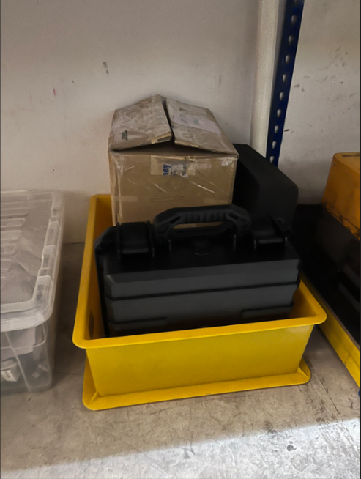 | 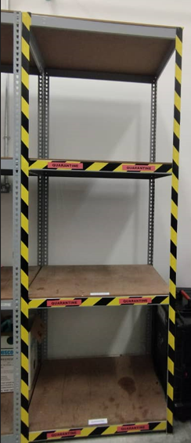
Quarantine area has been relocated to differentiate from serviceable rack as attached

