P.O.L Cabinet & P.O.L Masterlist

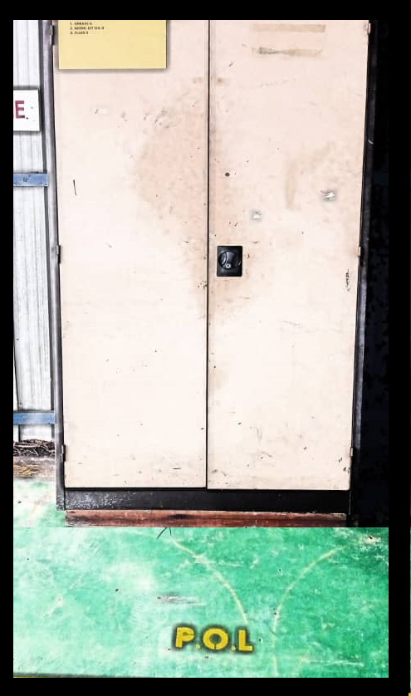

POL Masterlist

