WORKSHOP CAPABILITY PROCEDURE
FOR
INFLATABLE LIFE RAFT
IN TYPE F11R VALISE

GAM/WCP/PART 2.1.12

AMENDMENT - INITIAL

OWNER:
GALAXY AEROSPACE SDN. BHD

CAAM AMO/2016/02

PART 1.2 AMENDMENT RECORD

Each amendment of this document will be accompanied by a letter of transmittal showing the pages to be removed and those to be inserted. All pages will show the date of issue which can be cross checked with the list of effective pages to ensure it’s current.

Date of Amendment | Amdt. No. | Details of Amendment
22/01/2021 | Initial | Initial issue of GAM/WCP/PART 2.1.12

PART 1.3 LIST OF EFFECTIVE PAGES

Latest Amendment Number: 1 Date: 03/12/2021

Page Ref. | Page No. | Amd. No. | Dated | Page Ref. | Page No. | Amd. No. | Dated
1.1 | 1 | Initial | 22/01/2021
1.2 | 1 | Initial | 22/01/2021
1.3 | 1 | Initial | 22/01/2021
1.4 | 1 | Initial | 22/01/2021
1.5 | 1 | 1 | 03/12/2021
1.6 | 1 | Initial | 22/01/2021
1.7 | 1 | 1 | 03/12/2021
1.8 | 1 - 2 | 1 | 03/12/2021
1.9 | 1 | Initial | 22/01/2021
1.10 | 1 - 2 | Initial | 22/01/2021
1.11 | 1 | Initial | 22/01/2021
1.12 | 1 | Initial | 22/01/2021
1.13 | 1 - 2 | Initial | 22/01/2021

PART 1.4 TABLE OF CONTENT

1.1 | Title Page
1.2 | Amendment Record
1.3 | List of Effective Pages
1.4 | Table of Contents
1.5 | Introduction
1.6 | Register of Issued MOC
1.7 | Description, Scope of Capability and
1.8 | List of Approved Maintenance Data
1.9 | List of Equipment and Tool Requirement
1.10 | Approved Facility
1.11 | Certifying Personnel
1.12 | Training Requirement
1.13 | Sample of Workshop Worksheet

PART 1.5 INTRODUCTION

- Introduction
- This Workshop Capability Procedure is to address how GAM manages its Life raft workshop capabilities and activities and supporting MOE 2.9 Repair Procedure and Workshop Procedures Manual.
- GAM can now offer its expertise and MRO services to all carriers operating with Life raft to perform service of 1-year inspection task on Life raft system.
- This Workshop Capability Procedure covers GAM Capability, processes and certification within GAM Workshop Approval/System.

- Reference
- MCAR 2016
- CAAM Airworthiness CAD 8701
- GAM Maintenance Organization Exposition GAM/MOE
- GAM Workshop Management Procedure GAM/WMP
- Interactive Electronic Technical Publication (IETP)
39-A-25-60-00-00A-028A-A Emergency – General
89-A-25-60-00-00A-028A-A Emergency - General

PART 1.6 REGISTER OF ISSUED MOC

Item | MOC Number | Significant Y/N | Rev. no. | Dated
01 | GAM/MOC/21/0006 | Y | Initial | 22/01/2021
02 | GAM/MOC/21/0083 | Y | Initial | 06/12/2021

PART 1.7 DESCRIPTION, SCOPE AND MODEL OF COMPONENT UNDER WORKSHOP CAPABILITY

      - Description
- This section details the GAM capability to perform maintenance checks and service of 1-year inspection to Life raft.

      - Scope of Capability
- Maintenance for workshop capability to be carried out by GAM to service Life raft are as follows:
- Disassembly / Reassembly
- Detailed Inspection
- Leak Check
- Repair
- Inspection & Replacement

- Repair for failure or defect found during inspection which is out of limit or not covered within the approved manual must be repaired by the manufacturer or by an approved repair center.

      - Model of Component under Workshop Capability
Components | Model/ Series | Part Number
Life raft System | F11R Inflatable Life raft | 3G2560V00332
 |  | 3G2560V00432
 |  | 3G2560V00431
 |  | 3G2560V00331
 |  | 3G2560V00433
 |  | 3G2560V00333
 |  | 3G2560V00434
 |  | 3G2560V00334
 |  | 3G2560V00831
 |  | 3G2560V00731
 | F14R Inflatable Life raft | 8G2560V00131
 |  | 8G2560V00231

PART 1.8 LIST OF APPROVED MAINTENANCE DATA

      - Minimum Requirement of Approved Manuals
Series | Manuals
F11R Inflatable Life raft | INTERACTIVE ELECTRONIC TECHNICAL PUBLICATION (IETP)  - 39-A-25-62-07-00A-31AA-K  - Life raft container (left/right) – Detailed Inspection.  - 39-A-25-62-07-00A-530A-K  - Life raft container (left/right) – Disassemble Procedure.  - 39-A-25-62-07-00A-710A-K  - Life raft container (left/right) – Assemble Procedure.  - 39-A-25-62-07-01A-343A-K  - Personal locator beacon (Life raft container) – BIT operation (crew).  - 39-A-25-62-07-01A-520A-K  - Personal locator beacon (Life raft container) – Remove procedure.  - 39-A-25-62-07-01A-720A-K  - Personal locator beacon (Life raft container) – Install procedure.  - 39-A-25-62-07-01A-75AA-K  - Personal locator beacon (Life raft container) – Re-programming procedure.  - 39-A-25-62-07-01A-921A-K  - Personal locator beacon (Life raft container) – Battery box (life raft container) – Replacement (remove and install a new item).  - 39-A-25-62-07-02A-31AA-K  - Life raft container (left/right) – Detailed Inspection.  - 39-A-25-62-07-02A-364A-K  - Life raft container (left/right) – Leak Check.  - 39-A-25-62-07-02A-91LA-K  - Life raft container (left/right) – Unfold/fold procedures.  - 39-A-25-62-07-03A-921A-K  - Pressure gauge window (Life raft container) – Replacement (remove and install new item)  - 39-A-25-62-07-04A-251A-K  - Osmosis pump (Life raft container) – Clean with chemical agent.
F14R Inflatable Life raft | INTERACTIVE ELECTRONIC TECHNICAL PUBLICATION (IETP)  - 89-A-25-63-09-01A-530A-B  - Life raft container (left/right) – Disassemble Procedure.  - 89-A-25-63-09-01A-710A-B  - Life raft container (left/right) – Assemble Procedure.  - 89-A-25-63-09-01A-100D-B  - Life raft container (left/right) – Unfold/fold procedures.  - 89-A-25-63-09-01A-31AA-B  - Life raft container (left/right) – Detailed Inspection.  - 89-A-25-63-09-01A-340A-B  - Life raft container (left/right) – Function Test.  - 89-A-25-63-10-00A-343A-B  - Personal locator beacon (Life raft container) – BIT operation (crew).  - 89-A-25-63-10-00A-520A-B  - Personal locator beacon (Life raft container) – Remove procedure.  - 89-A-25-63-09-01A-720A-B  - Personal locator beacon (Life raft container) – Install procedure.  - 89-A-25-63-09-01A-75AA-B  - Personal locator beacon (Life raft container) – Re-programming procedure.  - 89-A-25-63-09-01A-921A-B  - Personal locator beacon (Life raft container) – Battery box (life raft container) – Replacement (remove and install a new item).

PART 1.9 EQUIPMENT AND TOOL REQUIREMENT

- List of Equipment and Tool Requirement
Description | P/N | GAM I/D
Belt Welder | 304355A | ST053
Welding Tester | 304356A | ST052
Hose with adapter :  Raft adapter | 304691A  - | ST068  ST220F
Plastic scraper | - | ST251
Spatula (Wooden) | - | ST391F
Vacuum device | - | ST054
Digital Manometer | - | CTE48
Safety Pin (SEI) | 11046009 | ST392F
Beacon, Dummy | 303965A | ST757F
Magnifying 10x | - | G2323
Raft Repacking kit :  Cap, recoil  Plug, protection  Round needle for raft stitching  Sleeker  Rachet strap | 304696A  11044009  AGS595C | ST393F  ST394F,ST395F  ST396F,ST397F  ST398F  ST400F  ST401F,ST402F,ST403F,ST404F

PART 1.10 APPROVED FACILITY

      - Minimum Requirement of Facility

        - Safety Equipment Workshop
Life raft
Type of Maintenance | Requirements
Fold/Unfold, Detailed Inspection, Leak Check, Repair,  Inspection & Replacement | No special requirements except for the: -  - Environment should be at the temperature of between 15°C and 35°C.  - Worktable should be clean and free from dust, sharp object, fluids or other unwanted materials (e.g. solvents or greases) on the worktable.  - Worktable must be of sufficient dimensions. The table flat must be smooth and it has no sharp objects that can cause damage to the Life raft.

      - Approved Facility for the Maintenance

- GAM has identified Safety Equipment Workshop at the Galaxy Aerospace (M) Sdn Bhd headquarters (GAM HQ) for all maintenance activities in the respective workshop.
- Safety Equipment Workshop is equipped with sufficient lighting, air conditioned, workbench, workstation and a desktop computer, internet connection, fire extinguisher, fire escape plan, INCOMING, HOLDING, OUTGOING and QUARANTINE area, equipment storage cabinet and racks.
- As there are no special requirements called for by the OEM except for minor requirements on inspection and leak check types of maintenance, it has been decided that any maintenance facility that can meet with the two requirements are considered suitable for carrying out the maintenance work on the life raft.
- List of approved maintenance facilities for the purpose of this capability are tabled below:

        - Life raft
Type of Maintenance | Requirements
Fold/Unfold, Detailed Inspection, Leak Check, Repair, Inspection & Replacement | - Specific Approved Facility at GAM HQ.  Safety Equipment Workshop  Galaxy Aerospace (M) Sdn Bhd.  Suite 11-14, Helicopter Centre, Malaysia International Aerospace Centre, Sultan Abdul Aziz Shah Airport, 47200 Subang, Selangor, Malaysia.  - Any CAAM AMO maintenance facility that can comply to the minimum facility requirement in para. 1.10.1.1 and approved by CAAM

      - Approved Facility – Safety Equipment Workshop, GAM HQ

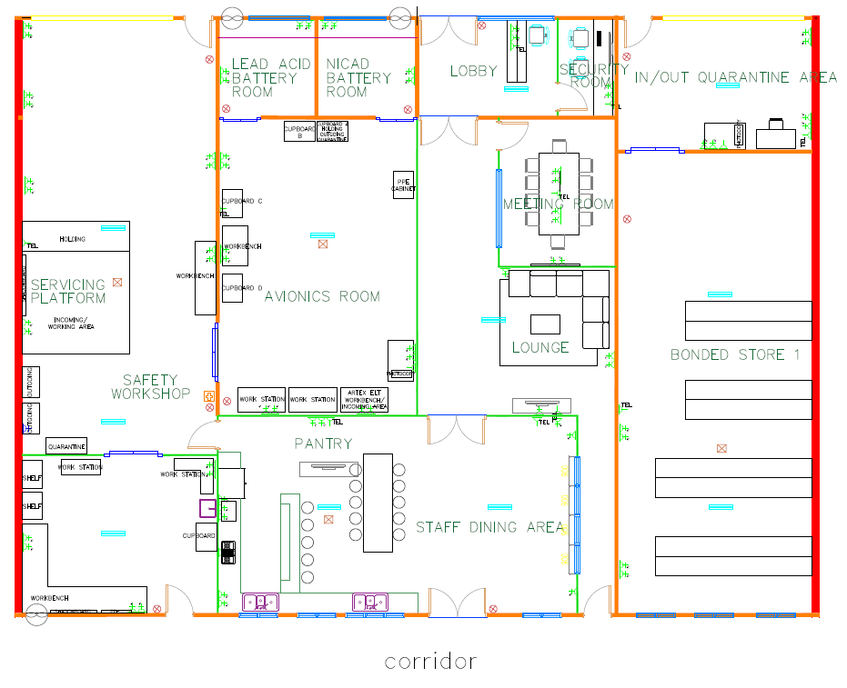
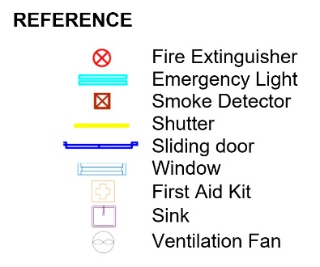

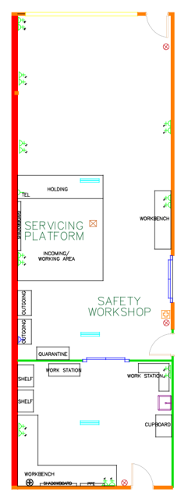

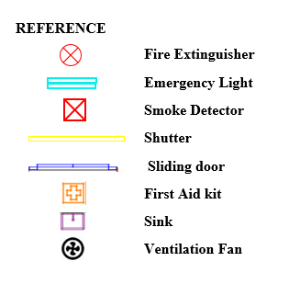

PART 1.11 CERTIFYING PERSONNEL

      - Requirement for Certifying Personnel (WMP Part 1.7.5)
- For aircraft requirement is a B1 Company Approval Holder on type.
- For a Company Approval Holder on Category W; Component C6 on Life raft.
      - Minimum Qualification for Company Approval
- As laid down in MOE Part 3.4.
      - Assessment on Certifying Personnel
- Certifying Personnel are subjected to Technical Competency Assessment i.a.w MOE Part 3.4.
      - List of Company Approval Holders
- List of Current Approval Holders of Component C6 on Life raft are listed in are table as below.

Scope Group | Approval Holders
a.I | B1 Category Approval Holder on type Approval Holder as listed in GAM/Q-001 (List of Approval Holder) of the latest revision.
a.II | W2 Category Approval Holder as listed in GAM/Q-001 (List of Approval Holder) of the latest revision.

PART 1.12 TRAINING REQUIREMENT

      - Requirement of Training for Certifying Personnel
- Specific training is required by certifying personnel to perform the maintenance. The training shall be performed by OEM / OEM recognized training organization / CAAM 145 organization.
- Certifying Personnel shall need to comply with the minimum training requirement as required by MOE Part 3.4.

PART 1.13 SAMPLE WORKSHEET

F11R Inflatable Life raft Workshop Worksheet

Refer Attachment I

ATTACHMENT I

