Production Planning & Control Procedure.

- Maintenance of aircraft fleets typically poses significant challenges with multiple, and in some ways conflicting objectives relating to the delivery of effective maintenance with the minimization of operational costs, whilst maintaining the desired level of Safety & Service.

- Production planning & Control could be described as the ability to utilize available resources to achieve the maximum output within the available maintenance slot period.

- A well-run Maintenance Production Planning Department could be considered the backbone within the Approved Maintenance Organization (AMO)) with many of the tasks being directly controlled by the Production Planning & Control Personnel. Details procedures as flow chart shown below:

FLOW CHART AIRCRAFT DOCUMENTATION

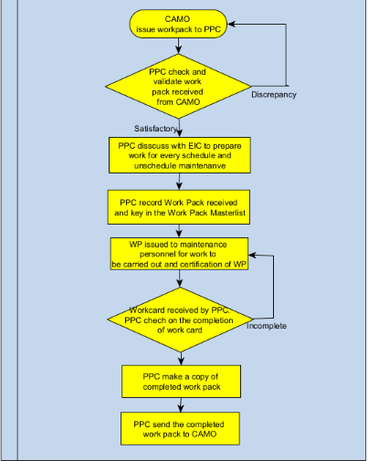

FLOW CHART OF DEMAND & RECEIVING PARTS

FLOW CHART OF EQUIPMENT SERVICING
Initial Quotation has been approved by AMMACE.
PPC email to Commercial to prepare Lampiran E & GAM Initial Quotation
PPC received Initial Quotation
PPC email to Procurement to RFQ from vendor
APPM Personnel will submit safety equipment form to PPC.
The planner who received the item should check the item & documents (Serviceable label/COC/Logcard/ARC)
GAM warehouse personnel received item from vendor after servicing completed and send the item to base.
PPC been informed that item has been complete serviced from vendor.
Revised Quotation has been approved by APMM, PPC email to Procurement for Revised Purchase Order to vendor.
PPC email to Commercial to prepare revised Lampiran E & revised quotation and submit to APMM.
PPC send to safety equipment to GAM store and inform vendor to collect.
Vendor will issue revised quotation after inspection has been done on equipment.
APMM personnel send safety equipment to PPC.
PPC inform Procurement to issue Purchase Order to vendor.

If documentation completed, the item can be sent to APMM personnel with Delivery Note and COC/ ARC

FLOW CHART OF CHECK OPERATIONAL AVAILABILITY (AO)
PPC will update written report.
PPC will give the data to Commercial for claim purposes.
If there is any error on the AO, AMMACE will return the AO for correction.
PPC will update the data in Lampiran G3, G3-1, G4, G7, G8 and G9
PPC collect the data from AO for whole month.
If not, PPC will make a copy for AMMACE to check every week.
PPC will check if the data from aircraft journey log.
If the is any mistake, PPC will do the correction, and make a copy for AMMANCE to check every week
Maintenance Inspector/Supervisor will give the AO for previous day for aircrafts.

