Component detail:
Description | P/N | S/N
Left Hand Main Wheel Assembly | 3G3240V00231
Right Hand Main Wheel Assembly | 3G3240V00231

1.0 | REMOVAL (AMP 39-A-32-41-03-01A-921A-B) & (AMP 39-A-32-41-04-01A-921A-B) (Refer Figure 1)
1.1 | Put the main wheel assembly (15, Figure 1) on a tire changer or an applicable worktable.  WARNING  To prevent injury to personnel, do not disassemble the Main Wheel assembly (15) until the tire (4) is fully deflated.  Remarks:
1.2 | Remove the cap (19) from the charging valve (17).  Remarks:
1.3 | Apply a Tire deflator (Schrader n. 7657) on the charging valve (17). Then fully release the tire pressure.  Remarks:
1.4 | WARNING  Do not remove the Valve Core (18) until the tire (4) is fully deflated. The Valve Core could eject at a high velocity if the tire is not fully deflated.  Remove the valve core (18) from the charging valve (17). Use the tire deflator to remove the valve core.  Remarks:
1.5 | Use a Tire bead breaker to apply pressure in equal increments around the side wall of the tire (4). Apply the pressure near the tire bead to break it from the tire bead seats  Remarks:
1.6 | Remove these parts from the wheel assembly (15):  - The six nuts (1)  - The six washers (2)  - The six bolts (8)  - The six countersunk washers (7)  Remarks:
1.7 | CAUTION  Do not apply force between the wheel flanges and the tire beads. This can cause damage to the wheel and the tire.  NOTE  If necessary, use a mallet to hit and release the tire bead from the wheel bead seats.  Pull the outboard wheel assembly (3) away from the inboard wheel assembly (6).  Remarks:
1.8 | Remove the tire (4) and the tube (3) from the outboard wheel assembly (3).  Remarks:
1.9 | Carefully remove the packing (5) from the inboard wheel assembly (6). Discard the packing (5).  Remarks:
1.10 | Do a detailed inspection on the inboard and outboard wheel subassemblies (6) and (3). Refer to paragraph B.
1.11 | Warning  The materials that follow are dangerous. Before you do this procedure, make sure that you know all the safety precautions and first aid instructions for these materials:  - Isopropyl alcohol (C039)  - Grease (C009)  - Antiseize compound (C148).  NOTE  - If you install a new Inboard wheel assembly (6), think that the packing (10) and fusible plug (9) are parts of the new assembly.  - If you install a new Outboard wheel assembly (3), think that the packing (12), fusible plug (13) and inflation valve assembly (14) are parts of the new assembly.  Make sure that the grease retainer tube (11) is in its position on the inboard wheel assembly (6).  Remarks:
1.12 | Apply a layer of Grease (C009) or Grease (C187) on the new Packing (5).  Remarks:
1.13 | Put the new packing (5) into the groove on the inboard wheel assembly (6).  Remarks:
1.14 | Put the new Tire (4) adjacent to the inboard wheel assembly (6). Make sure that there is the TUBELESS mark on the tire side wall.  Remarks:
1.15 | Clean the tire beads, the wheel bead seats and the wheel register surfaces with the Lint-free cloth (C011) and the Isopropyl alcohol (C039).  Remarks:
1.16 | Dry the parts you cleaned with a clean Lint-free cloth (C011) .  Remarks:
1.17 | Put the new tire (4) in its position on the inboard wheel assembly (6). Make sure that the red balancing dot is up and in the center between two bolt holes.  Remarks:
1.18 | Caution  Make sure that the packing (5), installed in the groove of the inboard wheel assembly (6), is not stretched or twisted.  Put the outboard wheel assembly (3) into the tire (4).  Remarks:
1.19 | Align the holes on the inboard wheel assembly (6) to the holes on the outboard assembly (3). To do this, use the two pins that are at 180° from each other.  Remarks:
1.20 | Turn the wheel to align the red balance dot of the tire (4) with the inflation valve assembly (14).  Remarks:
1.21 | Make sure that the grease retainer (11) and the packing (5) are in their correct position on the outboard wheel assembly (3).  Remarks:
1.22 | Caution  Do not use the bolts (8) and the nuts (1) to put the wheel halves together.  Assemble the two-wheel halves. To do this, obey one of the instructions that follow:  - Use a mechanical or an hydraulic press to assemble the wheel halves, or  - Install two rods, through the wheel bolt holes, and four nuts at 90° from the guide pins. Then assemble the wheel halves.  Remarks:
1.23 | Apply the Antiseize compound (C148) on the parts that follow:  - The thread and the heads of the six bolts (8)  - The six countersunk washers (7)  - The six washers (2)  - The six nuts (1).  Remarks:
1.24 | Install these parts that attach the wheel halves together:  - The six countersunk washers (7)  - The six bolts (8)  - The six washers (2)  - The six nuts (1).  Make sure that the countersunk side of the washers (7) are adjacent to the head of the bolt (8).  Remarks:
1.25 | Torque the six nuts (1) to an initial value of 13.55 N m (119.92 lbf in) in a criss-cross pattern. Obey the precautions that follow:  - If you use a power wrench, tighten the nuts (1) at not more than 50% of the full torque value. Then, use a manual torque wrench to tighten the nuts (1) to the full torque value.  - If you use an automatic wrench system, set a torque precision of ±4% to tighten the nuts (1) to the full torque value.  Remarks:
1.26 | CAUTIONS  - Tighten the nuts (1) to the full torque value in a slow movement without stops. If you stop the torque operation at more than the 70% of the torque, you must disassemble the fastener. In this case, you must do Step 4.3 thru Step 4.5 again on the applicable fastener.  - If you tighten nut (1) and bolt (8) to more than 110% of the full torque value, you must replace them.  - If, with a power wrench, you tighten nut (1) and bolt (8) more than 50% (but less then 110%), you must disassemble them. Then do Step 4.2 thru Step 4.4 again on the applicable nut and bolt.  Torque the six nuts (1) to 27.1 N m (20.0 lbf ft). Torque them in the same pattern used to turn the nuts to the initial torque value.  Remarks:
1.27 | Install the valve core (18) on the charging valve (17).  Remarks:
1.28 | Warning  - Inflate the tire slowly and with a continuous increase in pressure. It is dangerous to inflate the tire too quickly because this can cause an explosion.  - You must do the servicing of the tire and wheel assembly only with an approved inflate equipment.  - Do not inflate the tire at a pressure more than 15.85 ±0.1 bar (230 ±1.45 lbf/in2).  Put the wheel assembly (15) in a safety “cage”. Then inflate the tire as sufficient to set the tire bead against the wheel bead seats.  Remarks:
1.29 | Install the cap (19) on the charging valve (17).  Remarks:
1.30 | Do the leak check on the wheel assembly (15) as follow:  - Inflate the tire (4) at a pressure of 15.85 ± 0.1 bar (230 ± 1.45 lbf/in2) or (helicopter [11L]) at a pressure of 14.0 ± 0.1 bar (203 ± 1.45 lbf/in2).  Record pressure: _____________lbf/in2  - Apply the Soap water solution (Local supply) around these parts:  - The pressure release plug (13)  - The inflation valve assembly (14)  - The fusible plug (9).  - If you find no leaks, remove the soap solution with Water (Local supply) and a Sponge.  - Dry the parts you cleaned with the compressed air.  Remarks:
If you find leaks, do the operation that follow:

- Apply a Tire deflator (Schrader n. 7657) on the charging valve (17). Then fully release the tire pressure.
- Remove the valve core (18) from the charging valve (17). Use the tire deflator to remove the valve core.

- If the leak occurs through the valve stem of the inflation valve assembly (14), do the operations that follow:
- Torque the valve stem of the inflation valve assembly (14) to 20.3 thru 22.6 N m (180 thru 200 lbf in).
Record Torque: ____________lbf.in
- Do the leak check again on the inflation valve assembly (14).
- If the leak continues to stay, apply a Tire deflator (Schrader n. 7657) on the charging valve (17). Then fully release the tire pressure.
- Remove the inflation valve assembly (14) from the outboard wheel assembly (3).
- Remove the packing (16) from the inflation valve assembly (14). Discard the packing (16).
- Put a new Packing (16) on the inflation valve assembly (14).
- Install the inflation valve assembly (14) with the new packing (16) on the outboard wheel assembly (3).
- Torque the valve stem of the inflation valve assembly (14) to 20.3 thru 22.6 N m (180 thru 200 lbf in).
- Record Torque: ____________lbf.in

Do the leak check again on the inflation valve assembly (14).

- If the leak occurs through the pressure release plug (13), do the operations that follow:
- Torque the pressure release plug (13) to 27.1 N m (20 lbf ft).
- Do the leak check again on the pressure release plug (13).
- If the leak continues to stay, apply a Tire deflator (Schrader n. 7657) on the charging valve (17). Then fully release the tire pressure
- Remove the pressure release plug (13) from the outboard wheel assembly (3).
- Remove the packing (12) from the pressure release plug (13). Discard the packing (12).
- Put a new Packing (32-41-01-01-008) (12) on the pressure release plug (13).
- Install the pressure release plug (13) with the new packing (12) on the inboard wheel assembly (6).
- Torque the pressure release plug (13) to 27.1 N m (20 lbf ft).

Do the leak check again on the pressure release plug (13).
- If the leak occurs through the fusible plug (9), do the operations that follow:
- Torque the fusible plug (9) (two places) to 9.6 thru 11.3 N m (84.97 thru 100.00 lbf in). Record Torque: ____________lbf.in
- Do the leak check again on the fusible plug (9).
- If the leak continues to stay, apply a Tire deflator (Schrader n. 7657) on the charging valve (17). Then fully release the tire pressure.
- Remove the fusible plug (9) from the inboard wheel assembly (6).
- Remove the packing (10) from the fusible plug (9). Discard the packing (10).
- Put a new Packing (10) on the fusible plug (9).
- Install the fusible plug (9) with the new packing (10) on the inboard wheel assembly (6).
- Torque the fusible plug (9) (two places) to 9.6 thru 11.3 N m (84.97 thru 100.00 lbf in). Record Torque: ____________lbf.in
- Do the leak check again on the fusible plug (9).

Remarks:
1.31 | Do the 24 hours pressure retention-test as per paragraph 4.0
2.0 | DETAIL INSPECTION (AMP 39-A-32-41-00-00A-31AC-B) (Refer Figure 2)
2.1 | CAUTION  Each five replacements of the tire, do a special detailed inspection of the wheel to find defect in the wheel bead seat. Refer to the applicable steps of the data module AMP 39-A-32-41-00-00A-31BA-B.  Put the inboard and outboard wheel halves (5, Fig. 2) and (4) of the main wheel on an applicable work table.  Remarks:
2.2 | Examine the inboard and the outboard wheel halves (5) and (4) to make sure that there is no heat damage. Change of paint colour shows an heat damage.  Remarks:
2.3 | If you find that the wheel halves have heat damages, do the hardness test on the two wheel halves (5) and (4) as follows:  - Examine the fusible plug (6) on the inboard wheel half (5) to find a melt material. If you found that the fusible plug (6) is blown or melted, do the operations that follow:  - Examine the inboard and the outboard wheel halves (5) and (4) to make sure that they have the correct circular shape. To do this, measure their flange diameter at three different positions, equally distanced, around the outer diameter.  - The difference between the largest and the smallest diameter value must not be more than 0.76 mm (0.030 in).  Record: __________mm  - Replace the wheel halves if the circular shape dimensions of inboard and outboard wheel halves are not in the tolerance.  - If the circular shape dimensions of inboard and outboard wheel halves are in the tolerance, do the eddy current inspection of the two wheel halves. Refer to the applicable steps of data module AMP 39-A-32-41-00-00A-31BA-B.  Remarks:
2.4 | If the inboard wheel half (5) has a good result from the eddy current inspection, replace the fusible plug (6)  Remarks:
3.0 | BEARING REPLACEMENT (AMP 39-A-32-41-03-02A-921A-B & AMP 39-A-32-41-04-02A-921A-B) (Figure 3)
3.1 | Put the main wheel (1, Figure 3) on an applicable work table.  Remarks:
3.2 | Remove the bearing seal (4) from the wheel half (2).  Remarks:
3.3 | Remove the bearing (3) from the bearing cup (5). Discard the bearing.  Remarks:
3.4 | Do Step 3.2 and Step 3.3 and remove the bearing seal (9) and the bearing (8) from the wheel half (7).  Remarks:
3.5 | Clean these parts with the Lint-free cloth (C011) and the Dry-cleaning solvent (C120) :  - The two bearing cups (5) and (6).  - The two bearing seals (4) and (8).  - The two wheel halves (2) and (7  Remarks:
3.6 | WARNING  Be careful when you use the compressed air. Dust and particles can cause injury to your eyes. Always use applicable protective goggles.  Note: You must remove all the solvent and unwanted materials from the cleaned parts.  Dry the cleaned parts with the compressed air until you remove all the solvent.  Remarks:
3.7 | CAUTION  Handle the bearing carefully. If you do not obey this precaution, you can cause damage to the bearing during servicing. Use the Class 2 bearings only. Do not replace the Class 2 bearings with different class bearings.  Install the new Bearing (3) on the bearing seal (4).  Remarks:
3.8 | Note: 1. The alternate greases are not mixable. Refer to relevant data sheet for dangerous consumable and materials.  2. It is more satisfactory to lubricate the bearings by mechanical or other pressure procedures. This will prevent a possible grease contamination and an equal lubrication of the bearing.  Lubricate the bearing cup (5) and the bearing seal (4) with Grease (C009) or Grease (C187) . As an alternative use the Grease (C329) . You must apply the grease in a small quantity, but fully.  Remarks:
3.9 | Install the bearing (3) and the bearing seal (4) into the hub of the wheel half (2).  Remarks:
3.10 | Put a protection on the hub opening of the wheel half. This will protect the bearing from dirt and moisture until you install the wheel on the aircraft. If the drive cap is not available, put a protective cover on the hub of the wheel half.  Remarks:
3.11 | Do Step 3.7 thru Step 3.10 on the bearing (8) and the bearing seal (9).  Remarks:
4.0 | PRESSURE RETENTION TEST (AMP 39-A-32-41-03-01A-921A-B & AMP 39-A-32-41-03-01A-921A-B) (Figure 1)
4.1 | Do the 24 hours pressure retention-test as follows:  - Measure the tire pressure after one hour and record the value. Adjust the tire pressure if necessary. After 24 hours, measure the pressure in the tire again. Compare the values of the two measured tire pressures.  - If the pressure decreased by more than five percent, do the steps that follow:  - Remove the wheel assembly from the inflation safety “cage”.  - Put the main wheel assembly (15, Figure 1) on a tire changer or an applicable worktable
WARNING
To prevent injury to personnel, do not disassemble the Main Wheel assembly (15) until the tire (4) is fully deflated.

- Remove the cap (19) from the charging valve (17).
- Apply a Tire deflator (Schrader n. 7657) on the charging valve (17). Then fully release the tire pressure.
WARNING
Do not remove the Valve Core (18) until the tire (4) is fully deflated. The Valve Core could eject at a high velocity if the tire is not fully deflated.

- Remove the valve core (18) from the charging valve (17). Use the tire deflator to remove the valve core.
- Use a Tire bead breaker to apply pressure in equal increments around the side wall of the tire (4). Apply the pressure near the tire bead to break it from the tire bead seats
- Remove these parts from the wheel assembly (15):
- The six nuts (1)
- The six washers (2)
- The six bolts (8)
- The six countersunk washers (7)

CAUTION
Do not apply force between the wheel flanges and the tire beads. This can cause damage to the wheel and the tire.
NOTE:
If necessary, use a mallet to hit and release the tire bead from the wheel bead seats. Pull the outboard wheel assembly (3) away from the inboard wheel assembly (6).

- Pull the outboard wheel assembly (3) away from the inboard wheel assembly (6).
- Remove the tire (4) and the tube (3) from the outboard wheel assembly (3).
- Carefully remove the packing (5) from the inboard wheel assembly (6). Discard the packing (5).
- Do a detailed inspection on the inboard and outboard wheel subassemblies (6) and (3) as per paragraph B 1 thru 4 of this work sheet.
NOTE
- If you install a new Inboard wheel assembly (6), think that the packing (10) and fusible plug (9) are parts of the new assembly.
- If you install a new Outboard wheel assembly (3), think that the packing (12), fusible plug (13) and inflation valve assembly (14) are parts of the new assembly.

- Make sure that the grease retainer tube (11) is in its position on the inboard wheel assembly (6).
- Apply a layer of Grease (C009) or Grease (C187) on the new Packing (5).
- Put the new packing (5) into the groove on the inboard wheel assembly (6).
- Put the new Tire (4) adjacent to the inboard wheel assembly (6). Make sure that there is the TUBELESS mark on the tire side wall.
- Clean the tire beads, the wheel bead seats and the wheel register surfaces with the Lint-free cloth (C011) and the Isopropyl alcohol (C039).
- Dry the parts you cleaned with a clean Lint-free cloth (C011) .
- Put the new tire (4) in its position on the inboard wheel assembly (6). Make sure that the red balancing dot is up and in the center between two bolt holes.

CAUTION
Make sure that the packing (5), installed in the groove of the inboard wheel assembly (6), is not stretched or twisted.

- Put the outboard wheel assembly (3) into the tire (4).
- Align the holes on the inboard wheel assembly (6) to the holes on the outboard assembly (3). To do this, use the two pins that are at 180° from each other.
- Turn the wheel to align the red balance dot of the tire (4) with the inflation valve assembly (14).
- Make sure that the grease retainer (11) and the packing (5) are in their correct position on the outboard wheel assembly (3).
CAUTION
Do not use the bolts (8) and the nuts (1) to put the wheel halves together.

- Assemble the two-wheel halves. To do this, obey one of the instructions that follow:

- Use a mechanical or an hydraulic press to assemble the wheel halves, or
- Install two rods, through the wheel bolt holes, and four nuts at 90° from the guide pins.
- Then assemble the wheel halves.
- Apply the Antiseize compound (C148) on the parts that follow:

- The thread and the heads of the six bolts (8)
- The six countersunk washers (7)
- The six washers (2)
- The six nuts (1).

- Install these parts that attach the wheel halves together:

- The six countersunk washers (7)
- The six bolts (8)
- The six washers (2)
- The six nuts (1).

- Make sure that the countersunk side of the washers (7) are adjacent to the head of the bolt (8).

Remarks:
4.2 | Torque the six nuts (1) to an initial value of 13.55 N m (119.92 lbf in) in a criss-cross pattern. Obey the precautions that follow:  i) If you use a power wrench, tighten the nuts (1) at not more than 50% of the full torque  value. Then, use a manual torque wrench to tighten the nuts (1) to the full torque value.  ii) If you use an automatic wrench system, set a torque precision of ±4% to tighten the nuts (1) to the full torque value.  Remarks:
43 | CAUTIONS  - Tighten the nuts (1) to the full torque value in a slow movement without stops. If you stop the torque operation at more than the 70% of the torque, you must disassemble the fastener. In this case, you must do Step 4.3 thru Step 4.5 again on the applicable fastener.  - If you tighten nut (1) and bolt (8) to more than 110% of the full torque value, you must replace them.  - If, with a power wrench, you tighten nut (1) and bolt (8) more than 50% (but less then 110%), you must disassemble them. Then do Step 4.2 thru Step 4.4 again on the applicable nut and bolt.  Torque the six nuts (1) to 27.1 N m (20.0 lbf ft). Torque them in the same pattern used to turn the nuts to the initial torque value.  Remarks:
4.4 | Install the valve core (18) on the charging valve (17).  Remarks:
4.5 | WARNING  - Inflate the tire slowly and with a continuous increase in pressure. It is dangerous to inflate the tire too quickly because this can cause an explosion.  - You must do the servicing of the tire and wheel assembly only with an approved inflate equipment.  - Do not inflate the tire at a pressure more than 15.85 ±0.1 bar (230 ±1.45 lbf/in2).  Put the wheel assembly (15) in a safety “cage”. Then inflate the tire as sufficient to set the tire bead against the wheel bead seats.  Remarks:
4.6 | Install the cap (19) on the charging valve (17).  Remarks:
4.7 | Remove the wheel assembly (15) from the safety “cage”.  Remarks:

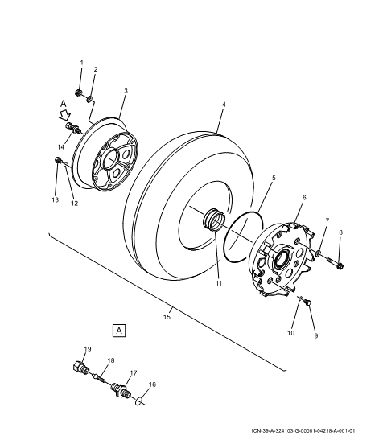

Figure 1 : Main Wheel Assembly – Removal & Installation

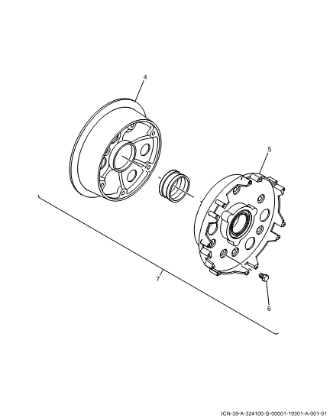

Figure 2: Main Wheel – Detailed Inspection

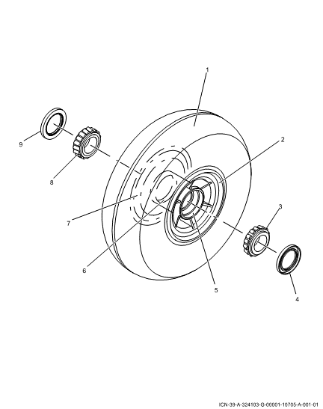

Figure 3: Main Wheel – Bearing Replacement

