A | AUDIT DETAILS
1. | Audit Type / Category | Tick where applicable  ☐ Scheduled  ☐ Surveillance |  | ☐ Vendor  ☐ Product  ☒ Variation to approval
 |  | Specify: CAMO-APMM Initial internal
2. | Audit Reference | - Technical Airworthiness Orders Part M. Dated 28 June 2021
3. | Auditor(s) | - Wan Ahmad Fadhil Wan Mohd Fauzi
4. | Auditee(s) | - Zaty Nadhira Binti Mohamed Zuhari  - Mohd Shazalie bin Ramlie
5. | Location | Stesen Udara Maritim Subang (SUMS), Agensi Penguatkuasaan Maritim Subang, Kementerian Dalan Negeri, Jalan TUDM, 40150 Shah Alam Selangor Darul Ehsan
B | AUDIT SUMMARY
1 | General Information  The audit focused on the GAM-APMM CAMO compliances with the regulations in the TAO-M regulation. Audit was performed as per –  - TAO-M Subpart G  The methodology of this audit is through –  - Documentation review  - Personnel Interview  - Facility Visit  The scope of this audit as below:  - Facilities  - Maintenance Data  - Manpower  - Procedure
2 | Facilities  - GAM-APMM CAMO facility located in SUMS. The allocated area consists of 2 rooms.  - CAMO office during audit is clean and organised. All CAMO staff have their own working space and each person is provided with laptop. Internet access is available with good performance for working online. Two printer is available in CAMO department.  - Lighting level are adequate to achieve comfortable visual environment.  - Noise level is acceptable to have a comfortable working station.  - The 6 cabinets to store all the documents are in acceptable condition.
3 | Maintenance data  - CAMO have the access to all maintenance data as stipulated on Draft Publication Master List Dated 20 July 2023.  - All publications were up to date for each type of aircraft.  - The access Electronic Technical Publication for AW139 and AS365N3 is using application IETP and Orion.
4 | Manpower  - Accountable Manager held by Managing Director, Dato Shamsul Kamar.  - Continuing Airworthiness Manager is Held by Zaty Nadhira.  - Quality Manager is held by Omar bin Ahmad.  - CAMO has a strength of 8 Personnel consist of 1 Manager, 1 Deputy Manager, 2 CAMO Planner, 2 Technical Services and 2 Technical records.  - All personnel have attended human factor, safety management system and aeronet training. However as stated in CAME Part 0.3.8.2. Training such as TAO-M and CAME were not conducted. (Obsevation 1).
5 | Procedure  - The policy and procedure are stipulated in CAME.  - The Maintenance forecast is generated by Aeronet and monitored by CAMO planner. The forecast is been verified during audit.  - The compliance of M.A. 301 is stipulated in CAME Part 1 and shall be reviewed after the CAMO approval is granted by DGTA.  - The TAO-M Subpart G scope were reviewed as below  No. Subject Remarks  M.A. 701 Scope Not applicable  M.A. 702 Application Item in (b) has been submitted to DGTA  M.A. 703 Extent of Approval Not applicable  M.A. 704 CAME All requirement in (a) and (c) has been complied in CAME. Item (b) is awaiting approval from DGTA.  M.A. 705 Facilities Refer to item 2 in this report.  M.A. 706 Personnel requirement Refer to item 4 in this report.  M.A. 707 Airworthiness review staff Not applicable  M.A. 708 Continuing Airworthiness Management The task activity for CAMO is stipulated in CAME part 1 and the procedure is acceptable. The AMP has been develop and awaiting approval from DGTA.  M.A. 709 Documentation Refer to item 3 in this report.  M.A. 710 Airworthiness Review Not applicable.  M.A. 711 Privileges of the organisation Not applicable.  M.A. 712 Quality system In the CAME Part 3. The requirement is comply to this regulation.  M.A. 713 Changes to the CAMO Has stated the policy in CAME Part 0.6.3  M.A.714 Record-keeping Policy and procedure in CAME Part 1.3. The allocated cabinet is locked and in good condition.  M.A.715 Continuity validity of approval Not applicable.  M.A.716 CAMO findings by the DGTA Not applicable.
3 | Conclusion  1 observation highlighted and there was (0) NCR raised during the audit. The audit was concluded to be satisfactory in general.
C | PREPARATION AND APPROVAL
1. | Prepared by
 | 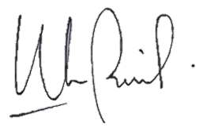  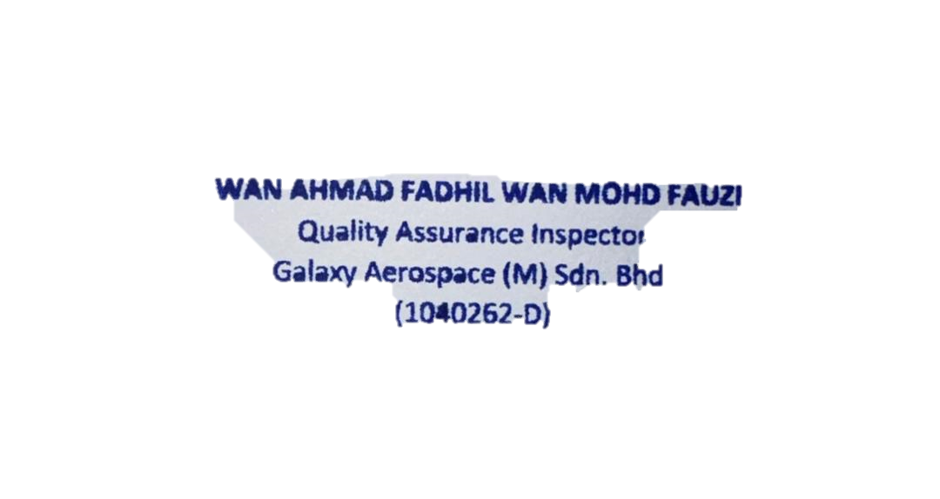  Signature :  Name : |  | Date : 24/07/2023
2. | Approved by
 | Signature :  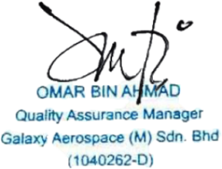  Name : |  | Date :24/07/2023

