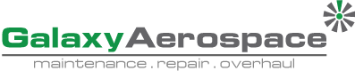

**SAFETY MEMO**

**To** : All Employees

**Date** : 03st September 2020

**Reference** : GAM-S/ME/49/SEPT20

**Subject** : ***RECOVERY MOVEMENT CONTROL ORDER (RMCO)***

1. As announced by government of Malaysia by the Prime Minister, the end of Conditional Movement Control Order (CMCO) or PKPB and been replaced by ***Recovery Movement Control Order (RMCO)*** or PKPP, and Galaxy Aerospace (M) Sdn. Bhd. will continue their effort to control the spread of COVID-19 within the organization and considering safety measures in all its operations.
2. The Recovery Movement Control Order (RMCO) was announced by the Government of Malaysia on the ***28th August 2020*** and will continues to be enforced on ***31st August 2020 to 31st December 2020*** with immediate effect.
3. Galaxy top priority is to ensure that our organization remains a capable and effective in their operation besides ensuring the well-being of staff and clients to meet operations requirements. Some new flexibility has been announced. However, all be encouraged to maintain their personal hygiene under all circumstances and wherever you are.
4. We will continue our operation with in compliance by referring to all Standard Operating Procedure (SOP) established and recommended by National Security Council (MKN) and Ministry of Health (MOH) Malaysia as guidance for a safe operation.
5. In the same regard, seeking all departmental head to disseminate this information to their subordinates and to paste this memo onto your respective notice board.

***#KitaJagaKita #KitaMestiMenang***

Thank you,

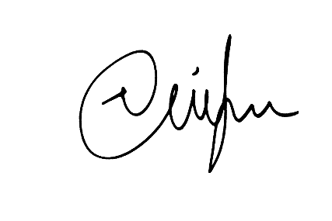

Mohammad Nizam Jaafar

**Safety Manager**

C.C – Managing Director

Chief Technical Operation Officer

Quality Assurance Manager