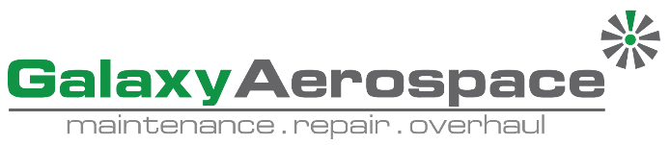

**Continuing Airworthiness Management Office Memo**

To: All Engineering & CAMO Staffs.

From: CAMO

CC: Quality Assurance Staffs

Issue: 11 July 2019

Subject: TOOL SB NO PT-940

Dear All,

New tool service bulletin published by Pratt & Whitney Canada. Detail as per below.

|  |  |  |  |  |  |  |  |
| --- | --- | --- | --- | --- | --- | --- | --- |
| **NO** | **SB NO** | **REVISION** | **ISSUE DATE** | **EFFECTIVITY** | **SUBJECT** | **USAGE** | **REMARKS** |
| 1 | PT-940 | C | 26 June 2019 | PT6C-67C (Fitted on aircraft AW139) | Tool Modification | Overhaul & Heavy Maintenance | - |

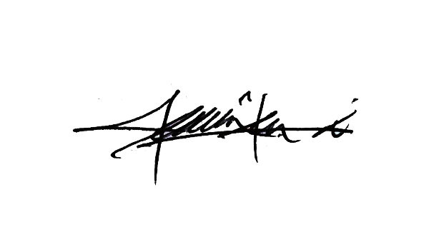Kindly refer Pratt & Whitney Canada Engine Tool SB No PT-940 in GAM Server for your acknowledgement.

Thank You.

Shamsul Kamar Bin Samsudin

Acting Continuing Airworthiness Manager

11 July 2019