

**Continuing Airworthiness Management Office Memo**

To: All Engineering & CAMO Staffs.

From: CAMO

CC: Quality Assurance Staffs

Issue: 11 July 2019

Subject: TMI 139-475, TMI 139-498, TMI 139-500, TMI 139-501

Dear All,

New Temporary Maintenance Instruction (TMI) published on Leonardo portal for aircraft AW139.

|  |  |  |  |  |  |  |
| --- | --- | --- | --- | --- | --- | --- |
| **NO** | **TMI NO** | **REV.** | **REV. DATE** | **EFFECTIVITY** | **SUBJECT** | **REMARKS** |
| 1 | 139-475 | B | 27 June 2019 | AC S/N 31203, 31209, 41262 & 41395 | ENG Reinforcement / Replacement Procedure | Not applicable to PGU & YTL fleet. |
| 2 | 139-498 | - | 02 May 2019 | All AW139 | Main & Tail rotor blade assy – Maintenance Procedures | Applicable to all |
| 3 | 139-500 | - | 25 June 2019 | AW139 with HF System Kit | Role Change Procedure – HF System – General | Applicable to PGU & YTL fleet |
| 4 | 139-501 | - | 19 June 2019 | All AW139 | Eng 1 & 2 install procedure | Applicable to all |

Kindly refer to all TMI in GAM Server for your acknowledgement.

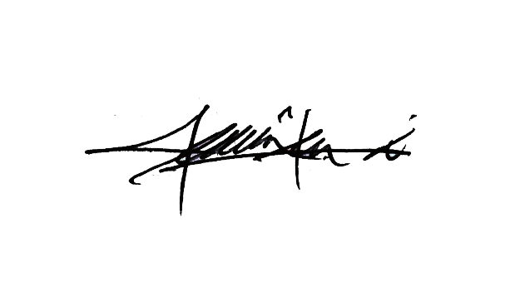

Thank You.

Shamsul Kamar Bin Samsudin

Acting Continuing Airworthiness Manager

11 July 2019