

**Continuing Airworthiness Management Office Memo**

To: All Engineering & CAMO Staffs.

From: CAMO

CC: Quality Assurance Staffs

Issue: 11 July 2019

Subject: ENGINE PT6C-67C ENGINE SB NO 41116 – INTRODUCTION OF TURBOSHAFT ENGINE FUEL

MANAGEMENT MODULE VENT PACKING KIT

Dear All,

New Service Bulletin has been released in Pratt & Whitney Portal introducing engine fuel module vent packing kit. This SB fall under category 9 (Spare Parts Information)

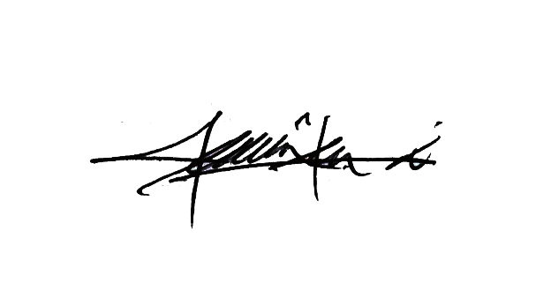

Kindly refer to PT6C-67C SB No 41116 in GAM server for your acknowledgement.

Thank You.

Shamsul Kamar Bin Samsudin

Acting Continuing Airworthiness Manager

11 July 2019