

**Continuing Airworthiness Management Office Memo**

To: All Engineering & CAMO Staffs.

From: CAMO

CC: Quality Assurance Staffs

Issue: 11 July 2019

Subject: Latest IETP for GE Engine

Dear All,

Latest issue Interactive Electronic Technical Publication (IETP) for GE engine model CT2-2E fitted on aircraft AW189 has been release. Detail as per below.

Engine Model: CT2-2E1 (fitted on AW189)

IETP Content:

1) **MAINTENANCE MANUAL**

Revision No: 2

Revision Date: 30 June 2019

2) **ILLUSTRATED PART CATALOG**

Revision No: 3

Revision Date: 30 June 2019

This issue superseded and replace older IETP with content MM revision 1 & IPC revision 2. Older IETP shall be removed first before installing the latest version.

Please be advised, all engineering and CAMO staff shall update their working computer (control computer) effected immediately. Software can be download from GAM Server.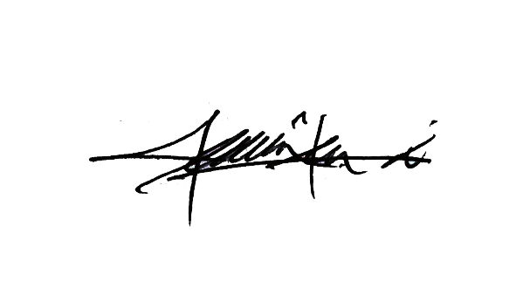

Thank You.

Shamsul Kamar Bin Samsudin

Acting Continuing Airworthiness Manager

11 July 2019