

**Continuing Airworthiness Management Office Memo**

To: All Engineering, CAMO Staffs & Operators.

From: CAMO

CC: Quality Assurance Staffs

Issue: 09 July 2019

Subject: AW189 Kit Compatibility Reference Handbook

Dear All,

Latest issue Kit Compatibility Reference Handbook (CRH) for aircraft type AW189 has been release. Detail as per below.

**Aircraft Type:** AW189

**CRH Issue:** N

**Issue Date:** 20 May 2019

CRH can be download from GAM Server.

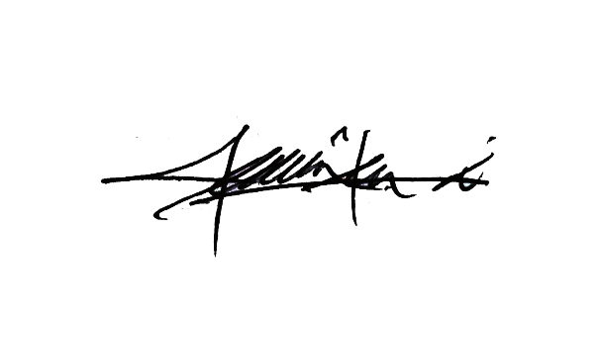

Thank You.

Shamsul Kamar Bin Samsudin

Acting Continuing Airworthiness Manager

03 July 2019