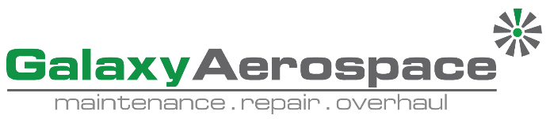

**Continuing Airworthiness Management Office Memo**

To: All Engineering Department & CAMO Department.

From: CAMO

CC: Quality Assurance Department

Issue: 07 July 2019

Subject: SIL GEN-153 Revision 2 – P&WC’s Oil Analysis Tech. Service Logistic Information

Dear All,

General Service Information Letter for all PT6C engine models has been published through Pratt & Whitney Canada Portal. Kindly refer SIL GEN-153 for your acknowledgement. This letter is to inform operators of the logistic instructions for the P&WC’s Oil Analysis Technology Service.

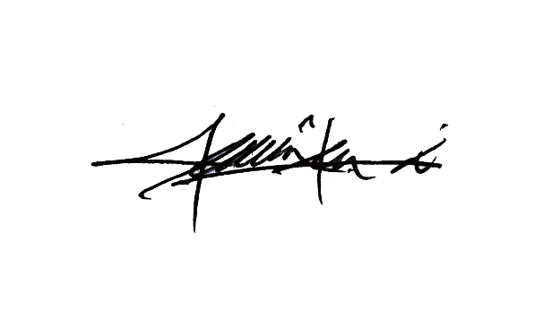

Thank You.

Shamsul Kamar Bin Samsudin

Acting Continuing Airworthiness Manager

07 July 2019