

**Continuing Airworthiness Management Office Memo**

To: All Engineering & CAMO Staffs.

From: CAMO

CC: Quality Assurance Staffs

Issue: 03 July 2019

Subject: TOOL SB NO PT-963, PT-911, PT-957, PT-961 & PT-958

Dear All,

New tool service bulletin published by Pratt & Whitney Canada. Detail as per below.

|  |  |  |  |  |  |  |  |
| --- | --- | --- | --- | --- | --- | --- | --- |
| **NO** | **SB NO** | **REVISION** | **ISSUE DATE** | **EFFECTIVITY** | **SUBJECT** | **USAGE** | **REMARKS** |
| 1 | PT-963 | A | 31 May 2019 | PT6C-67C (Fitted on aircraft AW139) | Tool Introduction | Overhaul & Heavy Maintenance | This SB raised to replace tool PWC72767 |
| 2 | PT-911 | - | 20 June 2019 | Tool Modification | Overhaul | - |
| 3 | PT-957 | - | 21 June 2019 | Tool PWC32445 Re-instated | Overhaul & Heavy Maintenance | - |
| 4 | PT-961 | - | 21 June 2019 | Tool Obsolete | Heavy Maintenance | - |
| 5 | PT-958 | - | 21 June 2019 | Tool Modification | Overhaul | - |

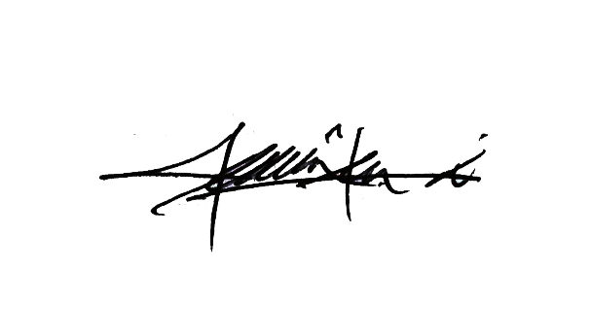

Thank You.

Shamsul Kamar Bin Samsudin

Acting Continuing Airworthiness Manager

03 July 2019