

**Continuing Airworthiness Management Office Memo**

To: All Engineering, CAMO Staffs & Operators.

From: CAMO

CC: Quality Assurance Staffs

Issue: 03 July 2019

Subject: AW189 Rotorcraft Flight Manual Update

Dear All,

Latest issue Rotorcraft Flight Manual (RFM) for aircraft type AW189 has been release. Detail as per below.

**Aircraft Type:** AW189

**IETP Issue:** 2

**Issue Date:** 30 Jun 2017

**Revision/Update:** 5

**Revision/Update Date:** 31 May 2019

There is no active Temporary Revision on this latest RFM. This revision already incorporated inside aircraft 9M-BOE and 9M-BOF on date 01.07.2019.

Please be advised, all engineering and CAMO staff should update their working computer (control computer) for softcopy version. RFM can be download from GAM Server.

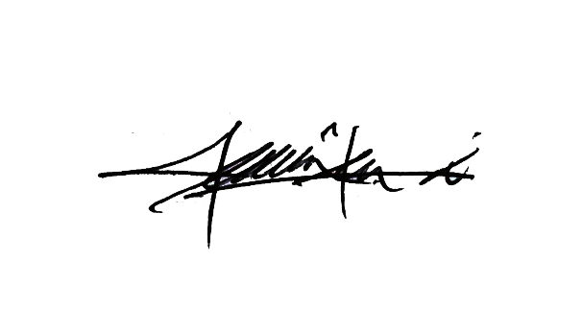

Thank You.

Shamsul Kamar Bin Samsudin

Acting Continuing Airworthiness Manager

03 July 2019