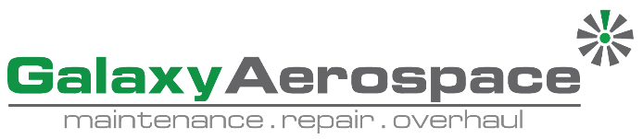

**Continuing Airworthiness Management Office Memo**

To: All Engineering & CAMO Staffs.

From: CAMO

CC: Quality Assurance Staffs

Issue: 20 June 2019

Subject: AW139 IETP Update

Dear All,

Latest issue Interactive Electronic Technical Publication (IETP) for aircraft type AW139 has been release. Detail as per below.

**Aircraft Type:** AW139

**IETP Issue:** 34th

**Issue Date:** 26 May 2019

**Revision/Update:** -

**Revision/Update Date:** -

This issue **superseded** and **replace** IETP issue 33th, update 005, dated 12 April 2019. IETP Issue 33th shall be removed first before installing the latest version.

Please be advised, all engineering and CAMO staff shall update their working computer (control computer) effected immediately. Software can be download from GAM Server.

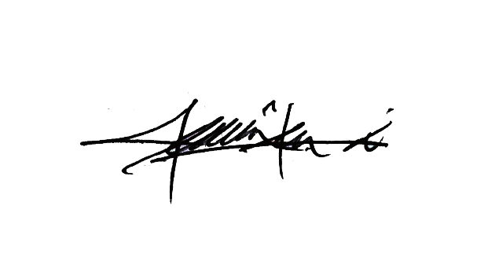

Thank You.

Shamsul Kamar Bin Samsudin

Acting Continuing Airworthiness Manager

20 June 2019