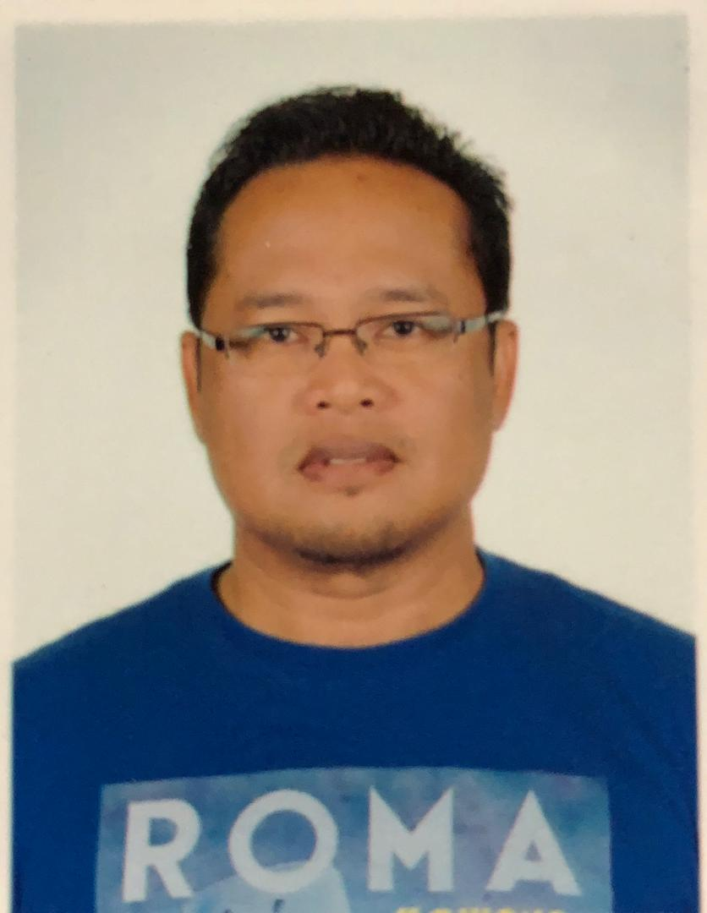

**YUSLI BIN YUSOF**

**No 28 Jalan Bandar U 26**

**Bandar University**

**32610 Seri Iskandar**

**Perak**

Phone Number : +6012 5868242

Email Address : yuzz9372@gmail.com

**PERSONAL PARTICULARS**

|  |  |  |  |
| --- | --- | --- | --- |
| IC NO | **: 720309-11-5689** | Gender | **: Male** |
| Age | **: 52 yrs** | Marital Status | **: Married** |
| Date Of Birth | **: March 09, 1972** | Place Of Birth | **: Terengganu** |
| Race | **: Malay** | Religion | **: Muslim** |
| Nationality | **: Malaysian** | Mobile No | **: +6012-5868242** |
| Postal Address | **: No 28 Jalan Bandar U 26**  **Bandar University**  **32610 Seri Iskandar**  **Perak** | Permanent Address | **: No 28 Jalan Bandar U 26**  **Bandar University**  **32610 Seri Iskandar**  **Perak** |

**EDUCATION**

1. Air Institute Of Technology (Royal Malaysian Air Force)

Certification : Certificate on Air Engine Technician (RMAF)

2. Sekolah Menengah Tok Perdana Sitiawan Perak (1988 - 1989)

Certification : Sijil Pelajaran Malaysia / Malaysia Education Certificate

**TRAINING / COURSES**

1. Air Engine Mechanic Course – Air Institute Of Technology RMAF(29 Jun 92 – 26 Aug 93)

2. C130H Airframe Systems And Power Plant Systems – RMAF Subang (20 Jun 94 – 21 Sep 94)

3. Air Engine Technician Course – Air Institute Of Technology RMAF(17 Nov 94 – 15 Dec 95)

4. Alouette Engine System Course – Airforce College RMAF Alor Setar (01 Nov 96 – 30 Nov 96)

5. Senior Supervisor Course – PLPP RMAF Subang (26 Jun 00 – 29 Julai 00)

6. Sikorsky S61A-4 Engine Maintenance Course – No 3 Sqn RMAF Butterworth (02 Mei 00 – 07 Jul 00)

7. Liquid Penetrant And Magnetic Particle Inspection (NDI Level 1) – Central Aerospace Engineering Services Establishment (RMAF) – (23 Sep 02 – 05 Oct 02)

8. Maintenance Supervisor Course – Institute Technology Of Aerospace RMAF (04 Jul 05 – 15 Jul 05)

9. Failure Mode And Effective Analysis – Linkfarr Sdn Bhd (19 Jul 04 – 21 Jul 04)

10. T1 ARRIUS 1 AS355 (Turbomeca ARRIUS 1) Type Arrius 1A/1A1-1E – Turbomeca Training Center France (19 Aug 13 – 23 Aug 13)

11. T1 Airframe Type Qualification On AS355 – Eurocopter Training Services France (26 Aug 13 – 20 Sep 13)

12. General Familiarization Course AS365N3 Airframe & Turbomeca Arriel 2C Engine – BHICAS

( 23, 24 & 30 Nov 13)

13. Human Factors In Aviation maintenance Professional Seminar – Global Aviation Services

( 15 Feb 14 – 16 Feb 14)

14. MS 1722 & OHSAS 18001 Interpretation & Implementation – NIOSH ( 8 – 11 Apr 14)

15. ISO 9001:2008 Quality Management System Awareness Training Course – Quantum Wave Enterprise (21 Apr 14)

16. Aircraft Maintenance Safety Training - Global Aviation Services (25 Jun 14 – 26 Jun 14)

17. MS 1722 & OHSAS 18001 Internal Audit – NIOSH (10 – 12 Feb 15)

18. Safe Handling Of Chemical And Chemical Spill Response Training – Envisafe Training (16 Dec 15)

19. Human Factors & Error Management – Elite Opa Sdn Bhd(21 Jan 16)

20. Foreign Object Damage & Suspected Unapproved Parts – Elite Opa Sdn Bhd (13 Jan 16)

21. Fire Safty Awareness – Malaysia Airport Berhad (11 Nov 16)

22. Aviation Human Factor – BHICAS (31 Oct 17)

23. Foreign Object Damage Prevention & Suspected Unapproved Parts Prevention – Aero Base Coaching Sdn Bhd (11 Apr 18)

24. Policy And Procedures – An Employee

Responsibility – HR Awareness Training Program - BHICAS (26 Sep 18)

25. Industrial Discipline – KnowLedge Hub (12 & 13 Nov 18)

26. Technical Report Writing – Compass Mind Asia (3 & 4 Dec 18)

27. Refresher Course (Mechanical) AS 555 SN Fennec Helicopter – RMN (10 – 14 Dec 18)

28. Technical Log & Job Card Writing – BHICAS (28 Dec 18)

29. Airframe Type Qualification Training AS365N3/N3+ - AIRBUS (5 Apr – 18 Apr 19)

(6 May – 10 May)

30. T1 Arriel 2 AS365N3 & EC 155 Arriel 2C/2C1/2C2 – SAFRAN (13 May – 17 May 19)

31. Technical Airworthiness Management (Regulation 4 & 5) Training – (25 June – 26 June 19)

32. Tropical Basic Offshore Safety Induction & Emergency Training With EBS And Travel Safely By Boat – TSTC (23 Aug – 25 Aug 20)

**WORKING EXPERIENCES**

**SEP 2022 – PRESENT**

**Workplace :** GALAXY AEROSPACE (M) SDN BHD

**Rank/Appointment :** Maintenance Inspector/Supervisor For AS 365N3 (B1.3 Cat – Airframe & Engine).

Maintenance Inspector/Supervisor For AS 555SN (B1.3 Cat – Airframe & Engine).

**Worked Exposure :** As a Maintenance Inspector/Supervisor.

* Carried out schedule and unscheduled maintenance, first line and second line maintenance, SB, ASB and AD on AS 365 N3 and AS 555 SN helicopter.
* Participated in 2 major inspection (C inspections) on AS 365 N3 helicopter.
* Participated in 1 major inspection (C inspection) on AS 555 SN.

**MAY 2013 – AUG 2022**

**Workplace :** BHIC Aero Services (JV with AIRBUS Malaysia)

**Rank/Appointment :** Maintenance Inspector/Certifiying staff For AS 365N3 (B1.3 Cat – Airframe & Engine).

Maintenance Inspector/Certifiying staff For AS 555SN (B1.3 Cat – Airframe & Engine).

Authorized Tradesperson For AS 365N3 & AS 555SN (B1.3 Cat – Airframe & Engine).

**Worked Exposure :** As a Senior Technician/ Maintenance Inspector.

* Carried out schedule and unscheduled maintenance, first line and second line maintenance, SB, ASB and AD on AS 365 N3 and AS 555 SN helicopter.
* Participated in 3 major inspection (C inspections) on AS 365 N3 helicopter
* Participated in 3 major inspection (C inspection) on AS 555 SN
* Lead 1 Major inspection on AS 555 SN (C inspection) as Supervisor of the project.

**JUN 2004 – JUL 2012**

**Workplace :** Central Aerospace Engineering Services Establishment (RMAF).

**Rank/Appointment :** Warrant Officer 1 / PW Suntingan, PW Pembangunan (Schedule Maintenance).

**Worked Exposure :** As a Senior Editor on RMAF Publication Management.

* Done editing job on new RMAF publication release.
* Done review on RMAF aircraft schedule servicing.

**JAN 1996 – MAY 2004**

**Workplace :** No 5 Squadron RMAF Labuan.

**Rank/Appointment :** Flight Sergeant / Senior Aircraft Technician.

**Worked Exposure :** In Charge of Engine Trade on Alouette MKIIIB,Sikorsky S61A-4(NURI).

* Done rectification and servicing to maintain serviceability of aircraft fleet.
* Manage man power and man hours to cope with squadron operation requirement.
* Aircraft 1st line maintenance on Alouette MK III B and Sikorsky S61A-4.

**SEP 1993 – NOV 1994**

**Workplace :** No 14 Squadron RMAF Subang.

**Rank/Appointment :** Aircraftman / Aircraft Technician.

**Worked Exposure :** Aircraft 1st line maintenance on C 130H.

* Done rectification and servicing to maintain serviceability of aircraft fleet.

**SKILLSETS**

**Computer skill** : Microsoft Office Application and Internet.

|  |  |  |
| --- | --- | --- |
| **Language Skill :** | BM - | Excellent in speaking and writing. |
| **(Excellent / Good /**  **Fair / Poor)** | English - | Good in speaking and writing. |

- Can work well in groups and without supervision.

- Can work under pressure and meet tight deadlines.

- Can adapt in new environment and willing to be transfer/travel. - - Responsible to accept the impact of any decision taken.

**EXPECTATION**

1. Working on field job as a Aircraft Technician.

- Intends to develop a career in the field of aviation by joining a company with high technology and extensive capabilities in aviation sector.

- To obtain a challenging and responsible position where I can contribute the best of my

skill and effort for the growth of the company.

2. Expected Salary – Negotiable.

**REFERENCE**

1. Ibrahim Hazly Mohamad Yusof

Senior Engineer / LAE

Galaxy Aerospace Malaysia

Email: [hazly.galaxyaerospace@gmail.com](mailto:hazly.galaxyaerospace@gmail.com)

Mobile Phone : +601161565692

+60192156576

#### 2. Aishah Nanyan

Quality Engineer

Bhic Aero Services

EMAIL: [aishah.nanyan@bhic.com.my](mailto:aishah.nanyan@bhic.com.my)

Mobile Phone : +60139577739

3. Major Zamri Bin Rosdan (Retired)

Maintenance Manager

Bhic Aero Services

EMAIL: [zamri.rosdan@bhic.com.my](mailto:zamri.rosdan@bhic.com.my)

Mobile Phone : +60123011178