Ratchet Tie Down Lashing Strap with 5 Tons Breaking Strength 50 mm x 9 m Car Lorry Truck Emergency Towing Strap RM 100.00

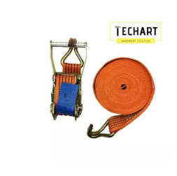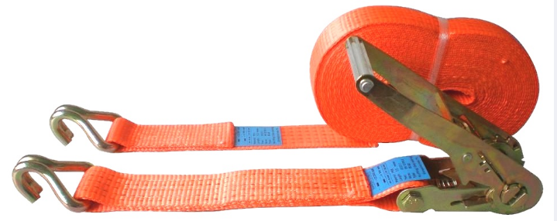

**Features:**

* Ratchet Tie Down Lashing Strap with 5 Ton Breaking Strength 2" x 9 Meters Car Lorry Truck Emergency Towing Strap
* Extendable Length up to 9 Meters for Convenient Work Usage and Safe Hauling
* High and Enhanced Quality Product for Daily Work and Emergency Use
* Forged Construction for Durability, Zinc Plated Surface for Lasting Finish, Non-Slip Ergonomic Handle for Extra Gripping
* A Must Have Tool for High Productive Usage During Work or During Emergencies
* Fine Finished Dichromate Steel for Extra Durability and Resistance to Corrosion
* Strap are made of Heavy Duty Polyester Webbing, Weather Resistant and UV-Protected for Ensured Durability
* Simple and Reliable Operation, Compact During Storage and Suitable for Portable Use
* Breaking Capacity: 5 Tons

**Details:**

Ratchet tie downs, lashings & ratchet straps are the modern, lightweight and thoroughly reliable method of securing all types of load across the entire spectrum of consumer, automotive and military requirements. They offer significant advantages over steel banding, rope, chains, having superior performance and properties as detailed below:

* Do not weaken with age
* Inherently absorbent of shocks
* Corrosion free
* Simpler, more positive inspection - if it looks all right, it is all right!
* Lighter weight means easier working, less risk of injury
* Lower weight also means lower transport costs
* Suppleness of polyester accommodates irregularities of the load. Tie Down Chains may damage the load if griped in the wrong place.
* Less risk of damage to polished, painted or sensitive surfaces
* Superior level of cargo control through high pre-tensioning

Ratchet Tie Down Belt With Metal Lock ( 2") 50mm x 10m Light Duty RM 70.00

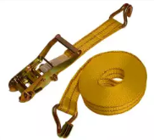 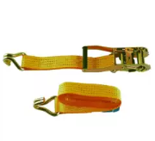

Product details of Ratchet Tie Down Belt With Metal Lock ( 2") 50mm x 10m Light Duty

* Ratchet Lock is Made from durable Steel
* Heavy Duty Steel Coated Hooks
* Drop Forged Heath Treated Vinyl
* 2 Inch wide x 33Ft long
* Automatic Quick Release

**SPECIFICATION**

* Ratchet Lock is Made from durable Steel
* Heavy Duty Steel Coated Hooks
* Drop Forged Heath Treated Vinyl
* 2 Inch wide x 33 Ft long
* Automatic Quick Release

**WHAT IN BOX**

* 1 x Set Ratchet 10meter

2PCS X 1" X 15' RATCHET TIE DOWN (RANDOM COLOR)

RM 70.00

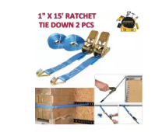 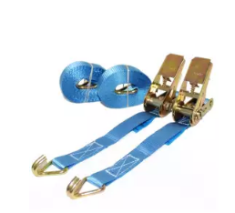

Product details of 2PCS X 1" X 15' RATCHET TIE DOWN (RANDOM COLOR)

* Specification Name:400 lbs. Capacity 1 inch x 15 feet Ratcheting Tie Downs Break strength:1200 lbs. Material:Polyester Quantity:2 Belt width:1 inch Length:15 feet

Safety Belt Ratchet Tie Down belt - 2 Ton x 10m RM 70.00

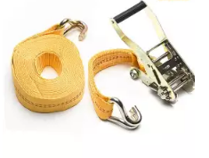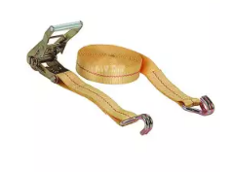

**Product details of MYDIYHOMEDEPOT - Safety Belt Ratchet Tie Down belt - 2Tonx 10m**

* Secure your ATV, motorcycle, small equipment, or other cargo for transport with these CAMBUCKLE TIE DOWN. The straps come in a pack containing. The 2 Ton x 10m. Ratchet Tie-Down provides maximum tension for demanding tie-down applications. Double J-Hooks attach to anchor points for outstanding ease of use and versatility. Hi-Test webbing is designed to remain tough even when subjected to weather and abrasion.