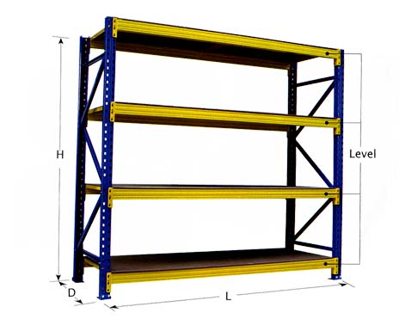

HEAVY DUTY RACKS/SHELVING

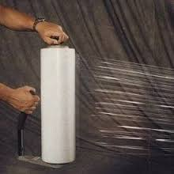 PLASTIC WRAPPING